CIS 331 Assignment #1
Getting Started With Java and NetBeans

Printout due in class on Friday 1/15/10

The purpose of this assignment is to familiarize yourself with the NetBeans integrated development environment (IDE). This is available in the computer lab. In addition, you can download JDK 6u16 with NetBeans 6.7.1 Bundle from http://java.sun.com/javase/downloads/netbeans.html.

In this assignment you will also learn some very simple, introductory Java syntax.

The deliverables for this assignment include screen images of your activities, a new java program listing along with its output, and the answers to a few questions.

DOWNLOADING AND INSTALLING

If you plan to do programming work on your own computer, you will need to download the JDK and NetBeans IDE onto your computer. To do so, go to http://java.sun.com/javase/downloads/netbeans.html.. Follow the directions to install Netbeans and the JDK on your computer.

PART 1: Setting up your NetBeans Project for the Liang7eSamples

You need to do two things here. First, you need to set up a project to contain the Liang samples. The samples themselves are available in the zip files that accompany the class notes. At this point, there are two folders of Liang examples, (ch1 and ch2), these are in the zip files for the first and third set of class notes.

- In NetBeans, select New Project from the File menu.
- In the New Project dialog, select Java Class Library as your project type, as shown here:

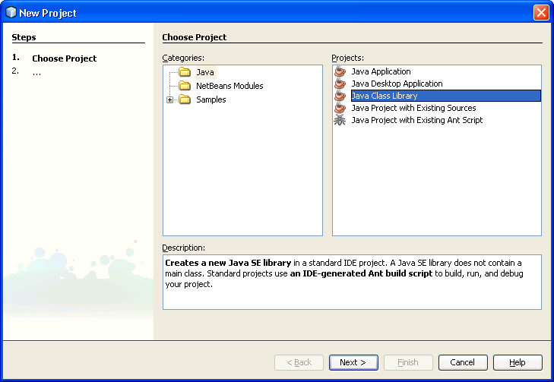

- Click the Next button. A New Java Class Library dialog will appear.
- In the New Java Class Library dialog, do the following::
  - Set the Project Name to Liang7eSamples
  - Select the folder location where you want your project to reside

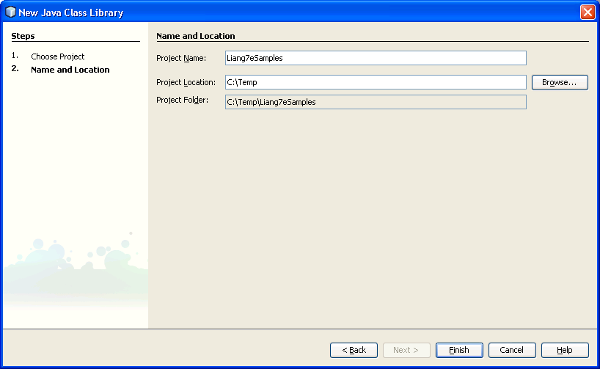

- Click the Finish button. A new project will appear in your Projects window:

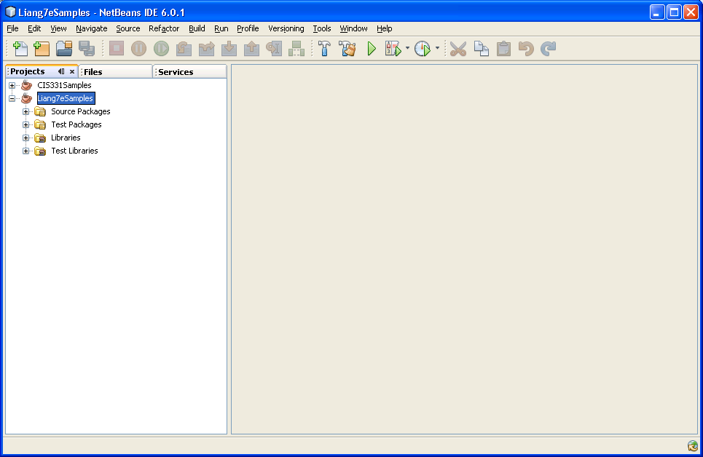

Now, from Windows Explorer or My Documents, get to the folder that was created (Liang7eSamples) and then get into the src subfolder. This is where the source code java files will be placed. Since I am sending these to you piecemeal, you will need to copy files into this folder from time to time.

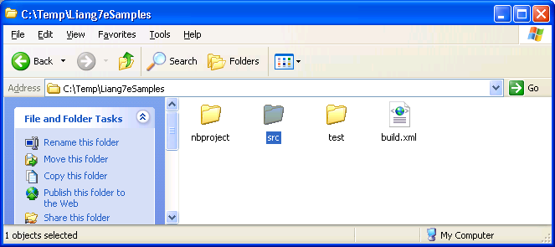

Next, download the ch01 folder from the zip files associated with the class notes for chapter 1. This should be placed into the src folder. Therefore, the contents of the src folder should now look like this:

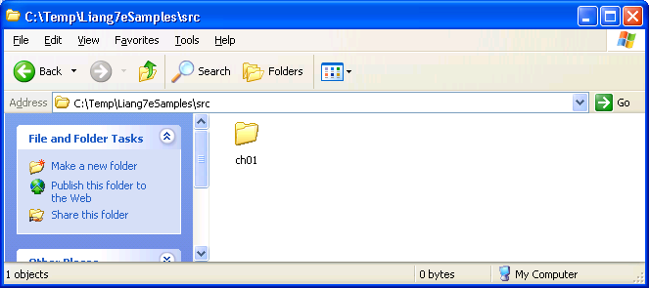

Back in Netbeans, in the Projects window expand on the Source Packages. You should see the ch01 package. Expand this package. You should see the Java classes in the package. Double-click on the Welcome.java icon. The editor window to the right will show the code.

Now, right-click on the Welcome.java icon. From the popup menu, select Run. File. The Welcome program will compile and execute, and you should see a welcome message in the Output window below.

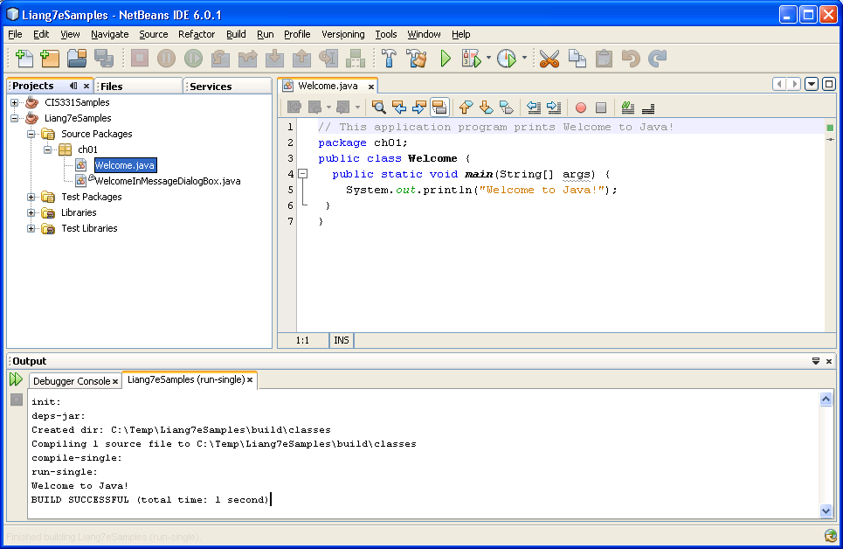

PART II: Understanding the file and directory structure

A Netbeans project is composed of four sections: Source Packages, Test Packages, Libraries, and Test Libraries. Mostly, you are just concerned with Source Packages. These are the packages (i.e. subfolders) that contain the source code for your Java programs. To see this, go to the Liang7eSamples folder in Windows. It looks something like this:

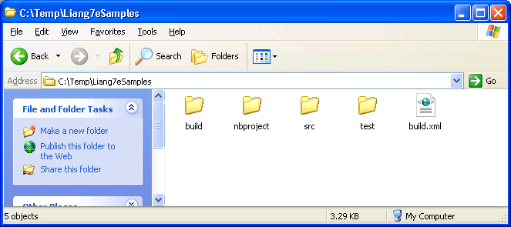

From here, get into the src folder. This is the folder that contains all the source packages, which are implemented as subfolders. You should see this:

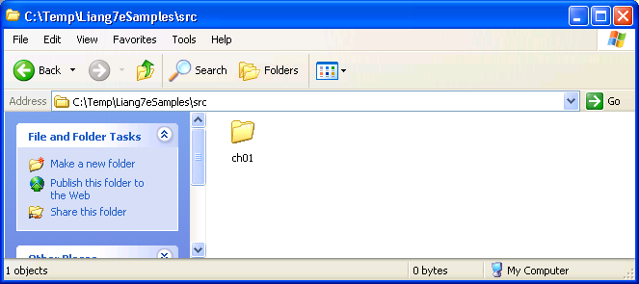

Note that the contents of the src directory is the same thing you see in NetBeans Projects window, under the Source Packages node of the tree:

Next, get into the ch01 folder. ch01 is the package that contains the Welcome and WelcomeInMessageDialogBox Java classes. The ch01 folder under the src folder contains the source code files for these classes, as shown below: Source code files have the .java file extension.

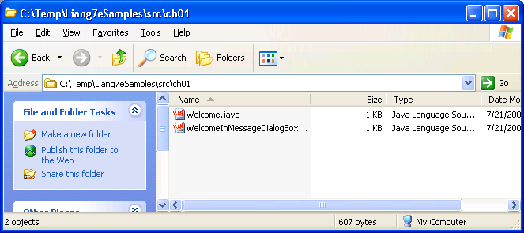

(NOTE: your icons may not look the same as mine. But you should see the same two fikes).

Now, go back up to the Liang7eSamples folder, and then get into the build subfolder. From here, go to the classes subfolder. Again, you will see package subfolder for ch01. But this folder contains the bytecode files with .class file extensions. Bytecode files are the files that contain the compiled code, not the source code. For example, when you compiled the Welcome.java file earlier, this caused a bytecode file to be created in the ch01 subfolder of the classes folder. Every compiled Java class is in its own bytecode file.

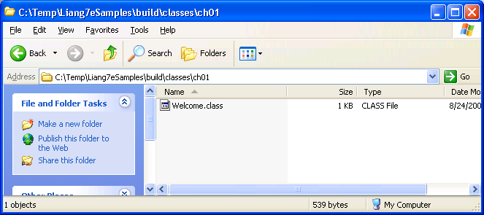

PART III: Setting up a NetBeans project for your CIS331 assignments

This semester, all your assignments will be created as part of a project that you will call CIS331Assignments, and each one will be placed in a separate package in that project. To get started, you must create the CIS331Assignments project. The steps for doing this are basically the same as for creating the Liang7eSamples project, except you will call this project CIS331Assignments instead of Liang7eSamples.

Please do this now. Then continue to Part IV.

Part IV: Writing a Simple Java Program

Each assignment you create this semester will be implemented as a package in your CIS331Assignment project (which you made in Part II above). Your first assignment is a very simple program, similar to the Welcome.java program in the ch01 package of Liang’s samples.

To create the package, in the Projects window, right click on the Source Packages under CIS331Assignments, and create a new package called assn1.

Now, in the new assn1 package, you will create your new java class. Right-click on the assn1 package, and in the popup menu choose New, then Java class. Call it whatever you want (in the example below, I called it Assn1Class. Note that the editor window will show the skeleton code for this new class:

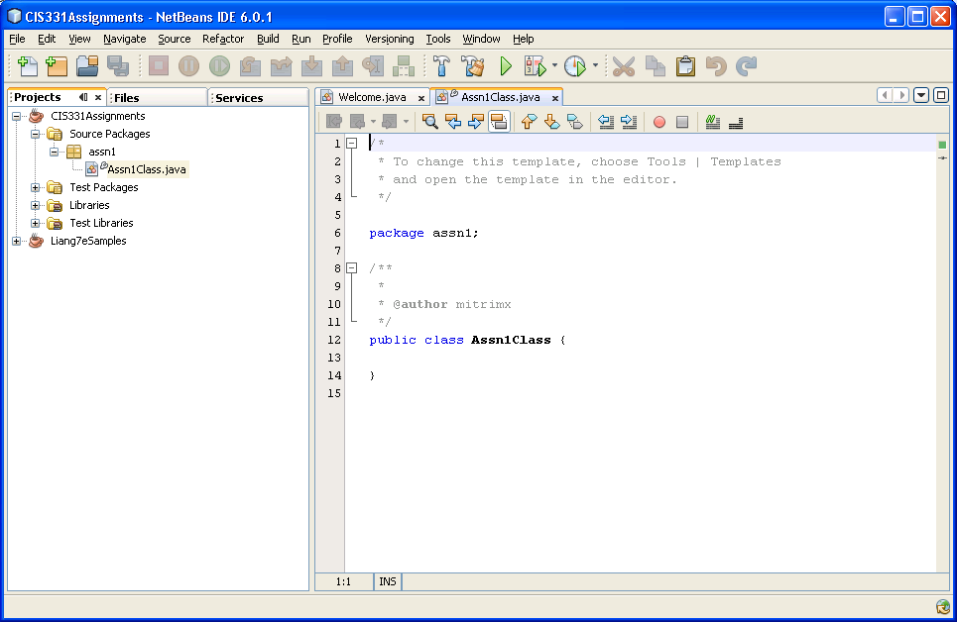

Now, in the comments at the top, replace the existing comments with your name and peoplesoft number, and with a pledge that this is your own work and you are abiding by the JMU honor code.

Now, create a main method for your program. The syntax for the main method is described in the class notes. You can copy and paste the main method from Liang’s Welcome.java example.

Now, write the code that will accomplish the following:

Your program should be similar to Liang’s Welcome.java program. However, instead of writing a single message, you should make it write the following lines:

- Your name
- Your PeopleSoft number (student ID)
- Your home town
- A list of all the classes you are taking this semester.

For example, after running the program the output might look like this:

My name is Joe Smith
My peoplesoft number is 00012345678
My home town is Harrisonburg, VA
I am taking the following classes:
CIS 331
CIS 330
CIS 366
CIS 320

DELIVERABLES

To prove to me that you have done this, I will want you to print out and turn in to me the screen image of your NetBeans environment. The screen image must display all of the following:

- The full source code listing of the program you wrote in part IV. (in the Source Editor window). Make sure all source code is visible.
- The Project window, showing the expanded CIS331Assignments, Source Packages, and assn1 package folders, so I can see that you created your project, package, and class correctly.
- The Output window displaying the output of the program execution.

In addition, please answer the following questions:

1) What is the file extension of a java source code file?
2) What is the file extension of a java bytecode file?
3) What is the name of the folder in which NetBeans puts source code package folders?
4) What is the name of the Java program that actually runs your classes (i.e. the “virtual machine”)?
5) What is the name of the Java program that converts Java source code into bytecode?

All the above must be done in a Word document, and turned in to me during class on the due date.

