CIS 331 Assignment #4
Arrays, Strings, and Stream I/O
Product Sales Summary

Due via blackboard by midnight Saturday 2/27/10

CARRY-OVER FROM ASSN3

Include these exercises from the book, unless you did them with assn3. Although they were initially intended for assn3, the snow days prevented us from covering the necessary materials in

- Exercise #6.1 p222 (this requires an array, since you need to go through the numbers again after you have calculated the average)
- Exercise #6.5 p222

THE MAIN ASSIGNMENT

For this assignment, you will write a program that reads product sales data from a text file, and then calculates the total revenue earned for each sales region and the total units sold and total amount of revenue earned for each product. The text file will contain one line of text for each product. Each line consists of the following data (delimited by spaces or tabs):

- product name
- product price
- units sold in North
- units sold in South
- units sold in East
- units sold in West

For example, consider this text file:

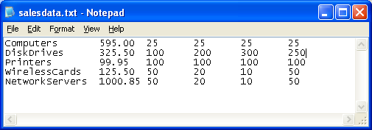

The price of DiskDrives is $325.50, and 100 units were sold in the north, 200 in the south, 300 in the east, and 250 in the west. You can see similar data for Computers, Printers, WirelessCards, and NetworkServers.

Your program should prompt the user (using standard input stream…no GUI please) for the file path:

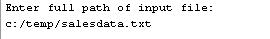
User input

Then, your program will output to the screen the summary of revenue for the regions, and also display the units sold and total revenue each product, along with the average revenue and products generating higher than the average. For the above data, the output will look like this:

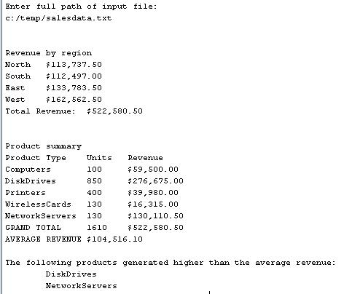

Note that the program first asks the user to enter the input file. Then it outputs the total revenue for each region and a grand total. (From the input data, you should be able to verify the validity of these result by performing a manual calculation.) After displaying the region summaries, the product-specify summaries are calculated. As you can see, a total of 100 computers were sold (25 in each region), and at $595 per unit, this came to a total of $59500.

Note also the currency format of the output, with a dollar sign preceding the revenue quantity and comma separating the thousands place. This can be done using: the NumberFormat class found in the java.text package. See page 1031 of your textbook for assistance in doing this. I expect your output to display proper currency format.

Your program must be flexible enough to handle a variety of input files. There may be as many as 100 products in the file. But in all cases, a single line of the text file will be structured as described above.

Program Data Representation

To make this work, you will need to create five arrays.

One array will contain the product names. A second array will contain the total units for each product. A third will contain total revenue for each product. These three are parallel arrays. This means that the same index in each array pertains to the same entity. For example, for the above data, the arrays for product names, units, and revenues will look like this at the end of the program execution:

Names Units Revenue
Computers |  | 100 |  | 59500
DiskDrives |  | 850 |  | 276675
Printers |  | 400 |  | 39980
WirelessCards |  | 130 |  | 16315
NetworkServers |  | 130 |  | 130110.5

These arrays must be large enough to handle an unknown number of products. As stated above, there can be as many as 100 products in the file. But there may also be less than 100. Therefore, although these arrays must be large enough for the maximum amount, many of the elements of the arrays will be empty. So, you should also have a variable to keep track of how many products are actually read from the file. This total products variable will also be used to keep track of the next available element in the three arrays, and can be used to index into these arrays. For example, the total products variable starts at 0, which means that you will index into element 0 of these arrays. For each product that you read from the file, you can increment the total products variable. Thus, after you have processed the first product, the total products variable will be 1, so you will index into element #1 of the arrays. Thus, the total products variable serves two purposes: keeping a running count of the products and indexing into these three arrays.

The third and fourth arrays will contain the names of the regions and the corresponding total revenue for each region. These are also parallel arrays, but their size is much smaller. You only need enough elements for the four different geographical regions.

You will also need other variables for keeping track of totals, inputting data from the file, etc.

Program Logic

The logic of the program works something like this:

- Prompt the user for the name of the file (note: this should be done using standard input stream, not any GUI)
- Read the response from the user.
- Open the input file specified by the user (via the Scanner method described in class)
- Loop as long as there is more data to read:
  - Read the product name as a string, and place it into the product name array
  - Read the price as a double, and place it into a variable to use in the revenue calculation
  - Read the remaining integers from the file (sales for each region). Use these to:
    - accumulate the total units for the product
    - add the units times price to the correct element of the region revenue array
  - place the total units into the units array, and place the units time revenue into the revenue array for the product
  - add one to the count of total products. You can use total product count to index into the names, units, and product revenue arrays.
- At this point you have accumulated all the data into the arrays. Now it is simply a matter of displaying the results, and accumulating grand totals. Each of these will be done in a loop.
- Finally, calculate and display the average revenue for the products, and identify the products that generate higher than the average

CAUTION

Conceptually, this is not a difficult problem, and doesn’t take that much coding to accomplish. My solution contains a total of approximately 60 lines of code in the main method. The problem of reading from the console input, reading text files, and array processing is simply what you learn from the class notes and code examples. You can use the code from these examples to help you.

However, translating this from concept to result will be a challenging task. You do NOT want to put this off to the last minute. There is no doubt that you will encounter obstacles along the way.

Use the debugger to help identify problems and bugs. Also, make sure to use me as a resource. I will give guidance where appropriate. But most importantly, get an early start and work diligently and consistently through the whole week.

PROGRAM STYLE

In addition to correct functionality of the program, I expect you to adhere to sound programming style.
Use descriptive variable names. Be sure to use proper indentation in your code and supply enough comments to make it clear what the program is doing.

At the top of your program listing, you need to include comments with:

- your name and peoplesoft number
- the course and section
- the assignment number
- a statement assuring me that this work was done in accordance to the JMU Honor Code.

DELIVERABLES

For this program, I will want the following (all zipped together):

- The .java file(s)
- A screen image (captured using Alt+PrtScrn and pasted into a Word document) showing the contents of memory at a particular “interesting” breakpoint during the execution of your Product Sales Summary program (use the debugger). This image should show an array expanded so that I can see the contents of individual elements of the array.
- A brief (1-2 sentence) description of what the debugger is showing you at the time of the breakpoint

