CIS 331 Assignment #5
Working with Methods and Arrays

Zip file due in digital dropbox by Friday night 3/19/10 before midnight

DESIRED PROGRAM BEHAVIOR

In this assignment, you are to write a program that behaves as described below. It should loop repeatedly, presenting a GUI menu for the user to select from, like this:

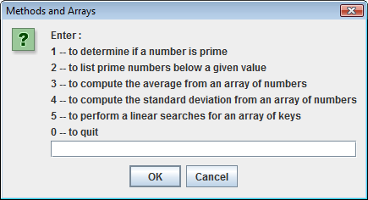

The user will enter a choice, and the program should perform the appropriate operation. The following are done:

1) Determining if a number is prime

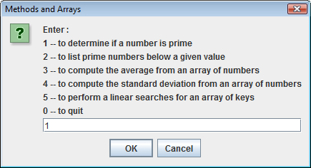

User enters a number:

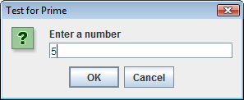

Display indicates whether or not the number is prime:

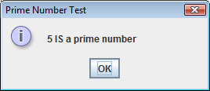

2) List all prime numbers below a given value

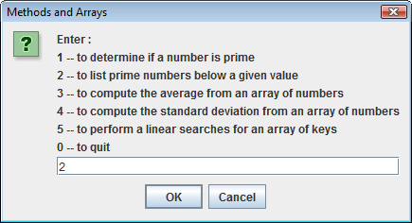

User enters a number

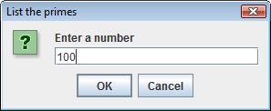

Display lists all prime numbers less than this value

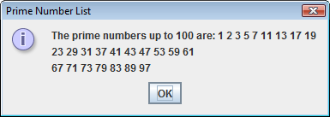

3) Compute the average from an array of values

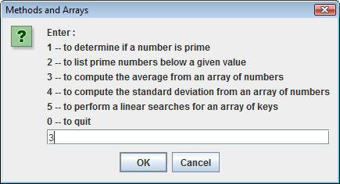

The user specifies the array size:

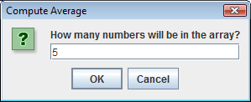

he user is repeatedly prompted to enter values for filling the array:

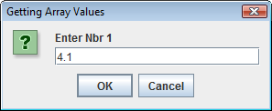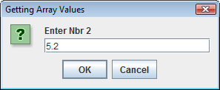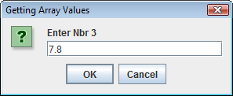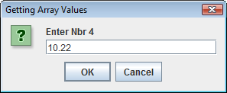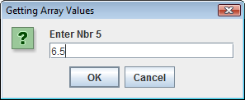

The user is presented with the results:
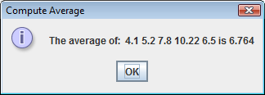
4) Compute the standard deviation from an array of values
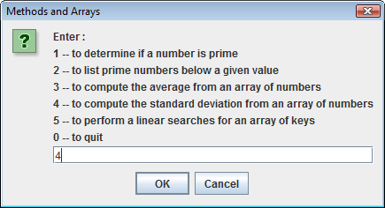

The user is prompted to enter the size of the array, then to enter each value (the same exact thing as when computing the average above).

The result would look something like this:

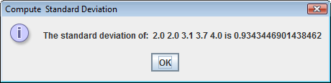

5) Perform linear searches on a data array for an array of keys (search values)

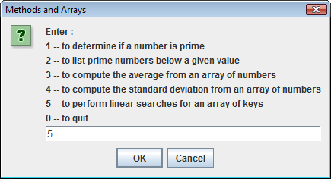

The user is prompted to enter the size and values for an array of keys (these are the numbers we will be searching for in the data). Then the user is prompted to enter the size and values for an array of data (this is the list of numbers that will be searched). Note that this process of obtaining array sizes and values is something that happens in options 3 and 4 as well.
The result from will be an output that looks something like this:

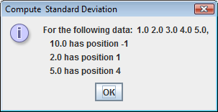

Note that a -1 position indicates that the value is not found in the data array.

0) Quit the program

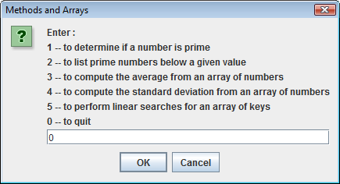

Program says goodbye and terminates:

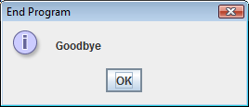

ERROR HANDLING

Your program must handle any errors that the user has. If the user enters an invalid number, or if the user enters a non-numeric value, you must present an error message and allow the user to try again. For example, the message could look like this:

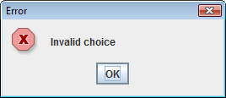

NOTE: if a non-numeric value is entered and you try to convert it to a number, this will generate an exception. So, your program needs to deal with this using exception handling (i.e. try and catch blocks).

PROGRAMMING TASKS

For this assignment, you will write a program that includes methods for various tasks. The signatures for these methods and descriptions of the tasks they perform are listed below:

- static boolean isPrime(int number)

This method returns True if the parameter is a prime number. A prime number is a number that has no factors other than itself and 1. For example, 2, 3, 5, and 7 are prime numbers, but 4, 6, 8, and 9 are not.

The trick to test if a number is prime is to make sure it is not divisible by any number (other than 1) lower than itself. So, if you had a loop that went from 2 to ½ the value of the number you are testing, and checked whether the number you are testing was divisible by the loop counter number, and if NONE of these came out true, then you would know it is a prime number.

- static String listPrimes(int number)

This method returns a string that contains all of the prime numbers that are less than or equal to the passed in parameter. For example, if the value of the parameter is 10, then the string should have 1, 2, 3, 5, 7.

This method involves a loop in which all the primes are concatenated to the string. When completed, the string is returned. This method should call the isPrime() method in order to determine, for each value in the loop, whether it is prime.

- static double average(double[] nbrs)

This method returns the average (i.e. the mean) of an array of numbers. You’ve already done this calculation in a previous assignment. Here, you put it into a method that can be called from anywhere in your program.

- static double standardDeviation(double[] nbrs)

This method returns the standard deviation of a collection of numbers. The standard deviation is based on the mean, which you should already know how to calculate. The standard deviation is based on a formula shown in association with problem 6.11 on page 223 of your textbook. Note that 6.11 specifies to use overloaded methods, but you only need to do the double version. Note also that your standardDeviation() method can make use of your average() method.

- static int[] linearSearches(double[] keys, double data[])

This performs a linear search for each of the keys. The search is performed on the data array. In your textbook, there is a linear search example, and this example is also in our class notes (Method2). The example linear search method has only one key, and it returns a single integer indicating the position where that key value is found in the data array. In this assignment, you need to extend that functionality so it takes in an array of keys, and gives back an array of positions.

NOTE: NONE OF THESE METHODS SHOULD INPUT VALUES FROM THE USER OR DISPLAY DATA TO THE USER. THEY ARE ALL TO RECEIVE THEIR VALUES AS FORMAL PARAMETERS, AND THEY ARE ALL TO RETURN VALUES TO THE CALLER OF THE METHOD. ALL USER-INPUT AND USER DISPLAY SHOULD BE DONE IN THE MAIN METHOD.

THE main METHOD

Your main method should have a loop that presents a menu of options to the user, and then performs the desired option. For each option, your main method will need to ask the user to input the number(s) that will be sent as arguments to the methods, call the appropriate method, and then will need display the results that were returned from the method. Again, as stated above, the methods listed above DO NOT involve any user interaction. They merely take in parameters, perform the appropriate computations, and return results.

The overall structure of the main method will be a loop with a nested decision structure (either an IF statement or a SWITCH). A structure similar to this is shown in the very last slide of the ControlStructures notes. This example is also provided in the zip file associated with the ControlStructures notes; it is called MenuDrivenLoop.java. Feel free to use this if you’d like as a starting point for your application.

Also, make sure to do any necessary exception and error handling in the main method.

PROGRAM STYLE

In addition to correct functionality of the program, I expect you to adhere to sound programming style.
Use descriptive variable names. Be sure to use proper indentation in your code and supply enough comments to make it clear what the program is doing.

At the top of your program listing, you need to include comments with:

- your name and peoplesoft number
- the course and section
- the assignment number
- a statement assuring me that this work was done in accordance to the JMU Honor Code.

DELIVERABLES

For this program, I will want a zip file containing the following:

- The .java source code file
- A screen image (captured using Alt+PrtScrn and pasted into a Word document) showing the contents of memory at a breakpoint within a method that has been called. You should show the call stack (frame stack) and allow me to see both the call stack and the local variables.
- A brief (1-2 sentence) description of what the debugger is showing you at the time of the breakpoint

