CIS 331 Programming Assignment #7
Refining the Person Class and using it in an Application

Due Saturday 4/10/10 before midnight

In this assignment, you will add static (class-wide) methods and data items to your Person class, and you will create a separate application class that makes use of the Person class’s features.

Refinements to the Person Class

You will use the Person class that was created in assignment #6 and add static methods and member variables as described below.

NOTE: IN ORDER TO ENCOURAGE ENCAPSULATION AND INFORMATION HIDING, YOUR PROGRAM SHOULD NOT ALLOW ANY MEMBER VARIABLES TO BE DIRECTLY ACCESSED FROM OUTSIDE THE CLASS…THUS THESE MEMBER VARIABLES MUST BE PRIVATE. ANY ACCESS TO THE PRIVATE MEMBER VARIABLES FROM OUTSIDE THE CLASS WILL BE DONE THROUGH THE ACCESSOR METHODS, WHICH WILL BE PUBLIC. THIS INCLUDES BOTH INSTANCE AND STATIC MEMBER VARIABLES.

In addition to the instance variables you created in the previous assignment, you will add the following class (static) member variables. First, you will have a static member variable called people, which will be an array of references to Person objects. You will also have a static member variable (initialized to a value of zero) called totPeople, which you will use to keep track of how many people you have. Also, it would be useful to have a static member constant (MAXPEOPLE) as the upper bound for how many people to allow in the array…this can be used to set the size of the array.

There will also be static methods for the following purpose:

- listing the names of people in the array. This method can be called listPersons, and should loop through the array listing the names of the people. It should return a String that contains the list of all the person names.

- finding a person in the array. This method can be called findPerson. It should take as a parameter a single string containing the first name followed by a space followed by the last name of the desired person. Then it should search the array, looking for a match. If it finds a match, the method should return the index value for the array element that contains the matching person. If it cannot find a match, the method returns -1 as a value. This is a typical linear search method, but note that it should not matter if the case of the input name matches the case of the person’s name. Thus, it would be useful for this method to make use of your existing equals method that was created in assignment #6.

- a method creating a Person object and adding it to the array of people. This method can be called addPerson. It will take as parameters the first name, last name, age, gender, and marital status. This method will return a Boolean value, which will indicate whether the attempt to add a new person was successful or not. The method should first check to see if the array of people is full. If it is, the method should return false. Otherwise the method should create an instance of the Person class using the overloaded constructor, assign the reference to the next available spot in the people array, and increment the totPeople count, then return a true value indicating a successful add of a person.

NOTE: in order to be flexible in the size of the array (and therefore in indicating the maximum number of people to allow) make use of the constant member MAXPEOPLE for defining the maximum number of people instead of hard-coding a number value throughout your code.

- calculating the average age of all people in the array. You can call this method averageAge, and it should return a double value.

- a get- accessor method for obtaining a particular person from the array of people (you can call it getPerson). The return type of this method should be Person (that is, it will return a reference to a person object). It should take as a parameter an integer value. This value will serve as an index. Your method should return the person in the array element of the people array that is indexed by the parameter value. The reason you need a getPerson method is because that array, like all other member variables, is private. getPerson will then be useable from outside the Person class to retrieve one of the people from the array.

As with assignment #6, there should be NO user interaction in your Person class, even in the static methods. All communication will take place between the method and the calling statements using parameters and return values.

The Application Class

You will also create (in a separate .java source code file) an application class (you can call it PeopleApplication) that makes use of your Person class. As an application, this class will of course have a main method. You will present a menu of choices to the user (actually this can be done in a separate menuChoice method). The menu of choices should include: (1) adding a new person, (2) displaying a list of all people (3) displaying information about a particular person, (4) display the average age of the people in the array, and (5) quitting the application. Make sure to validate that the user is giving a correct choice in response to the menu, and handle any exceptions that may be generated because of erroneous inputs.

If the user selects option (1), your application program should prompt the user in order to obtain the name, age, gender and marital status of the person, then call the addPerson method of the person class passing these as parameters. If addPerson returns a false value (indicating that the array was full), display an error message to the user, otherwise display a message indicating a successful add.

If the user selects (2), your application program should call the listPersons method, and display the string value that was returned (this return value will be the list of peoples’ names.

If the user selects (3), you should ask the user to enter the full name of the person to find, then call the findPerson method passing this value as a parameter. If the findPerson method returns a value of -1 (indicating that the desired person was not found), you should display an error message that indicates that the desired person was not found. If it returns a positive value, you should use this value to obtain the person at that index of the array (call the getPerson method to do this), and then call the personInfo method (or whatever you called it in your Person class) passing it a true value in order to obtain the string containing all information about that person. The string that returns from the personInfo method should then be displayed to the user.

If the user selects (4), you should call the averageAge method and display its result.

You can choose whether you want this to use JOptionPane for input/output or standard input/output using Scanner and Ssytem.out.print/println.

Deliverables:

You will send to Blackboard's digital dropbox a zip file with the package folder containing your source code files (.java files) for both your Person and your PeopleApplication classes. In addition, please modify the Person class UML diagram to indicate the static members, and include this in your zip file. (NOTE: static members are indicated in UML by underlining the member name; this can be done by setting the scope of the member to Classifier instead of Instance).

SAMPLE RUNTHROUGH

The following screens give an idea of the expected behavior of your application. Note that although I am doing this using JOptionPane, you could choose to use standard I/O if you want. The actual displays may not look exactly like this, but you should use this as a guideline.

Present a menu to the user…ensure that valid data is entered. Handle any exceptions or invalid choices with an error message and allow the user to re-enter the menu choice:

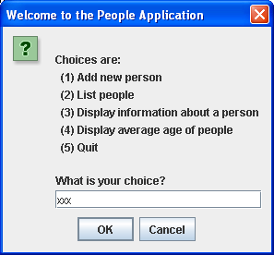

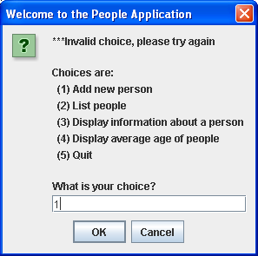

If the user chooses to add a new person, prompt for firstname, lastname, age, gender, and marital status.

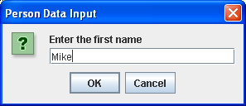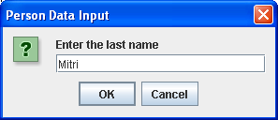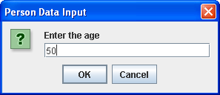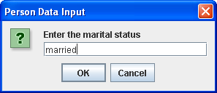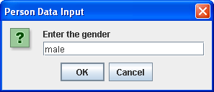

Then call the addPerson method, passing these values as parameters. addPerson will decide if there is enough space, and if so instantiate a new person and add it to the array, then return a true value…if not it will return a false value.

So, your main method should either display a confirmation or an error message:

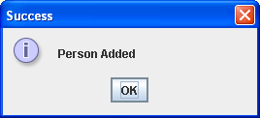 OR

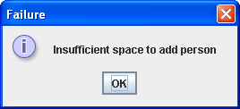

If the user chooses to list the people, your main method will call listPersons and display the resulting string:

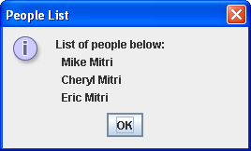

If the user chooses to find a specific person, your main method will prompt for the full name (first and last), and then call findPerson. If found,, the return value from findPerson is the index in the people array, so you will call getPerson passing that value and for the resulting Person object you will call personInfo and display the string that returns:

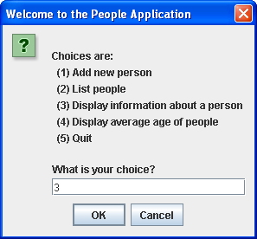

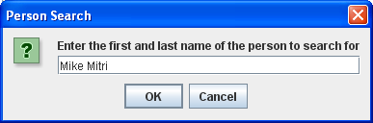

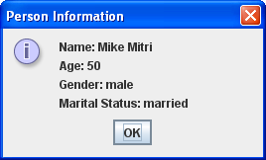

But if the person does not exist, and findPerson returns a -1, your main method should display an error message:



If the user chooses the average age, the main method should call averageAge and display a message that shows the resulting value:

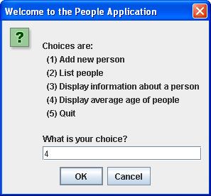

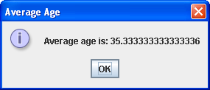

If the user chooses to quit, say goodbye and terminate the application:

