CIS 331 Programming Assignment #9
Creating a GUI Application for Person Processing
Due Thursday, 5/6/10 before midnight

In this assignment, you will create a Frame-base application that serves as a GUI interface to the Person class (Faculty and Student are not needed in this assignment). In this program you will gain practice in working with JFrame containers, JPanel containers, JTextField, JList, and JLabel components. You will learn how to control the layout of your containers using a variety of layout managers. You will respond to two types of events (list selections and action) by implementing listener interfaces. And you will use your previous knowledge of text file I/O to write to and read from a file of the people.

Modification to the Person Class

Change your toString method so that rather than just returning the string “Person”, it actually returns the first and last names of the person. This modification will enable the JList to display the first and last names. As discussed in the class notes, a JList component relies on the toString method of the objects in its data collection in order to decide what to actually display in the list.

You will also need to make two new static methods. readPeople should read data from a text file into the people array. writePeople should write the contents of the people array to the text file. A typical text file will look like this:

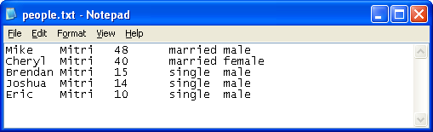

Your Application Class
Your application class should be based on a JFrame. To understand the behavior of this class, you should run mine. The components included in this class should be as follows:

- You need a JList component that will contain the names of all the people in the Person.people array. The Person.people array is the data source for this component.
- You need JLabels and JTextFields for first name, last name and age.
- You will need a JComboBox for representing the marital status options.
- You will need JRadioButtons for the gender options.
- You need buttons for adding a person, changing data for a person, clearing the display of the text fields, reading data from a file, and writing data to a file.
- These components must be arranged in the following fashion. The left side of the frame should include the list box. The labels and text fields should make up the right side of the frame. The buttons should be on the bottom. As the frame increases and decreases in size the part that dominates the resizing should be the portion containing the textfields and labels. The listbox should not really change width. The buttons at the bottom should always remain at the bottom and should resize as the frame gets wider or narrower. You should ensure that a label is always directly above the text field to which it is associated.

Below is a picture of what the screen might look like:

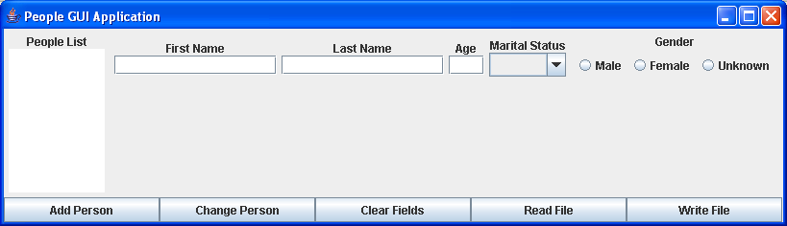

Now, watch what happens when the frame is resized:

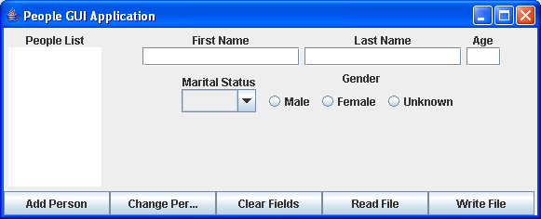

You see that the specific text fields and labels in the right portion of the frame have wrapped around. Note also that the label is ALWAYS directly above the associated text field component. Finally, note at the bottom that the buttons have maintained their positions, but they have shrunk in size. The closer you can make your solution match mine, the better.

The functionality of the program should be as follows:
The program must respond to any button click. When the add button is clicked, the program should add a person to the array of people. When the change button is clicked, the program should change the data for the currently selected person based on the values in the text fields. (NOTE: both of these should be accomplished by making use of appropriate methods of the Person class.) When the clear button is clicked, the text field values should be blanked out. When the Read button is clicked, the data from the file should be read and Person objects should be instantiated and the array should be filled. When the Write button is clicked the Person items in the array must be written to the data file. When the user selects an item from the list, its data should be displayed in the text fields.

The pictures below show some of these things happening:

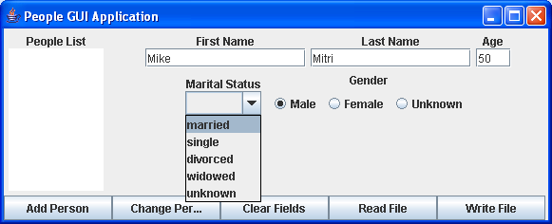
Entering data.

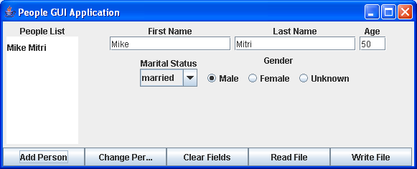
Clicked the Add button to add a person…result: the person is added to the people array and the list is refreshed accordingly.

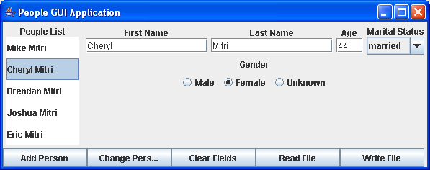
Selected a person from the list…result: the selected person is obtained from the array and values are placed in the appropriate components.

I have a class that is a subclass of JPanel you can use for ensuring that the label and component are always in proper alignment with each other. If you create instances of this class and then use these to place into the frame it will ease your programming task. Simply copy this code and made it part of your PeopleGUI application.

// class for a labeled component
class LabelComponent extends JPanel{
JLabel l;

public LabelComponent(String s, Component c){
setLayout(new BorderLayout());
l = new JLabel(s);
l.setHorizontalAlignment(SwingConstants.CENTER);
add(l,BorderLayout.NORTH);
add(c,BorderLayout.CENTER);
}
}

Deliverables:

You will post to Blackboard's digital dropbox a zip file with three files: your modified Person.java file, your PeopleGUI.java application, and a sample text file containing data.

