CIS 484
ASP .NET Coding Exercise

For this exercise, you will provide the user with information about the customer who made the largest single order payment (in terms of total money received) during a specified time period. When the user first brings up the form, it should look like this:
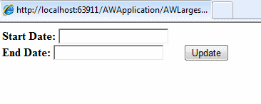
If the user enters a legitimate start and end date, the result should look something like this (notice the color of the company name):
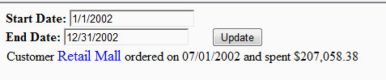

As a hint, the simplest thing is to use a single SqlDataSource with a query that includes a subquery.
You need to ensure that the user enters valid data. Specifically, both text fields need to be filled, and they need to be filled with legitimate date values. In addition, the end date must exceed the start date. You should make sure that an illegitimate field gets the focus. Also, if a field is empty, then set it to be yellow. For all errors, give appropriate error messages. Examples follow (on the next page).

