A MINSKY-KINDLEBERGER PERSPECTIVE ON THE FINANCIAL CRISIS
J. Barkley Rosser, Jr. (contact)
Professor of Economics, James Madison University
Tel: 540-568-3212, email: rosserjb@jmu.edu

Marina V. Rosser, Professor of Economics
James Madison University
Tel: 540-568-3094, email: rossermv@jmu.edu

Mauro Gallegati, Professor of Economics
Università Politecnica delle Marche, Ancona, Italy
Email: Mauro.gallegati@gmail.com

January, 2012
Abstract:
Hyman Minsky and Charles Kindleberger discussed three different patterns of speculative bubbles. One is when price rises in an accelerating way and then crashes very sharply after reaching its peak. Another is when price rises and is followed by a more a similar decline after reaching its peak. The third is when price rises to a peak, which is then followed by a period of gradual decline known as the period of financial distress, to be followed by a much sharper crash at some later time. All three patterns occurred during the financial crisis of 2008-09. Oil prices during 2008 showed the first pattern (peaking in July, 2008); housing prices over nearly a decade showed the second (peaking in 2006), and stock markets showed the third pattern (peaking in October, 2007). Policy directed at containing such bubbles should not use overly broad tools such as general monetary policy, but should be crafted to aim at specific bubbles. Whereas buffer stocks may be useful for commodity bubbles, limits on leverage or taxes on transactions may be more useful for financial markets.

JEL Codes: G01, G12, G18
Keywords: speculative bubbles, period of financial distress, financial crisis, leverage limits, Tobin taxes
Introduction: The Three Types of Bubbles
The three types of speculative bubbles are most clearly laid out in Charles Kindleberger’s Manias, Panics, and Crashes (1978, 2000), with the first explanation of the most widespread third type based on work of Hyman Minsky (1972, 1982), whose discussion more generally underpinned Kindleberger’s discussion of the nature and pattern of how speculative bubbles develop and end. Minsky laid out a general framework, and Kindleberger supplied numerous historical examples to fill out this general framework, with the subsequent editions of his book expanding this set of examples and providing yet more supporting details for the more general story.
The first is that most commonly found in theoretical literature on speculative bubbles and crashes (Blanchard and Watson, 1982; DeLong et al, 1990). In this pattern prices rise rapidly, usually at an accelerating rate in most of the theoretical literature, then to drop very sharply back to a presumed fundamental level after reaching the peak. The general argument is that speculative bubbles are self-fulfilling prophecies. Price rises because agents expect it to do so, with this ongoing expectation providing the increasing demand that keeps the price rising. If due to some exogenous shock the price stops rising, this breaks the expectation, and the speculative demand suddenly disappears, sending the price back to its fundamental (or thereabouts) very rapidly where there is no expectation of the price rising. In the case of the stochastically crashing rational bubble model of Blanchard and Watson, the price rises at an accelerating rate. This occurs because as it rises the probability of a crash rises, and the rational agents require an ever rising risk premium to cover for this rising probability of crash.
In the second type the price rises, reaches a peak that may last for awhile, and then declines again, sometimes at about the same rate as it went up. There is no crash as such, in contrast with other types of bubbles in which there is a period when the price declines much more rapidly than it ever rose, often characterized by panic among agents as described by both Minsky and Kindleberger. In this type of bubble, many agents may be quite unhappy as the price declines, but there is no general panic. Some might argue that such a pattern is not really a bubble in that how one truly identifies a bubble is precisely by the occurrence of a dramatic crash of price. However, in this case one observes a price that appears to be above the fundamental and then moves back down towards that fundamental.
The main problem then becomes whether or not one can define or observe such a fundamental, which is particularly difficult for assets that do not generate an income stream, such as many collectible items. Indeed, some have argued that all attempts to identify fundamentals face the problem of the misspecified fundamental, that what an econometrician or other observer may think is the fundamental is not what agents in the market think is the fundamental, which cannot be determined for sure.
The third type of bubble is that which exhibits a period of financial distress, a type first identified and labeled by Minsky (1972). In this the price rises to a peak that is followed initially by a gradual decline for awhile, but then there is a panic and crash. According to Kindleberger (1978, 2000, Appendix B), this is by far the most common type of bubble, with most of the larger and more famous historical ones conforming to its pattern, including among others the Mississippi bubble of 1719, the South Sea bubble of 1720, the US stock market bubble of 1928-29, and the same which crashed in 1987, even as this has been the least studied of bubble types. What is involved is heterogeneous behavior by agents, with some insiders getting out at the peak while others hang on during the period of financial distress until the panic and crash.
Rosser (1991, Chap. 5; 1997) initiated efforts to mathematically model such bubbles using models of fundamentalists and chartists, with Gallegati et al (2011) showing that one can generate such patterns using agent-based mean field models of a Brock and Hommes (1997) type in which heterogeneous agents change their trading strategies over time according to their performance. The behavior of such systems depends critically on how readily agents change their strategies and also the degree to which they tend to herd in imitation of each other. In this model, a crucial element for obtaining the period of financial distress element is assuming a wealth constraint, something argued by many as indeed triggering or aggravating crashes as with margin calls in stock markets, with these particularly prominent in the 1929 US stock market crash (Galbraith, 1954).

The Three Bubble Types in the Financial Crisis of 2008-2009
The great financial crisis of 2008-2009 that put the world deep into its Great Recession exhibited all three bubble types, with the heart of the crisis being precisely the collapse of various speculative bubbles. In considering these we can see some tendencies for certain sorts of markets to be more likely to follow one bubble type or another.
The leading example of the first bubble type would be the oil market. Given that oil does not generate a direct financial flow in a way that most financial assets do, it is essentially impossible to determine whether what happened was truly a speculative bubble or not. However, there is no doubt that after a long period of gradually rising price through most of the first decade of the 21st century, there was an acceleration of the price rise in early 2008 reaching a dramatic peak of $147.29 on July 11, only to be followed by a nearly uninterrupted sharp decline to a low of $30.28 for West Texas Intermediate (WTI) crude on December 23, 2008. This latter may well have been an overshoot as the price has since risen back to the general range of $100 per barrel, although not reaching the previous peak. Figure 1 shows the price of West Texas intermediate crude oil per barrel with monthly trading ranges for 2003-2011.

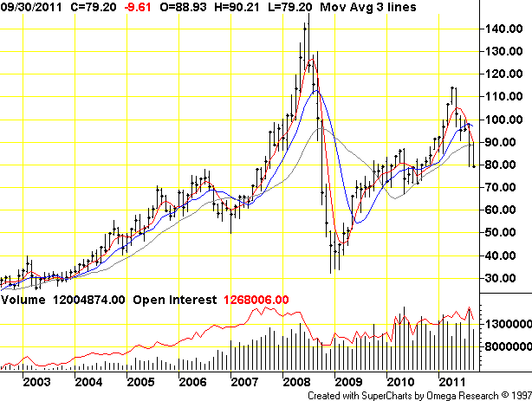
Figure 1: Light Crude Oil (Pit) Monthly Prices, West Texas Intermediate
The role that this particular price gyration played in the onset of the recession probably had more to do with the high prices of the summer of 2008 than the collapse of that price during the rest of the year, in contrast with some other bubbles. However, some of the other more prominent bubbles that have resembled this in the past have also been in commodities, such as the tulipmania of 1636-37 and the silver price bubble of the early 1980s.
The clear case for the second type of bubble was in real estate, particularly in housing. Here we have widely accepted measures of fundamentals in the form of rent and income, with the price-rent and price-income ratios viewed as indicators of whether or not there is a bubble in this market. Robert Shiller (2005, Chap. 2) presented the historical record on these measures, showing that by 2005 they had reached highs never previously observed in US history going back to the 1890s. Almost certainly this was a speculative bubble, and its rise and decline followed the second type of pattern, rising to 2006 and declining at about the same rate it went up to a bottom in 2009, with a mixed pattern since. Figure 2 shows the values for the US nationwide for the 10 and 20 city Case-Shiller indexes for 1987 through 2011.
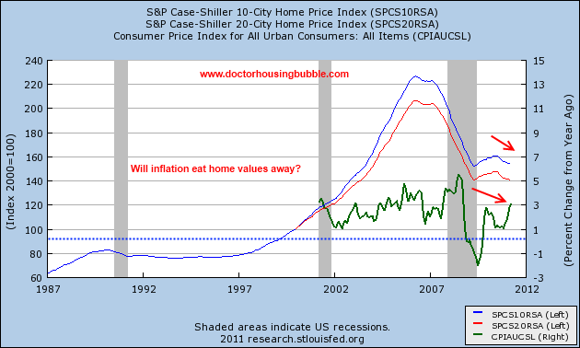
Figure 2: Housing Prices in US, Case-Shiller Index, 1987-2011
We can see this pattern showing up in other real estate bubbles as well, with that in Japan in the 1980s and 1990s an example. One reason why we may often fail to see a hard crash in real estate, particularly in single family homes, if not in other types, is that individuals become reluctant to sell when their homes fall in value. Volume tends to decline more dramatically than price as people hold on, thus slowing the rate of decline in price. This is less likely to hold for more commercial forms of real estate. Needless to say, it was the decline of prices in real estate that would trigger the later broader declines in various financial markets that would more directly drive the recession, although the decline in housing prices itself was the front edge of the recession as it led to a decline in housing construction, the first portion of the GDP to go into actual decline beginning in 2007.
The third and most frequent type of bubble showed up in many financial markets around the world. An obvious case is the US stock market as measured by the Dow-Jones industrial average (DJIA), whose pattern resembles that of most other stock indexes during this period. Thus, it peaked in October, 2007 after a fairly steady rise, albeit marked by day-to-day fluctuations, and then went into a decline of about the same rate, only to fall very sharply after the extreme crisis of September 18-19, 2008, to reach a bottom in March, 2009, from which it has only partially recovered since. Figure 3 shows the levels of the DJIA for 2000-2011,.
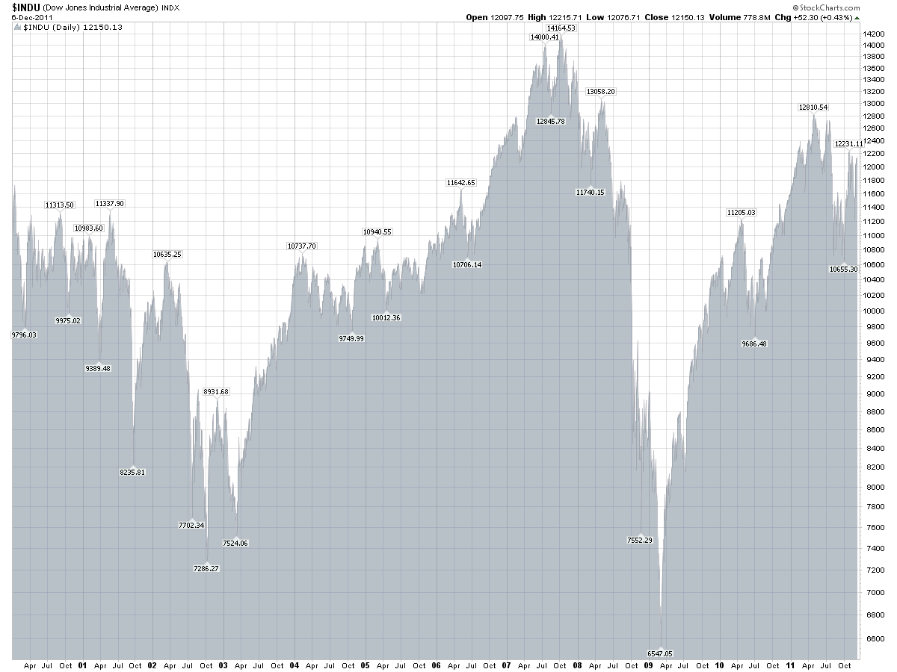
Figure 3: Dow-Jones Industrial Average, 200-2011, Daily Data
The precipitous decline of the US stock market after September, 2008 without doubt played into sharp declines in consumption and GDP in the US during this period. However, arguably a more crucial set of markets were those in financial derivatives, particularly those based on the housing market, whose sudden collapse after the failure of Lehmann Brothers in September, 2008 triggered the immediate crisis of that period that led to the subsequent crash in the stock market. These markets had been showing rising yields since July, 2007, three months prior to the stock market peak. It could be argued that the earlier stock market prices were not necessarily a bubble, and that indeed the pattern in the stock market simply reflected movements in the fundamentals driven by these changes in other markets such as housing and the financial derivatives market.
One does not see a rising price in such higher level derivatives markets as credit-default swaps (CDS) or collateralized debt obligations (CDO) as these were generally rated as AAA and thus had a floor on their yields prior to July, 2007. Thus we see the evidence of speculation or bubbles in the volumes in these markets. Thus the totals outstanding at yearend for CDSs in 2004 were $4.2 trillion, rising to $62.2 trillion for 2007, and falling to $38.6 trillion for 2008, with gradual declines since (ISDA). In the more complicated CDO market there was a pretty complete collapse with $520 billion issued in 2006, a number that fell to a mere $4.3 billion in 2009 (ibid).

Can Policy Restrain Such Bubbles and How?
While we think that it is worthwhile for governments to attempt to change the institutional and regulatory arrangements regarding markets in order to restrain or reduce many speculative bubbles we note two caveats to begin with regarding this. The first is that not all bubbles are necessarily bad things. They often accompany major expansions of real investment in significant new technologies or innovative products. Sustained positive animal spirits play in important role in these expansions and the rising asset values as well as financing supplied that are associated with bubbles in the assets associated with these investments can play an important role in getting them to achieve a substantial level. Thus, the dotcom bubble was associated with a major wave of building fiber optic and other infrastructure capabilities of value, and the collapse of the dotcom bubble only resulted in a relatively minor recession, in contrast with the events of 2008-2009.
The other caveat is to recognize how hard it is to implement any sort of serious discretionary anti-bubble policy due to the rising wealth that appears during the boom phase of a bubble. People are making money, and people who are making money will resist very strongly what they perceive to be arbitrary actions that might bring an end to their acquisition of new wealth. Such newly wealthy people are often able to bring strong political pressure to bear, thus making it difficult to implement any of the policies that we might suggest. This in itself suggests that the most effective are likely to be those policies that are automatic or built into the institutional framework of the economy rather than being discretionary.
Perhaps the most obvious is discretionary monetary policy to restrain bubbles through rising interest rates. To the extent that bubbles have appeared due to arguably overly stimulative monetary policy, such may be acceptable, but such an approach may be like using chemotherapy on a patient when a more localized or directed procedure would be less damaging and more effective. As is well known, such a policy can itself bring about a general recession. So, we favor more specific and directed policies rather than relying on monetary policy to restrain bubbles.
With respect to commodities, a way to go may be to use buffer stocks. This is in fact possible for the oil market in particular, with the US Strategic Petroleum Reserve (SPR) constituting exactly such a buffer stock. It is not clear that the interventions in the market using it have always been all that successful, and in the case of oil in particular with some of the producers such as Saudi Arabia able to increase or decrease production at will, an intervention by the US government using the SPR may well be easily offset by one of these producing countries. However, for other markets such as in agriculture or metals, such stocks may be more effective as they are more competitive markets not controlled by such large individual producers. However, we do not often see such speculative bubbles in agricultural commodities, with interventions by governments in them more often taking the form of buying up surpluses in order to prop up prices above competitive market levels. Buffer stocks in metals may be more possible, although in those markets again, the lack of income flows associated with them makes it hard to identify when there are bubbles, with the inability to identify such bubbles playing into the hands of those who think that there should be no such interventions in these markets.
In both real estate and financial markets, a clear culprit in stimulating speculative bubbles is the availability of credit and of high leverage. Limits on these in the form of requiring substantial down payments for house purchases or limits on leverage in various financial markets, including derivatives, look desirable and could presumably contribute to achieving the goal of fewer and smaller bubbles in these markets. Nevertheless, such policy efforts must face a hard reality emphasized by both Minsky and Kindleberger, the tendency once bubbles get going for lending standards to relax and leverage ratios to rise. As prices rise and both lenders and borrowers are making money, caution gets thrown to the wind and agents will seek ways to circumvent existing limits or regulations through the use of alternative vehicles that are unregulated. This has been a major reason for the rise of the shadow banking system where many of the problems that led to the crisis of 2008 developed. While regulation imposing leverage limits is desirable for this sector, they are being strongly resisted, although in some cases it can be argued that the market has worked as in the case of the collapse of CDO market.
Finally we note the proposals for a transaction tax, aka Tobin tax (or more popularly, “Robin Hood tax”), initially suggested by James Tobin (1978). These have been tried in various locations with mixed results, but are again being seriously considered, particularly in Europe. Careful studies such as by Pellizzari and Westerhoff (2009) suggest that indeed such taxes on financial transactions may reduce volatility and slow such bubbles. However, they also find that these are somewhat fragile results very much subject to institutional details and microstructures of the markets in question. Historical experience has not shown too much effect of them, with in some cases activity leaving the markets with such taxes to move to ones without them. This suggests that indeed if they are to be implemented, this should be done over as large an area as possible to minimize such escapist tactics, a point emphasized by Tobin himself originally. As it is, in the end the pressure for adopting such taxes may come more from a desire for increased revenues on the part of governments facing steep budget deficits and seeing these as a relatively politically painless way to obtain them, rather than as some great method for reducing financial market volatility, even if that may be a benefit as well to some extent.

Conclusions
The three types of speculative bubbles identified by Minsky and Kindleberger appear to have occurred during the runup to the financial crisis of September, 2008, which led to a global Great Recession. The first type given by a sudden collapse from a peak price was seen in the oil market in 2008, with the peak in July of that year. The second type given by a gradual decline in price after a peak was seen in the US housing market, with the peak probably in the second quarter of 2006. The third type given by a period of financial distress during which price declines gradually followed by a crash was seen in various financial markets, including both stock markets as well as more complicated markets for higher order derivatives such as credit-default swaps and collateralized debt obligations, peaking in October, 2007 for the stock market and earlier in July of that year for the derivatives markets.
While many obstacles exist for the effective implementation of anti-bubble policies, and some bubbles may serve useful purposes and should be left alone (and sometimes it is difficult to know when one is in a bubble or not), some policies may be available for restraining them. For commodities the use of buffer stocks is the most likely to have an impact. For financial markets, including real estate, stricter limits on leverage should at least reduce the size of such bubbles, if not completely eliminate them. Also, Tobin or transactions taxes may limit volatility in such markets somewhat.
However, we caution against using broad brush policy approaches that affect the entire macroeconomy to combat speculative bubbles in particular markets. The obvious such policy tool is monetary policy, and this should be used to manage the overall economy rather than to do so for bubbles in specific markets.

References
Ahmed, Ehsan, Roger Koppl, J. Barkley Rosser, Jr., Mark V. White. “Complex Bubble Persistence in Closed-End Country Funds.” Journal of Economic Behavior and Organization 32, 1 (1997): 19-37 (Ahmed et al, 1997).
Blanchard, Olivier J., Mark W. Watson. “Bubbles, Rational Expectations, and Financial Markets.” In Crises in the Economic and Financial Structure, edited by P. Wachtel, 295-315. Lexington: Lexington Books, 1982 (Blanchard and Watson, 1982).
Brock, William A., Cars H. Hommes. “A Rational Route to Randomness.” Econometrica 65, 5 (1997): 1059-1095 (Brock and Hommes, 1997).
Case-Shiller Index. http://www.calculatedriskblog.com/2011/12/case-shiller-house-prices-fall-to-new.html (Accessed 12/29/11).
Crude Oil Price History. http://futures.tradingcharts.com/chart/CO/M (Accessed 12/29/11).
DeLong, J. Bradford, Andrei Shleifer, Lawrence H. Summers, Robert J. Waldman. “Positive Feedback Investment Strategies and Destabilizing Rational Speculation.” Journal of Finance 45, 2 (1990): 379-395 (DeLong et al, 1990).
Dow-Jones Industrial Average History. http://stockcharts.com/freecharts/historical/djia2000.html (Accessed 12/29/11).
Ferraira, Fernando, Joseph Gyourko. “Neighborhood Housing Booms.” Mimeo, University of Pennsylvania, Presented at American Economic Association, Chicago, 2012 (Ferraira and Gyourko, 2012).
Galbraith, John Kenneth. The Great Crash. Boston: Houghton Mifflin, 1954 (Galbraith, 1954).
Gallegati, Mauro, Antonio Palestrini, J. Barkley Rosser, Jr. “The Period of Financial Distress in Speculative Markets: Interacting Heterogeneous Agents and Financial Constraints.” Macroeconomic Dynamics 15, 1 (2011): 60-79 (Gallegati et al, 2011).
ISDA. http://www.isda.org/statistics/recent.html#2005end (Accessed 12/29/11).
Jiang, Zhu-Qiang, Wei-Xing Zhou, Didier Sornette, Ryan Woodard, Ken Bastiaensen, Peter Cauwells. “Bubble Diagnosis and Prediction of the 2005-2007 and 2008-2009 Chinese Stock Market Bubbles.” Journal of Economic Behavior and Organization 74, 3 (2010): 149-162 (Jiang et al, 2010).
Kindleberger, Charles P. Manias, Panics, and Crashes: A History of Financial Crisis, 1st edition. New York: Basic Books, 1978 (Kindleberger, 1978).
Kindleberger, Charles P. Manias, Panics, and Crashes: A History of Financial Crisis, 4th edition. New York: John Wiley & Sons, 2000 (Kindleberger, 2000).
Minsky, Hyman P. “Financial Instability Revisited: The Economics of Disaster.” Reappraisal of the Federal Reserve Discount Mechanism 3 (1972): 97-136 (Minsky, 1972).
Minsky, Hyman P. “The Financial Instability Hypothesis: Capitalistic Processes and the Behavior of the Economy.” In Financial Crises: Theory, History, and Policy, edited by Charles P. Kindleberger, Jean-Paul Laffargue, 12-29. Cambridge: Cambridge University Press, 1982 (Minsky, 1982).
Pellizzari, Paolo, Frank Westerhoff. “Some Effects of Transaction Taxes under Different Microstructures.” Journal of Economic Behavior and Organization 72, 3 (2009): 850-863 (Pellizzari and Westerhoff, 2009).
Rosser, J. Barkley, Jr. From Catastrophe to Chaos: A General Theory of Economic Discontinuities. Boston: Kluwer, 1991 (Rosser, 1991).
Rosser, J. Barkley, Jr. “Speculations on Nonlinear Speculative Bubbles.” Nonlinear Dynamics, Psychology, and Life Sciences 1, 4 (1997): 275-300 (Rosser, 1997).
Shiller, Robert J. Irrational Exuberance, 2nd edition. Princeton: Princeton University Press, 2005 (Shiller, 2005).
Tobin, James. “A Proposal for International Monetary Reform.” Eastern Economic Journal 4, 3-4 (1978): 153-159 (Tobin, 1978).

Jiang et al (2010) combine such an approach with a pattern of accelerating oscillations in their log-periodic power law model that has managed to forecast quite closely the peaks of some Chinese stock market bubbles.
More generally there is much disagreement regarding the definition of what a bubble is. While the most common definition is of a price remaining above a fundamental value for some extended period, at least one difficulty is that some may argue that there is not even a fundamental at all, with some Post Keynesians and econophysicists making this point. There are also arguments over whether prices that do not change much can be considered to be stationary bubbles or not bubbles at all.
One case where a fundamental may well be pretty well defined is that of closed-end funds, which consists of a set of assets that have a net asset value that may differ from the value of the fund. Generally, the net asset value will be the fundamental, adjusted for tax or transactions costs, so they can be identified as possessing clear premia or discounts (Ahmed et al, 1997).
Source is Crude Oil Price History.
It could be argued that this bubble also conforms to the third type as there was a gradual decline in 2006 before the more rapid one beginning in 2007. However, that later rate of decline was only slightly more rapid than the rise, and there were regional variations with areas outside of the large cities not peaking until early 2007. Ferreria and Gyourko (2012) document that specific housing bubbles around the US peaked over an 18 month period and individually did not show any sort of period of financial distress pattern, declining after their respective peaks at approximately the same rate they rose before it, even as these rates varied considerably across neighborhoods across the US.
Source is Case-Shiller Index.
Source is Dow-Jones Industrial Average.
Indeed, the most extreme example of this is arguably the Great Depression, with the contractionary monetary policy carried out by the US Federal Reserve during 1929-30 largely being motivated precisely by a desire to end the perceived speculative bubbles occurring in the stock market.

