COMPLEX DYNAMICS AND POST KEYNESIAN ECONOMICS

- Barkley Rosser, Jr.
Program in Economics
James Madison University
Harrisonburg, VA 22807 USA
Email: rosserjb@jmu.edu

[forthcoming in Complexity, Endogenous Money and Macroeconomics: Essays in Honour of Basil J. Moore, edited by Mark Setterfield, London: Routledge, 2005]

February, 2005

Acknowledgement: The author wishes to thank Geoff Harcourt and Mark Setterfield for useful and thoughtful remarks. The usual caveat holds.

Introduction
The nature of the relationship between complex dynamics and Post Keynesian economics (PKE) has been a controversial matter for some time. Some argue that it is a distraction that leads innocent Post Keynesians into “classical sin.” Davidson (1994, 1996) argues that core Post Keynesian (PK) ideas such as that insufficient aggregate demand arise from fundamental uncertainty in a monetary economy do not depend on nonlinearity or complexity, that these core concepts are axiomatically and ontologically true, and that the inability of agents to forecast well in dynamically complex situations reflects mere epistemological problems of insufficient computational abilities. Thus complex dynamics is merely a classical stalking horse.
This writer (Rosser, 1990, 1998, 2001) disagrees with the argument presented above and its relatives (Mirowski, 1990; Carrier, 1993). Dynamic complexity provides a foundation for fundamental uncertainty in Keynesian and PK models, and this applies to most of the various sub-branches of PKE besides Davidson’s “fundamentalist” or “Keynes-Post Keynesian” approach.
The argument will be considered regarding three subdivisions of Post Keynesianism as identified by Hamouda and Harcourt (1988): the aforementioned fundamentalist Keynesianism, Sraffian (or neo-Ricardian), and Kaleckian (or Kaleckian-Robinsonian). Following King (2002, chap. 10), I admit to being more in sympathy with those he describes as “synthesizers” than with the more partisan sectarians of these approaches. I shall describe how each sub-branch has been analyzed using ideas of complex dynamics, and I suggest that this common element should be kept in mind by those who do hold to any of the more sharply held positions in this debate. I shall also discuss PK approaches that are not so easily labeled, notably the hysteresis and evolutionary approaches. I shall discuss the question of equilibrium versus disequilibrium and methodological issues relating to open versus closed systems.
Of the schools of PKE, Basil J. Moore has been identified with the fundamentalist Keynesian school, based on his role as perhaps the most influential developer and advocate of the idea of endogenous money (Moore, 1988). Along with the idea of fundamental uncertainty, the fundamentalist Keynesian school is also often viewed as stressing the role of money in the economy more than the Sraffian or Kaleckian schools. However, Moore has increasingly stressed the role of complexity in various forms as intrinsically linked with the process of endogenous money formation and the uncertainties of economic dynamics, openly disagreeing with Davidson on this issue on the PKT internet list and elsewhere. He argues that all this implies the need for non-equilibrium and open-system approaches in his forthcoming book, Shaking the Invisible Hand: Complexity, Endogenous Money and Exogenous Interest Rates.

Defining Complex Dynamics
Elsewhere (Rosser, 1999a) I have discussed defining complex dynamics for applications in economics. Richard Day (1994) argues that a system is dynamically complex if due to endogenous reasons it fails to converge to a point, a limit cycle, or a smooth explosion or implosion. Such systems can generate endogenous discontinuities in system variables. Nonlinearity somewhere in the system is a necessary but not sufficient condition for such endogenous dynamics in an economy, with simple exponential growth models showing how nonlinear dynamics may not be complex as defined above.
For Post Keynesians the endogenous nature of fluctuations is important, as the new classical school explains macroeconomic fluctuations as due to exogenous stochastic shocks describable by a probability function implicitly known by agents with rational expectations. Such fluctuations may be both equilibrium and Pareto optimal, thus abrogating any argument for sustained policy intervention. The reality of complex dynamics undermines this view on two grounds, first that the presence of complex endogenous dynamics means that the economy is not necessarily self-stabilizing or optimal, and second that such dynamics undermine the assumption of rational expectations. Chaotic dynamics imply sensitive dependence on initial conditions (Rosser, 1996), or “butterfly effect,” the idea that a butterfly flapping its wings in Brazil could set off hurricanes in the United States (Lorenz, 1993). Recognition of this led one prominent new classical economist to modify his views (Sargent, 1993).
While the physicist Seth Lloyd has accumulated about 45 different definitions of “complex system” from many different disciplines (Horgan, 1997, p. 303, footnote 11), most of these have not been used in economics. Some emphasize difficulty for computability or length of algorithms, used occasionally in economics (Albin, 1982; Albin with Foley, 1998; Leijonhufvud, 1993; Stodder, 1997). Another definition with some resonance with standard Sraffian models is “structural” and focuses on the “complicatedness” of patterns of intersectoral connections and institutional relations in the economy (Pryor, 1995; Stodder, 1995). Some argue that complexity implies a new philosophical perspective on how humanity relates to nature and the world, indeed on how each individual does so, replacing formal deduction with inductive or abductive methods as analysts seek to understand an ever-changing and evolving complex reality.
In Rosser (1999a) I identified the first definition above as “broad tent complexity,” seen as consisting of four sub-types, the “four C’s,” cybernetics, catastrophe theory, chaos theory, and “narrow tent complexity.” The first was developed by Norbert Wiener (1961) and has had relatively limited application in economics, with Forrester (1977) being an important example. Catastrophe theory was developed by René Thom (1972), with Christopher Zeeman’s (1974) model of stock market crashes and Hal Varian’s (1979) model of endogenous business cycles based on an arguably Post Keynesian model of Kaldor (1940) providing economic applications. Chaos theory had numerous developers in mathematics and physics, with Robert May 1976) first suggesting applications in economics, and David Rand (1978) the first to take him up on it. “Small tent complexity” emphasizes models of heterogeneous interacting agents, often using computer simulations, with Thomas Schelling’s (1971) model of urban racial segregation and Hans Föllmer’s (1974) statistical mechanics model being early examples. Horgan argues that these were all fads that have risen and deservedly fallen, but I argue that they represent a cumulative intellectual development that is now reaching fruition and that allows PK ideas to broadly enter mainstream economics, which is undergoing profound changes that are leading it into uncharted areas (Colander, Holt, and Rosser, 2004).

Complex Dynamics and the Schools of Post Keynesian Economics

Fundamentalist Keynesianism or Keynes-Post Keynesianism
The central argument of this sub-branch of PK thought emphasizes the foundational role of fundamental uncertainty based on Keynes’s own ideas, hence the adjective “fundamentalist”. This was a profoundly important idea for Keynes, while it was less so for Sraffa and Kalecki. It first appears in Keynes’s (1921) Treatise on Probability and is brought to center stage in Chapter 12 of his 1936 General Theory, where it is seen as the foundation for animal spirits driving macroeconomic fluctuations.
When the neo-Keynesian-classical synthesis was dominant, the crucial PK figure to emphasize uncertainty in Keynesian analysis was G.L.S. Shackle (1955). Among those influenced by Shackle were Brian Loasby (1976), John Hicks (1979) and especially Paul Davidson (1978, 1982-83), who would emphasize that uncertainty explains how holding money can bring about involuntary unemployment and also how it undermines rational expectations. That uncertainty underlies the demand for money has been further developed by Moore (1988) and by Runde (1994). Davidson (1996) does not believe that complexity theory enhances these arguments.
Complex dynamics enter into the analysis of Keynesian uncertainty in at least two ways. Complex dynamics provide an independent source of such fundamental uncertainty and uncertainty, as discussed by Keynes in Chapter 12 of the General Theory, can lead to speculative bubbles in asset markets. These can lead to financial fragility (Minsky, 1972) and follow a variety of complex dynamics (Day and Huang, 1990; Keen, 1995, 1997; Rosser, 2000a, Chaps. 4-5).
If a system exhibits chaotic dynamics it is subject to sensitive dependence on initial conditions, arguably the most important defining characteristic of chaotic dynamics. If a small change in an initial condition or a parameter value can lead quite rapidly to substantially different behavior in a system, this disrupts the learning mechanisms that underpin rational expectations (Rosser, 1996). Figure 1 shows the original example of sensitive dependence discovered by Edward Lorenz (1963) for a three equation model of climate. The bifurcation point occurred after simulating the system and restarting a second simulation partway through to get coffee. The different path arose from roundoff error at the sixth decimal place.
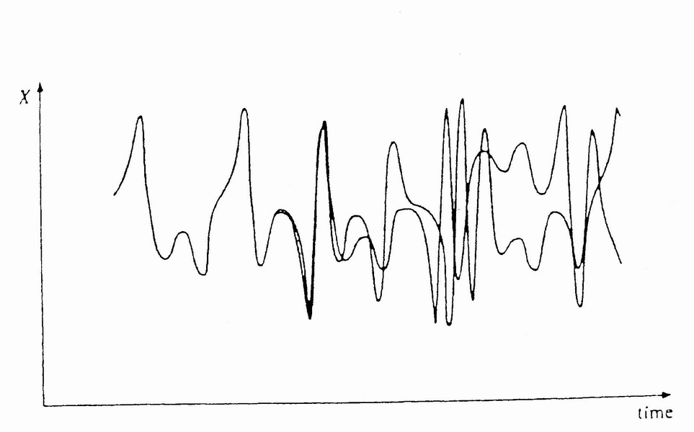
Figure 1: Butterfly Effect
Another source of possible of deep uncertainty in economic systems due to complex dynamics is the possibility of fractal basin boundaries, first found for economics by Hans-Walter Lorenz (1992) in the arguably PK model of Kaldor (1940). With fractal basin boundaries there are multiple equilibria, and the basins of attraction for each of the equilibria are entwined with each other so that their boundaries may become arbitrarily close to each other. There may not be chaotic dynamics, but the system can jump discontinuously from one basin of attraction to another from nearly infinitesimal changes, thus rendering the possibility of forming rational expectations impossible. Figure 2, from Peitgen, Jürgens, and Saupe (1992), shows the basins and their boundaries for a system in which a metal ball on a string is suspended over three magnets.
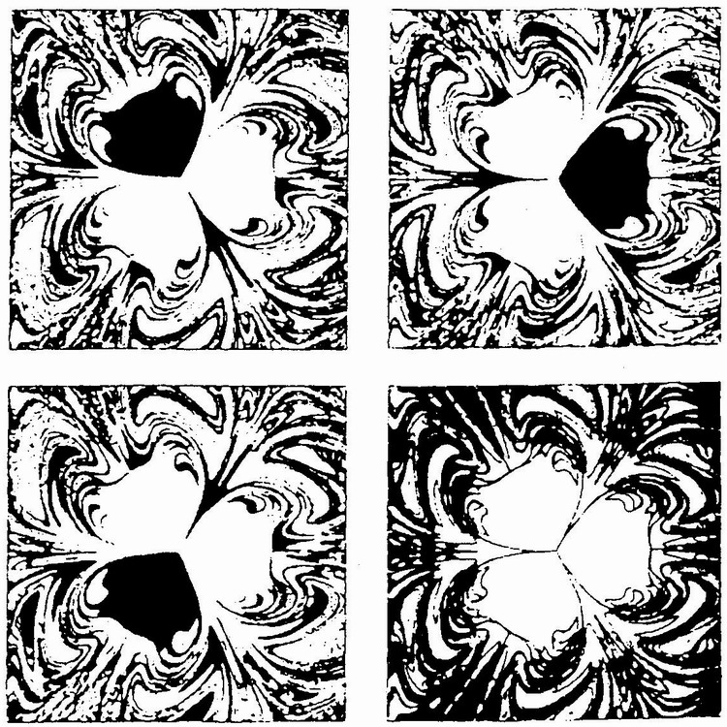
Figure 2: Basins of Attraction with Frontal Boundaries, Three Magnets
How uncertainty can lead to speculative dynamics that imply complex dynamics and financial fragility is that a source of uncertainty is our inability to know what other people are thinking (Carabelli, 1988; Davis, 1993; Arestis, 1996; Koppl and Rosser, 2002). This can lead to group dynamics as analyzed by Keynes for the beauty contest, where each party tries to guess the average state of expectation of the other parties. When different people have different views about each other’s expectations the results can be dynamically complex, even when some of the parties may actually possess rational expectations. This is the problem of heterogeneous expectations identified with the “narrow tent complexity” view.
A basic example is the first model using catastrophe theory in economics (Zeeman, 1974) of stock market dynamics in a world of “fundamentalist investors” (with something like rational expectations) and “chartist” investors who chase trends. The balance between these two groups varies as outcomes in the market vary. As long as the fundamentalists dominate the market there is a unique equilibrium and the market is stable. However, when the chartists dominate there may be multiple equilibria, unstable speculative bubbles, and eventual market crashes. Figure 3 presents a cusp catastrophe model developed by Zeeman where the vertical axis is the rate of change of prices in the market, the F axis represents the demand by fundamentalists, and the C axis represents the demand by chartists. When a crash happens the proportion of investors shifts back towards dominance by the fundamentalists until a new outbreak of speculation appears. Such dynamics very much reflect arguments made by Keynes and by Hyman Minsky.
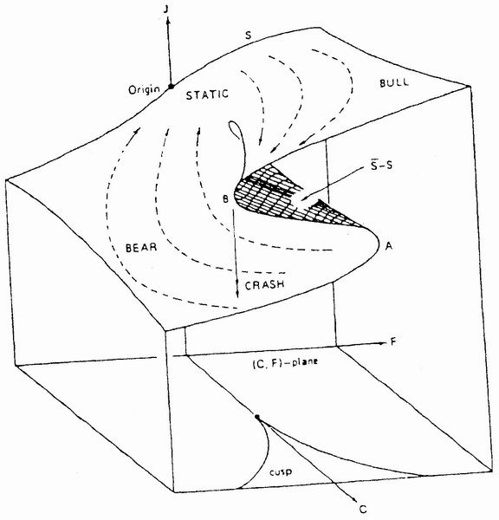
Figure 3: Zeeman Stock Market Crash Model
A similar model can also generate chaotic dynamics, or “chaotic bubbles” (Day and Weihong Huang, 1990). They add a third set of agents, market makers to the basic Zeeman model of fundamentalists and chartists (“sheep” in Day and Huang). Figure 4 shows the time pattern for such a model when the destabilizing “sheep” are dominant, with their actions generating chaotic dynamics. The market oscillates between chaotically rising bull markets and chaotically declining bear markets.
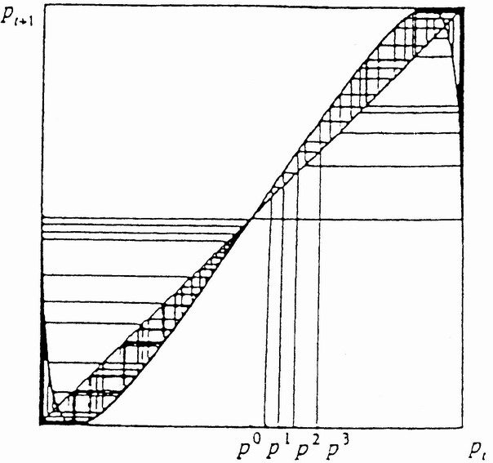
Figure 4: Chaotically Switching Bull and Bear Bubbles
Brock and Hommes (1997, 1998) show a larger range of complex dynamics arising from models in which agents switch back and forth between costly strategies that are more stabilizing and less expensive strategies that may be destabilizing. A model with many different agents following an evolving set of competing strategies has been studied by Arthur, Holland, LeBaron, Palmer, and Tayler (1997), its essential dynamics resembling those already described. If a majority of the agents pursue stabilizing strategies the market is stable, but as a majority moves towards strategies that resemble trend chasing the market destabilizes and behaves in a complex and erratic manner.
Even without financial speculation, there is a large literature showing how money itself can lead to chaotic dynamics within more or less Keynesian models. Many of these models are less fundamentalist Keynesian in nature than Kaleckian (Foley, 1987; Delli Gatti, Gallegatti, and Gardini, 1993; Semmler and Sieveking, 1993; Chiarella and Flaschel, 2000), or Minskian (Keen, 1995, 1997).

Sraffianism or neo-Ricardianism
As discussed by Geoff Harcourt (1972), the Sraffian or neo-Ricardian sub-branch emerged out of the Cambridge controversies in the theory of capital, initially over the implications of the possibility of the reswitching of techniques and the associated possibility of capital reversal. Although associates of Keynes had vetted problems with aggregating capital for some time (Robinson, 1954), the key publication was Piero Sraffa’s (1960) Production of Commodities by Means of Commodities after a 35 years gestation period, which really crystallized the debate. This book was the foundational document for the broader Sraffian approach (Kurz and Salvadori, 1995). For many younger economists in the 1960s this capital controversy provided a critique of standard neoclassical theory, and many observers, including Harcourt, have seen it as a crucial stage in the evolution of PK thought. Thus it is frustrating for many that this theoretical victory by the Sraffians had so little impact on mainstream economics and that there emerged the deep divide between the fundamentalist Keynesians and the Sraffians.
A major source of this divide has been the Sraffians emphasizing comparisons between long-run steady states, while Keynes dismissed long run equilibrium (“In the long run we are all dead.”). The first warning shot of this divide came with Joan Robinson’s (1974) attack on the concept of equilibrium more broadly when she contrasted it with history, or the contrast between “logical” and “historical” time. Such models also tend to ignore uncertainty and the role of money. Indeed, they often abstract from any dynamic analysis at all, with some exceptions, notably Luigi Pasinetti (1993).
Nevertheless, one can find seeds of complex dynamics hiding within Sraffian models, especially those relating to the capital controversies. The possibility that discontinuity lies hidden beneath apparent continuity was a deep implication coming from some of the models, with Pasinetti (1969) probably the first to recognize this, arguing that “continuity in the variation of techniques as the rate of profit changes, does not imply continuity in the variation of the values of capital goods per man and of net outputs per man,” a point also emphasized by Donald Harris (1973).
Some economists (Yeager, 1976) argued that the existence of continuous substitutability in production functions was sufficient to eliminate the Sraffian paradoxes of capital theory such as reswitching. However, Rosser (1978) provides an example of such continuous substitution that nevertheless exhibits reswitching. Figure 5 shows such an “eccentric reswitching” example, the axes showing wage and profit rates, and the outer envelope of the wage-profit curves for each technique is the wage-profit frontier.
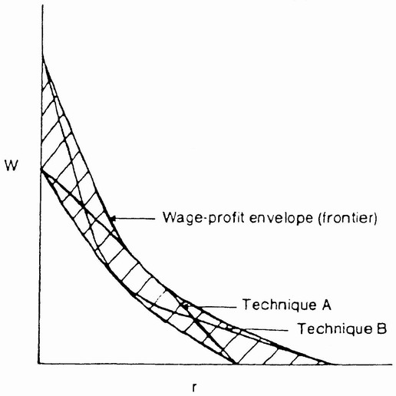
Figure 5: Eccentric Reswitching Case
Somewhat less Sraffian, allowing for an optimal adjustment process in this model, Rosser (1983) considers movement from one equilibrium state to another when the rate of population growth varies continuously. A discontinuity in the profit rate can emerge at a particular point, when the system jumps from one half of the wage-profit frontier to the other. Rosser (1983; 2000a, chap. 8) shows that this can be analyzed with a cusp catastrophe framework. Day and Walter (1989) show the possibility for “historical reswitching” in dynamic models of technological change over very long time horizons with chaotic dynamics. Thus, Sraffian models contain the possibility of complex dynamics, although in order to observe such possibilities one must move beyond the Sraffian framework of only considering comparisons between long run steady states.

Kaleckianism
Michał Kalecki has been regarded (Robinson, 1966; Feiwel, 1975; Sawyer, 1985; King, 1996) as providing a more solid foundation for a unified PKE analysis than Keynes or Sraffa. Although lacking as sophisticated an analysis of financial markets and such philosophical conundra as fundamental uncertainty as Keynes, he has a microfoundation based on the degree of monopoly and a mathematical model of fluctuations (1935, 1937, 1939), later combined with growth (1971), and more clearly recognizes the roots of this analysis in Marx’s study of the surplus value realization problem. Unlike the Sraffians he abjures long-run equilibria and argues that economic dynamics consist of a series of short-run equilibria simply strung together, emerging out of each other. Any possible long-run equilibrium is rendered irrelevant by the traverse, that the movement toward an equilibrium also moves it. In the more recent controversies among Post Keynesians, the Kaleckians have seemed the centrist synthesizers between the more sharply conflicting fundamentalist Keynesians and Sraffians.
Kalecki focus upon microfoundations is of less interest to us here because it did not lead to any models involving complex dynamics. However, his analysis of macroeconomic fluctuations played a profoundly innovative and seminal role and laid the groundwork for a large literature in complex dynamics, even as he did not study such models himself.
Although somewhat incomplete and flawed (and only a partial translation of an earlier model formulated in Polish), the crucial breakthrough in English was Kalecki’s 1935 paper in Econometrica, “A Macrodynamic Theory of Business Cycles,” which would be refined and improved in later versions in 1937 and 1939. At the core of this theory is his investment model, a nonlinear function of profits, which in turn are related to aggregate output. Shifts of this function with the capital stock can generate cyclical fluctuations. Another model that relies on a nonlinear investment function directly related to the level of output that shifts in a similar manner to Kalecki’s was developed by Nicholas Kaldor (1940), and it is from this variation, particularly a version due to Chang and Smyth (1971), that a large modern literature showing the possibility of multiple varieties of complex dynamics arose. Figure 6 shows the nonlinear investment function from Kaldor’s model, which has a more Keynesian equilibrium associated with an equality of savings and investment. As the investment function shifts up and down business cycles with discontinuities can emerge, a result shown within a catastrophe theory context by Varian (1979).
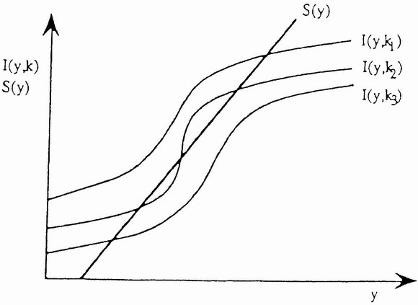
Figure 6: Shifting Nonlinear Investment Function
What is involved in such models is a mechanism somewhat similar to the investment accelerator, known to generate cyclical fluctuations since Aftalion (1913). Harrod (1936) combined it with Kahn’s multiplier (1931) to provide a model that generated fluctuations. Paul Samuelson (1939) suggested that the consumption function of the multiplier-accelerator model might be nonlinear, but then Hicks (1950) and Richard Goodwin (1951) proposed nonlinear accelerators to give nonlinear investment functions within such models. Strotz, McAnulty, and Naines (1953) first discovered chaotic dynamics while studying Goodwin’s model, without realizing what they had discovered. Among those studying chaotic and other complex dynamics arising from Hicks’s formulation have included Blatt (1983), Hommes (1991), and Puu (2000).
The alternative strand derived from Kalecki and Kaldor has generated an even more subtle variety of complex dynamics models. After the Varian model, others found chaotic dynamics arising from this model as well, notably Dana and Malgrange (1984), Hermann (1985), and Lorenz (1987a). A later study by Lorenz (1992) would be the first to observe fractal basin boundaries in an economic model. It was also the first paper in economics to demonstrate the possibility of non-chaotic strange attractors and of transient chaotic dynamics.
The original Kalecki model of the 1930s had a greater emphasis class struggle entering the profit equation that ultimately drove investment. Although not taken from Kalecki, Goodwin’s (1967) predator-prey model of class struggle in a cyclical growth model has a Marxist element. Variations of this model were shown to be able to generate chaotic dynamics by Pohjola (1981), Lorenz (1987b), Skott (1989), Goodwin (1990), Jarsulic (1994), and Chiarella and Flaschel (2000). Soliman (1997) showed that it could also generate models with fractal basin boundaries. Thus, even if few of these studies were directly of Kalecki’s own models, his basic ideas have played a very important role in the general evolution of models of complex macroeconomic dynamics.

Hysteresis and Evolutionary Models
Derived from the Greek hysterein, meaning “to be behind,” hysteresis is one of many economic concepts derived from physics (Ewing, 1881), its original use referring to how a magnetized ferric metal does not return to its unmagnetized state after the magnetic force is removed from it. In economics it has come to mean that the impact of an exogenous shock persists in the system in some way, even after the shock ceases. There are many interpretations, definitions and applications of this (Mitchell, 1993), but we are interested in those that assume a nonlinear source, implying multiple equilibria, with the possibility of catastrophic dynamics. Arguing that the physics concept is relevant to Post Keynesian analysis, especially of the persistence of unemployment after negative demand shocks, has been Rod Cross (1987, 1993), although Davidson (1993) has criticized this approach as being another classical model pretending to be Keynesian.
Others advocating the hysteresis approach in PK models (Setterfield, 1993, 1997; Katzner, 1993, 1999) invoke Joan Robinson’s (1962, 1974) distinction between logical and historical time, arguing that the path of history puts one into the zone of one kind of equilibrium or another. Setterfield also invokes the cumulative causation arguments of Kaldor (1972) and the path dependence arguments of Paul David (1985) and Brian Arthur (1994), with these implying possibilities of technological lock-ins, potentially of an unfavorable nature. Setterfield (1997) uses such arguments to explain the relative economic decline of Great Britain after 1900. French Regulation School adherent Frédéric Lordon (1997) combines such arguments to analyze larger regimes of technological change and growth, arguably more a Schumpeterian evolutionary view.
Puu (1989) presents a business cycle model that combines catastrophic hysteresis effects with chaotic dynamics (or chaotic hysteresis), a variation of the Hicks-Goodwin nonlinear accelerator model in which the investment function is cubic and thus exhibits non-monotonicity. For particular parameter values the model follows dynamics exhibited in Figure 7, where the horizontal axis is national income and the vertical axis is the rate of change of national income. Puu (2000) has since shown that this model can also generate fractal basin boundaries.

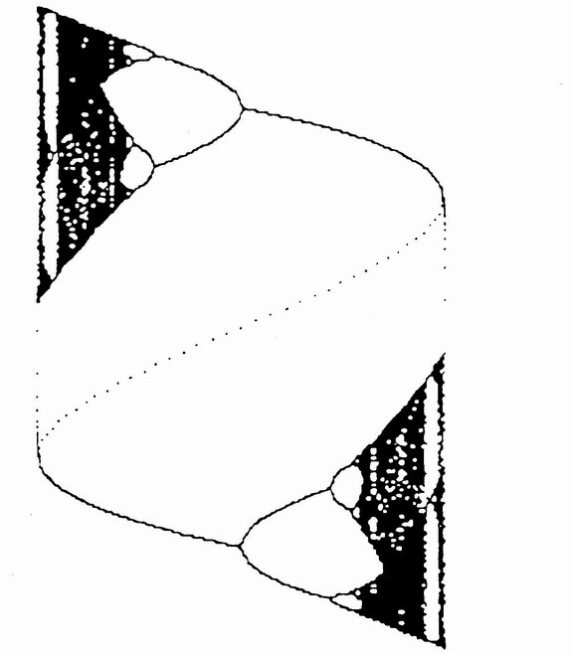
Figure 7: Chaotic Hysteresis in Puu Nonlinear Accelerator Model
A more recent addition to PK approaches is evolution, with Cornwall and Cornwall (2001) affirming it, although it is arguably distant from more traditional Keynesian and Post Keynesian approaches. One factor in this development is the opening to the institutionalists, perhaps due to the apparent melting away of the Sraffians. Traditionally the old institutionalists have emphasized evolution, as symbolized by the Assocation for Evolutionary Economics, reflecting the influence of Thorstein Veblen (1898), with Geoffrey Hodgson (1993) important recently. The emphasis on hysteresis and path dependence, especially as derived from the Robinsonian emphasis on historical rather than logical time furthers this also, fitting with the complex dynamics view of Basil Moore (forthcoming) that disavows an equilibrium perspective and posits emergent order that does not go in any particular direction, but simply evolves.
Finally, Schumpeterian models of technological change have been merged with models of cyclical fluctuations combining various nonlinear business cycle models discussed above, with such a view broadly consistent with a Kaleckian perspective. Those considering chaotic dynamics in connection with such models include Goodwin (1986), Henkin and Polterovich (1991), Mosekilde, Larsen, Sterman, and Thomsen (1993), Silverberg and Lehnert (1996), and Rosser and Rosser (1997). Day and Walter (1989) combine Schumpeterian technological change with Malthusian population dynamics in a model that can exhibit chaotic dynamics in shorter periods and “historical reswitching” between technologies in longer periods, as shown in Figure 8 with the horizontal axis being time and the vertical being output. This model was inspired by an effort to understand the nature of the collapse of the Mayan civilization.
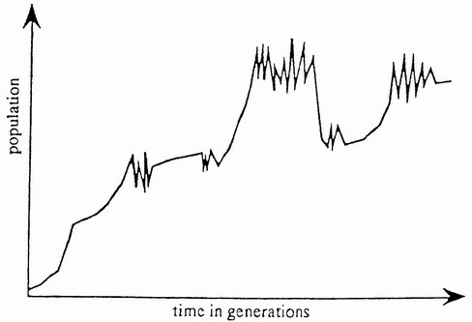
Figure 8: Long-Run Day-Walter Dynamics
with Chaos and Historical Reswitching

Some Methodological Considerations: Where Do We Go From Here?
Let us consider two linked questions posed by Moore’s views on the implications of complex dynamics for PKE, one his view that complex dynamics obviate any usefulness of the equilibrium concept, the other that complex dynamics imply that economic systems are ultimately open and evolutionary. These are reasonable and consistent conclusions, even if not the only ones possible.
Regarding equilibrium, an important point is Joan Robinson’s argument regarding historical versus logical time, the view being that equilibrium is a construct of the latter and thus ultimately irrelevant in the real world of the former, a view shared with the more radical Austrians and also profoundly derived from arguments Shackle (1974). Such a view is also favored by some Kaleckians, especially those who argue that the problem of the traverse implies that equilibrium is meaningless, even though Kalecki’s models always had at least temporary equilibria in them. Those pursuing such perspectives tend to criticize the Sraffians and their emphasis upon the role of long-run steady states as “centers of gravitation.”
While financial markets exhibit rather trivial temporary equilibria and equilibria can be easily obtained in some auctions, many markets are rarely, if ever, in equilibrium. The issue becomes whether it is more useful to consider their dynamics as reflecting out-of-equilibrium adjustments determined by their position (and motion) relative to the (possibly moving) equilibrium state, or to view the motion of the equilibria as so great or rapid or chaotic or endogenous as to render the concept useless. Furthermore, there are the problems of possible multiple equilibria or non-existence of equilibrium at all.
I think we shall never know for sure. That we rarely observe equilibrium does not mean that equilibrium does not exist. The older theorists of equilibrium, including Walras (1900, p. 370) and Marshall (1920, p. 346), were acutely aware of this tension. Both made statements about how in the real world the equilibria are constantly being jerked around, even endogenously, and both knew of the possibility of multiple equilibria. Furthermore, the tension shows up in the work of Karl Marx as well. Marx (1967 [1894], pp. 188-89) argued that supply never equals demand except briefly by accident, even though they equate on average over time, essentially the vision of the Sraffians with their centers of gravitation. Marx of the second volume of Capital was an equilibrium theorist, in contrast with Marx of the first and third volumes.
The discussion above has referenced “basins of attraction,” zones of variable values in which a system’s motion will tend in a certain direction or other. With unique and stable point equilibria, the standard view sees such motion heading straightforwardly towards the equilibrium point. However, in complex dynamics the nature of even a still attractor towards which a system tends may be very complex itself, for example, “strange,” possessing a fractal shape, implying a complex dynamic, even chaotic, in equilibrium. Furthermore, the convergence to the attractor may also be complex. Thus the concept of equilibrium itself may be quite messy.
Finally, in Moore’s view open complex systems are associated with the non-existence of any equilibrium and the tendency for economies to evolve in a self-organizing manner with no particular direction. The idea of open systems came from dialectics (Bogdanov, 1912-22), general systems theory (von Bertalanffy, 1962), and more recent critical realist arguments (Lawson, 1997; Dow, 1999). This view will probably be increasingly influential among Post Keynesian economists.
A point of potential contradiction involves the question of exogenous versus endogenous models. One of the strongest links between complex dynamics and PK views has been the idea of endogenous macroeconomic fluctuations. Moore would argue that this represents non-ergodic self-organization, contrasted with the ergodic fluctuations due to exogenous shocks of the new classical model. The odd contradiction is that latter model is arguably more “open” than the former, driven by forces outside itself, which may in turn behave non-ergodically. The endogenous system is in a sense “closed,” even if it evolves spontaneously in an endogenous and non-ergodic manner.

Conclusions
Much of the development of complex dynamics in economics has been based on PK models. Complex dynamics models generate key ideas of PKE such as non-ergodicity and fundamental uncertainty. Thus PKE and complex economics dynamics theory have coevolved. Indeed, complex dynamics may even offer a reconciliation between the Sraffian and other schools of PK thought. To the extent that Sraffians are willing to allow that short-run dynamics around centers of gravitation may be irregular or chaotic or complex in other ways, much as Henri Poincaré (1890) first discovered chaotic dynamics while studying gravitational dynamics for three body systems (and the “tumbling” asteroid Hyperion appears to have a chaotic orbit), then the door to a possible reconciliation among Post Keynesians may not be closed.

References
Aftalion, A. 1913. Les Crises Périodiques de Surproduction, Vols. I-II. Paris: Rivière.

Ahmad, Syed. 1991. Capital in Economic Theory: Neoclassical, Cambridge, and Chaos. Aldershot: Edward Elgar.

Albin, Peter S. 1982. “The Metalogic of Economic Prediction,” Mathematical Social Sciences, 3, pp. 329-358.

Albin, Peter S. with Duncan K. Foley. 1998. Barriers and Bounds to Rationality: Essays on Economic Complexity and Dynamics in Interactive Systems. Princeton: Princeton University Press.

Arestis, Philip. 1992. The Post Keynesian Approach to Economics: An Alternative Analysis of Economic Theory and Policy. Aldershot: Edward Elgar.

Arestis, Philip. 1996. “Post-Keynesian Economics: Towards Coherence,” Cambridge Journal of Economics, 20, pp. 111-135.

Arestis, Philip, Steven P. Dunn, Malcolm Sawyer. 1999. “Post Keynesian Economics and its Critics,” Journal of Post Keynesian Economics, 21, pp. 527-549.

Arestis, Philip and Peter Skott. 1993. “Conflict, Wage Determination, and Hysteresis in U.K. Wage Determination,” Journal of Post Keynesian Economics, 15, pp. 365-386.

Arthur, W. Brian. 1994. Increasing Returns and Path Dependence in the Economy. Ann Arbor: University of Michigan Press.

Arthur, W. Brian, John H. Holland, Blake LeBaron, Richard Palmer, and Paul Tayler. 1997. “Asset Pricing Under Endogenous Expectations in an Artificial Stock Market,” in W.Brian Arthur, David A. Lane, and Steven N. Durlauf, eds., The Economy as an Evolving Complex System II. Reading: Addison-Wesley, pp. 15-44.

Bertalanffy, Ludwig von. 1962. General Systems Theory. New York: George Braziller.

Blatt, John Marcus. 1983. Dynamic Economic Systems: A Post-Keynesian Approach. Armonk: M.E. Sharpe.

Bogdanov, A.A. 1912-22. Vseobshcina Organizatsionnaia Nauka: Tektologia [The Universal Science of Organization: Tektology], Vols. 1-3. St. Petersburg-Moscow: Izdatelstvo A.I. Grbschebina.

Bortis, Heinrich. 1997. Institutions, Behaviour and Economic Theory: A Contribution to Classical-Keynesian Political Economy. Cambridge: Cambridge University Press.

Brock, William A. and Cars H. Hommes. 1997. “A Rational Route to Randomness,” Econometrica, 65, pp. 1059-1095.

Brock, William A. and Cars H. Hommes. 1998. “Heterogeneous Beliefs and Routes to Chaos in a Simple Asset Pricing Model,” Journal of Economic Dynamics and Control, 22, pp. 1235-1274.

Carabelli, A. 1988. On Keynes’s Method. London: Macmillan.

Carrier, David. 1993. “Will Chaos Kill the Auctioneer?” Review of Political Economy, 5, pp. 299-320.

Chang, W.W. and David J. Smyth. 1971. “The Existence and Persistence of Cycles in a Nonlinear Model: Kaldor’s 1940 Model Re-Examined,” Review of Economic Studies, 38, pp. 37-44.

Chiarella, Carl and Peter Flaschel. 2000. The Dynamics of Keynesian Monetary Growth: Macrofoundations. Cambridge: Cambridge University Press.

Coddington, Alan. 1976. “Keynesian Economics: The Search for First Principles,” Journal of Economic Literature, 14, pp. 1258-1273.

Coddington, Alan. 1982. “Deficient Foresight: A Troubling Theme in Keynesian Economics,” American Economic Review, 72, pp. 480-487.

Cohen, Avi J. and G.C. Harcourt. 2003. “Whatever Happened to the Cambridge Capital Theory Controversies?” Journal of Economic Perspectives, 17(1), pp. 199-214.

Colander, David, Richard P.F. Holt, and J. Barkley Rosser, Jr. 2004. The Changing Face of Economics: Conversations with Cutting Edge Economists. Ann Arbor: University of Michigan Press.

Cornwall, John and Wendy Cornwall. 2001. Capitalist Development in the Twentieth Century: An Evolutionary-Keynesian Analysis. Cambridge: Cambridge University Press.

Cross, Rod B. 1987. “Hysteresis and Instability in the Natural Rate of Unemployment,” Scandinavian Journal of Economics, 89, pp. 71-89.

Cross, Rod B. 1993. “On the Foundations of Hysteresis in Economic Systems,” Economics and Philosophy, 9, pp. 53-74.

Dana, Rose-Ann and Pierre Malgrange. 1984. “The Dynamics of a Discrete Version of a Growth Model,” in J.P. Ancot, ed., Analyzing the Structure of Economic Models. Boston: Martinus Nijhoff, pp. 115-142.

David, Paul. 1985. “Clio and the Economics of QWERTY,” American Economic Review, Papers and Proceedings, 75, pp. 332-337.

Davidson, Paul. 1978. Money and the Real World, 2nd edition. London: Macmillan.

Davidson, Paul. 1982-83. “Rational Expectations: A Fallacious Foundation for Studying Crucial Decision-Making Processes,” Journal of Post Keynesian Economics, 5, pp. 182-197.

Davidson, Paul. 1993. “The Elephant and the Butterfly: Or Hysteresis and Post Keynesian Economics,” Journal of Post Keynesian Economics, 15, pp. 309-322.

Davidson, Paul. 1994. Post Keynesian Macroeconomic Theory. Aldershot: Edward Elgar.

Davidson, Paul. 1996. “Reality and Economic Theory,” Journal of Post Keynesian Economics, 18, pp. 479-508.

Davis, John B. 1993. Keynes’s Philosophical Development. Cambridge: Cambridge University Press.

Day, Richard H. 1994. Complex Economic Dynamics: An Introduction to Dynamical Systems and Market Mechanism, Volume I. Cambridge: MIT Press.

Day, Richard H. and Weihong Huang. 1990. “Bulls, Bears, and Market Sheep,” Journal of Economic Behavior and Organization, 14, pp. 299-329.

Day, Richard H. and Jean-Luc Walter. 1989. “Economic Growth in the Very Long Run: On the Multiple Interaction of Population, Technology, and Social Infrastructure,” in William A. Barnett, John Geweke, and Karl Shell, eds., Economic Complexity: Chaos, Sunspots, Bubbles, and Nonlinearity. Cambridge: Cambridge University Press, pp. 253-289.

Delli Gatti, Domenico, Mauro Gallegatti, and Laura Gardini. 1993. “Investment Confidence, Corporate Debt and Income Fluctuations,” Journal of Economic Behavior and Organization, 22, pp. 161-188.

Dow, Sheila C. 1999. “Post Keynesianism and Critical Realism: What Are the Connections?” Journal of Post Keynesian Economics, 22, pp. 15-34.

Ewing, J.A. 1881. “On the Production of Transient Electric Charge in Iron and Steel Conductors by Twisting Them when Magnetised or by Magnetising Them when Twisted,” Proceedings of the Royal Society of London, 33, pp. 21-23.

Feiwel, George R. 1975. The Intellectual Capital of Michał Kalecki: A Study in Economic Theory and Policy. Knoxville: University of Tennessee Press.

Fischer, Edwin O. and Werner Jammernegg. 1986. “Empirical Investigation of a Catastrophe Theory Extension of the Phillips Curve,” Review of Economics and Statistics, 68, pp. 9-17.

Föllmer, Hans. 1974. “Random Economies with Many Interacting Agents,” Journal of Mathematical Economics, 1, pp. 51-62.

Forrester, Jay W. 1977. “Growth Cycles,” De Economist, 125, pp. 525-543.

Foster, John Bellamy. 2000. Marx’s Ecology: Materialism and Nature. New York: Monthly Review Press.

Gabisch, Günter. 1984. “Nonlinear Models of Business Cycle Theory,” in G. Hammer and D. Pallaschke, eds., Selected Topics in Operations Research and Mathematical Economics. Berlin: Springer-Verlag, pp. 205-222.

Garegnani, Pierangelo. 1970. “Heterogeneous Capital, the Production Function and the Theory of Distribution,” Review of Economic Studies, 37, pp. 407-436.

Garegnani, Pierangelo. 1983. “Two Routes to Effective Demand,” in Jan A. Kregel, ed., Distribution, Effective Demand and International Relations. London: Macmillan, pp. 69-80.

Goodwin, Richard M. 1951. “The Nonlinear Accelerator and the Persistence of Business Cycles,” Econometrica, 19, pp. 1-17.

Goodwin, Richard M. 1967. “A Growth Cycle,” in C.H. Feinstein, ed., Socialism, Capitalism, and Economic Growth: Essays Presented to Maurice Dobb. Cambridge: Cambridge University Press, pp. 54-58.

Goodwin, Richard M. 1986. “The Economy as an Evolutionary Pulsator,” Journal of Economic Behavior and Organization, 7, pp. 341-349.

Goodwin, Richard M. 1990. Chaotic Economic Dynamics. Oxford: Oxford University Press.

Halevi, Joseph and Peter Kriesler. 1992. “An Introduction to the Traverse in Economic Theory,” in Joseph Halevi, David Laibman, and Edward J. Nell, eds., Beyond the Steady State: A Revival of Growth Theory. Basingstoke: Macmillan, pp. 225-234.

Hamouda, Omar F. and Geoffrey C. Harcourt. 1988. “Post Keynesianism: From Criticism to Coherence,” Bulletin of Economic Research, 40, pp. 1-33.

Harcourt, Geoffrey C. 1972. Some Cambridge Controversies in the Theory of Capital. Cambridge: Cambridge University Press.

Harcourt, Geoffrey C. 1976. “The Cambridge Controversies: Old Ways and New Horizons-Or Dead End?” Oxford Economic Papers, 28, pp. 25-65.

Harcourt, Geoffrey C. 1981. “Marshall, Sraffa, and Keynes: Incompatible Bedfellows?” in Claudio Sardoni, ed., On Political Economists and Modern Political Economy: Selected Essays of G.C. Harcourt. London: Routledge, pp. 250-264.

Harris, Donald J. 1973. “Capital, Distribution, and the Aggregate Production Function,” American Economic Review, 63, pp. 100-113.

Harrod, Roy F. 1936. The Trade Cycle. Oxford: Clarendon Press.

Hayek, Friedrich A. 1967. “The Theory of Complex Phenomena,” in Friedrich A. Hayek, Studies in Philosophy, Politics, and Economics. London: Routledge & Kegan Paul, pp. 22-42.

Henkin, G.M. and Victor M. Polterovich. 1991. “Schumpeterian Dynamics as a Nonlinear Wave Model,” Journal of Mathematical Economics, 20, pp. 551-590.

Hermann, R. 1985. “Stability and Chaos in a Kaldor-Type Model,” Department of Economics Discussion Paper No. 22, University of Göttingen.

Hodgson, Geoffrey M. 1993. Economics and Evolution: Bringing Life Back into Economics. Ann Arbor: University of Michigan Press.

Holt, Richard P.F. and Steven Pressman, eds. 2001. A New Guide to Post Keynesian Economics. London: Routledge.

Hicks, John R. 1950. A Contribution the Theory of the Trade Cycle. Oxford: Oxford University Press.

Hicks, John R. 1965. Capital and Growth. Oxford: Oxford University Press.

Hicks, John R. 1979. Causality in Economics. New York: Basic Books.

Hommes, Cars H. 1991. Chaotic Dynamics in Economic Models: Some Simple Case-Studies. Groningen: Wolters-Noordhoff.

Horgan, John. 1997. The End of Science: Facing the Limits of Scientific Knowledge in the Twilight of the Scientific Age, paperback edition. New York: Broadway Books.

Jarsulic, Marc. 1994. “Continuous-Time Dynamical Models with Distributed Lags,” in Willi Semmler, ed., Business Cycles: Theory and Empirical Mehtods. Boston: Kluwer Academic, pp. 145-161.

Kahn, Richard F. 1931. “The Relation of Home Investment to Unemployment,” The Economic Journal, 41, pp. 173-198.

Kaldor, Nicholas. 1934. “A Note on the Determinateness of Equilibrium,” Review of Economic Studies, 1, pp. 122-136.

Kaldor, Nicholas. 1940. “A Model of the Trade Cycle,” The Economic Journal, 50, pp. 78-92.

Kaldor, Nicholas. 1972. “The Irrelevance of Equilibrium Economics,” The Economic Journal, 82, pp. 1237-1255.

Kalecki, Michał. 1935. “A Macrodynamic Theory of Business Cycles,” Econometrica, 3, pp. 327-344.

Kalecki, Michał. 1937. “A Theory of the Business Cycle,” Review of Economic Studies, 4, pp. 77-97.

Kalecki, Michał. 1939. Essays in the Theory of Economic Fluctuations. London: Allen & Unwin.

Kalecki, Michał. 1971. Selected Essays on the Dynamics of the Capitalist Economy. Cambridge: Cambridge University Press.

Katzner, Donald W. 1993. “Some Notes on the Role of History and the Definition of Hysteresis and Related Concepts in Economic Analysis,” Journal of Post Keynesian Economics, 15, pp. 323-345.

Katzner, Donald W. 1999. “Hysteresis and the Modeling of Economic Phenomena,” Review of Political Economy, 11, pp. 171-181.

Keen, Steve. 1995. “Finance and Economic Breakdown: Modeling Minsky,” Journal of Post Keynesian Economics, 17, pp. 607-635.

Keen, Steve. 1997. “From Stochastics to Complexity in Models of Economic Instability,” Nonlinear Dynamics, Psychology, and Life Sciences, 1, pp. 151-172.

Keynes, John Maynard. 1921. Treatise on Probability. London: Macmillan.

Keynes, John Maynard. 1936. The General Theory of Employment, Interest and Money. London: Macmillan.

King, John E., ed. 1996. An Alternative Macroeconomic Theory: The Kaleckian Model and Post-Keynesian Economics. Boston: Kluwer Academic.

King, J.E. 2002. A History of Post Keynesian Economics Since 1936. Cheltenham: Edward Elgar.

King, J.E., ed. 2003. The Elgar Companion to Post Keynesian Economics. Cheltenham: Edward Elgar.

Koppl, Roger and J. Barkley Rosser, Jr. 2002. “All That I Have to Say Has Already Crossed Your Mind,” Metroeconomica, 53, pp. 339-360.

Kregel, Jan A. 1983. “Effective Demand: Origins and Development of the Notion,” in Jan A. Kregel, ed., Distribution, Effective Demand and International Relations. London: Macmillan, pp. 50-68.

Kurz, Heinz D. and Neri Salvadori. 1995. Theory of Production: A Long Period Analysis. Cambridge: Cambridge University Press.

Lavoie, Marc. 1992. Foundations of Post-Keynesian Economic Analysis. Aldershot: Edward Elgar.

Lawson, Tony. 1997. Economics and Reality. London: Routledge.

Leijonhufvud, Axel. 1993. “Towards a Not-Too-Rational Macroeconomics,” Southern Economic Journal, 60, pp. 1-13.

Loasby, Brian J. 1976. Choice, Complexity and Ignorance. Cambridge: Cambridge University Press.

Lordon, Frédéric. 1997. “Endogenous Structural Change and Crisis in a Multiple Time-Scales Growth Model,” Journal of Evolutionary Economics, 7, pp. 1-21.

Lorenz, Edward N. 1963. “Deterministic Non-Periodic Flow,” Journal of Atmospheric Science, 20, pp. 130-141.

Lorenz, Edward N. 1993. The Essence of Chaos. Seattle: University of Washington Press.

Lorenz, Hans-Walter. 1987a. “Strange Attractors in a Multisector Business Cycle Model,” Journal of Economic Behavior and Organization, 8, pp. 379-411.

Lorenz, Hans-Walter. 1987b. “Goodwin’s Nonlinear Accelerator and Chaotic Motion,” Zeitschrift für Nationalökonomie, 47, pp. 413-418.

Lorenz, Hans-Walter. 1992. “Multiple Attractors, Complex Basin Boundaries, and Transient Motion in Deterministic Economic Systems,” in Gustav Feichtinger, ed. Dynamic Economic Models and Optimal Control. Amsterdam: North-Holland, pp. 411-430.

Marshall, Alfred. 1920. Principles of Economics, 8th edition. London: Macmillan.

Marx, Karl. 1967. Capital: A Critique of Political Economy, Vol. III: The Process of Capitalist Production as a Whole. New York: International Publishers, originally in German, 1894.

May, Robert M. 1976. “Simple Mathematical Models with Very Complicated Dynamics,” Nature, 261, pp. 459-467.

Minsky, Hyman P. 1972. “Financial Instability Revisited: The Economics of Disaster,” Reappraisal of the Federal Reserve Discount Mechanism, 3, pp. 97-36.

Mirowski, Philip. 1990. “From Mandelbrot to Chaos in Economic Theory,” Southern Economic Journal, 57, pp. 289-307.

Mitchell, William F. 1993. “Testing for Unit Roots and Persistence in OECD Unemployment Rates,” Applied Economics, 25, pp. 1489-1501.

Moore, Basil J. 1988. Horizontalists and Verticalists: The Macroeconomics of Credit Money. Cambridge: Cambridge University Press.

Moore, Basil J. forthcoming. Shaking the Invisible Hand: Complexity, Endogenous Money and Exogenous Interest Rates. Cheltenham: Edward Elgar.

Mosekilde, Erik, Erik Reimer Larsen, John D. Sterman, and Jesper Skovhus Thomsen. 1993. “Mode Locking and Nonlinear Entrainment of Macroeconomic Cycles,” in Richard H. Day and Ping Chen, eds., Nonlinear Dynamics & Evolutionary Economics. Oxford: Oxford University Press, pp. 58-83.

Nell, Edward J. 1998. The General Theory of Transformational Growth. New York: Cambridge University Press.

Nusse, Helena E. and Cars H. Hommes. 1990. “Resolution of Chaos with Applications to a Modified Samuelson Model,” Journal of Economic Dynamics and Control, 14, pp. 1-19.

O’Donnell, Rod M. 1990. “Keynes on Mathematics: Philosophical Foundations and Economic Applications,” Cambridge Journal of Economics, 14, pp. 29-47.

O’Driscoll, Gerald P. and Mario J. Rizzo. 1985. The Economics of Time and Ignorance. New York: Blackwell.

Palley, Thomas I. 1996. Post Keynesian Economics: Debt, Distribution and the Macro Economy. London: Macmillan.

Pasinetti, Luigi L. 1969. “Switches of Technique and the Rate of Return in Capital Theory,” Quarterly Journal of Economics, 74, pp. 508-531.

Pasinetti, Luigi L. 1993. Structural Economic Dynamics: A Theory of the Economic Consequences of Human Learning. Cambridge: Cambridge University Press.

Peitgen, Heinz-Otto, Hartmut Jürgens, and Dietmar Saupe. 1992. Chaos and Fractals: New Frontiers of Science. New York: Springer-Verlag.

Pohjola, Matti T. 1981. “Stable, Cyclic and Chaotic Growth: The Dynamics of a Discrete Time Version of Goodwin’s Growth Cycle Model,” Zeitschrift für Nationalökonomie, 41, pp. 27-38.

Poincaré, Henri. 1890. “Sur les Équations de la Dynamique et le Probléme de Trois Corps,” Acta Mathematica, 13, pp. 1-270.

Pryor, Frederic L. 1995. Economic Evolution and Structure: The Impact of Complexity on the U.S. Economic System. New York: Cambridge University Press.

Puu, Tönu. 1989. Nonlinear Economic Dynamics. Heidelberg: Springer-Verlag.

Puu, Tönu. 1995. “The Chaotic Monopolist,” Chaos, Solitons & Fractals, 5, pp. 35-44.

Puu, Tönu. 2000. Attractors, Bifurcations, and Chaos: Nonlinear Phenomena in Economics. Heidelberg: Springer-Verlag.

Rand, David. 1978. “Exotic Phenomena in Games and Duopoly Models,” Journal of Mathematical Economics, 5, pp. 173-184.

Reynolds, Peter J. 1987. Political Economy: A Synthesis of Kaleckian and Post Keynesian Economics. Brighton: Wheatsheaf.

Robinson, Joan. 1933. The Economics of Imperfect Competition. London: Macmillan.

Robinson, Joan. 1954. “The Production Function and the Theory of Capital,” Review of Economic Studies, 21, pp. 81-106.

Robinson, Joan. 1962. Economic Philosophy. Hammondsworth: Penguin.

Robinson, Joan. 1966. “Kalecki and Keynes,” in Economic Dynamics and Planning: Essays in Honour of Michał Kalecki. Oxford: Pergamon, pp. 335-341.

Robinson, Joan. 1971. Economic Heresies: Some Old Fashioned Questions in Economic Theory. London: Macmillan.

Robinson, Joan. 1974. History Versus Equilibrium. Thames Papers in Political Economy.

Rosser, J. Barkley, Jr. 1978. “Continuity and Capital-Reversal: Comment,” Economic Inquiry, 16, pp. 143-146.

Rosser, J. Barkley, Jr. 1983. “Reswitching as a Cusp Catastrophe,” Journal of Economic Theory, 31, pp. 182-193.

Rosser, J. Barkley, Jr. 1990. “Chaos Theory and the New Keynesian Economics,” The Manchester School of Economic and Social Studies, 58, pp. 265-291.

Rosser, J. Barkley, Jr. 1996. “Chaos Theory and Rationality in Economics,” in L.Douglas Kiel and Euel Elliott, eds., Chaos Theory in the Social Sciences: Foundations and Applications. Ann Arbor: University of Michigan Press, pp. 199-213.

Rosser, J. Barkley, Jr. 1998. “Complex Dynamics in New Keynesian and Post Keynesian Models,” in Roy J. Rotheim, ed., New Keynesian Economics/Post Keynesian Alternatives. London: Routledge, pp. 288-302.

Rosser, J. Barkley, Jr. 1999a. “On the Complexities of Complex Economic Dynamics,” Journal of Economic Perspectives, 13(4), pp. 169-192.

Rosser, J. Barkley, Jr. 1999b. “The Prehistory of Chaotic Economic Dynamics,” in Murat R. Sertal, ed., Contemporary Economic Issues, Volume 4: Economic Behaviour and Design, IEA Conference Volume 124. London: Macmillan, pp. 207-224.

Rosser, J. Barkley, Jr. 2000a. From Catastrophe to Chaos: A General Theory of Economic Discontinuities, Volume I: Mathematics, Microeconomics, Macroeconomics, and Finance, 2nd edition. Boston: Kluwer Academic, first edition, one volume, 1991.

Rosser, J. Barkley, Jr. 2000b. “Aspects of Dialectics and Non-Linear Dynamics,” Cambridge Journal of Economics, 24, pp. 311-324.

Rosser, J. Barkley, Jr. 2001. “Alternative Keynesian and Post Keynesian Perspectives on Uncertainty and Expectations,” Journal of Post Keynesian Economics, 23, pp. 545-566.

Rosser, J. Barkley, Jr. 2002. “The Development of Complex Oligopoly Dynamics and Theory,” in Tönu Puu and Irina Sushko, eds., Oligopoly Dynamics: Models and Tools. Heidelberg: Springer-Verlag, pp. 15-29.

Rosser, J. Barkley, Jr., ed. 2004. Complexity in Economics, Volumes I-III. Cheltenham: Edward Elgar.

Rosser, J. Barkley, Jr. and Marina Vcherashnaya Rosser. 1997. “Schumpeterian Evolutionary Dynamics and the Collapse of Soviet-Bloc Socialism,” Review of Political Economy, 9, pp. 211-223.

Runde, Jochen. 1990. “Keynesian Uncertainty and the Weight of Arguments,” Economics and Philosophy, 6, pp. 275-292.

Runde, Jochen. 1994. “Keynesian Uncertainty and Liquidity Preference,” Cambridge Journal of Economics, 18, pp. 129-144.

Samuelson, Paul A. 1939. “A Synthesis of the Principle of Acceleration and the Multiplier,” Journal of Political Economy, 47, pp. 786-797.

Sargent, Thomas J. 1993. Bounded Rationality in Macroeconomics. Oxford: Clarendon Press.

Sawyer, Malcolm C. 1985. The Economics of Michał Kalecki. London: Macmillan.

Schelling, Thomas C. 1971. “Dynamic Models of Segregation,” Journal of Mathematical Sociology, 1, pp. 143-186.

Semmler, Willi and Malte Sieveking. 1993. “Nonlinear Liquidity Growth Dynamics with Corridor Stability,” Journal of Economic Behavior and Organization, 22, pp. 189-208.

Setterfield, Mark. 1993. “Towards a Long-Run Theory of Effective Demand: Modeling Macroeconomic Systems with Hysteresis,” Journal of Post Keynesian Economics, 15, pp. 347-364.

Setterfield, Mark. 1997. Rapid Growth and Relative Decline: Modelling Macroeconomic Dynamics with Hysteresis. London: Macmillan.

Shackle, G.L.S. 1955. Uncertainty in Economics and Other Reflections. Cambridge: Cambridge University Press.

Shackle, G.L.S. 1974. Keynesian Kaleidics: The Evolution of a General Political Economy. Edinburgh: Edinburgh University Press.

Silverberg, Gerald and Doris Lehnert. 1996. “Evolutionary Chaos: Growth Fluctuations in a Schumpeterian Model of Creative Destruction,” in William A. Barnett, Alan P. Kirman, and Mark Salmon, eds., Nonlinear Dynamics and Economics: Proceedings of the Tenth International Symposium in Economic Theory and Econometrics. Cambridge: Cambridge University Press, pp. 45-74.

Skott, Peter. 1989. Conflict and Effective Demand in Economic Growth. Cambridge: Cambridge University Press.

Soliman, A.S. 1997. “Assessing the Effect of Shock Policies in Nonlinear Macroeconomic Dynamic Systems Using Fractal Boundaries in Parameter Space,” Chaos, Solitons & Fractals, 8, pp. 909-915.

Sraffa, Piero. 1960. Production of Commodities by Means of Commodities: Prelude to a Critique of Economic Theory. Cambridge: Cambridge University Press.

Stodder, James P. 1995. “The Evolution of Complexity in Primitive Economies: Theory,” Journal of Comparative Economics, 20, pp. 1-31.

Stodder, James P. 1997. “Complexity Aversion: Simplification in the Herrnstein and Allais Behaviors,” Eastern Economic Journal, 23, pp. 1-16.

Strotz, Robert H., J.C. McAnulty, and Joseph B. Naines, Jr. 1953. “Goodwin’s Nonlinear Theory of the Business Cycle: An Electro-Analog Solution,” Econometrica, 21, pp. 390-411.

Thom, René. 1972. Stabilité Structurelle et Morphogenèse: Essai d’une Théorie Générales des Modèles. New York: Benjamin, English translation, 1975.

Varian, Hal R. 1979. “Catastrophe Theory and the Business Cycle,” Economic Inquiry, 17, pp. 14-28.

Veblen, Thorstein. 1898. “Why is Economics Not An Evolutionary Science?” Quarterly Journal of Economics, 12, pp. 373-392.

Walras, Léon. 1900. Éléments d’Économie Politique Pure, 4th edition. Lausanne: F. Rouge, English translation, 1926.

Wiener, Norbert. 1961. Cybernetics: Or Control and Communication in the Animal and the Machine, 2nd edition. Cambridge: MIT Press.

Yeager, Leland B. 1976. “Toward Understanding Some Paradoxes in Capital Theory,” Economic Inquiry, 14, pp. 313-346.

Zeeman, E. Christopher. 1974. “On the Unstable Behavior of the Stock Exchanges,” Journal of Mathematical Economics, 1, pp. 39-44.

It is well known that there has been much controversy regarding the spelling of this term, with “post-Keynesian” and “Post-Keynesian” both often used. I follow John E. King’s A History of Post Keynesian Economics Since 1936 (2002) and The Elgar Companion to Post Keynesian Economics as justification, with this usage seemingly more widespread recently. Harcourt personally reports that Joan Robinson was using the term “post-Keynesian” as early as the late 1950s.
The term “fundamentalist Keynesianism” is due to Coddington (1976). Not particularly liking that, Davidson (1994) introduced “Keynes-Post Keynesianism” as an alternative.
For earlier versions of this trifurcation see Harcourt (1976, 1981).
King argues that Joan Robinson (1971) was the first synthesizer, although she later turned against the Sraffian approach, if not against Sraffa himself. He identifies more recent synthesizers as Peter Reynolds (1987), Philip Arestis (1992), Marc Lavoie (1992), Thomas Palley (1996), and Heinrich Bortis (1997), with Edward Nell (1998) also arguably qualifying. King sees the Kaleckian sub-branch as more open to synthesis than the other two, with the fundamentalists and the Sraffians engaging in the sharpest of conflicts at the Trieste summer conferences in the 1980s (Kregel, 1983; Garegnani, 1983). A sign that many no longer consider the Sraffians to be Post Keynesians is their exclusion from A New Guide to Post Keynesian Economics (Holt and Pressman, 2001), with some replacing them with the Institutionalists (Arestis, Dunn, and Sawyer, 1999).
The archives of the pkt list are at http://archives.econ.utah.edu/archives/pkt/index.htm.
Some Keynesian observers would include convergence to limit cycles as part of complex dynamics. This is sufficient for endogenous macroeconomic cycles implying the need for government intervention to stabilize the economy.
Davidson argues that the core Keynesian ideas will hold in linear models as long as non-ergodicity and thus fundamental uncertainty is assumed to hold axiomatically and ontologically, thus implying that the complexity view is insufficiently general. However, nonlinear systems may generate fundamental uncertainty even when they are ergodic, as for example in cases of chaotic dynamics, hence rendering this argument about generality undetermined (Rosser, 1998).
Some of Forrester’s followers at the MIT Sloan School of Management have arguably been involved in all four of the C’s, notably John Sterman (Mosekilde, Larsen, Sterman, and Thomsen, 1993).
The first demonstration of possible chaotic dynamics in economics was by Strotz, McAnulty, and Naines (1953) in studying Goodwin’s (1951) arguably Post Keynesian nonlinear accelerator model. However, they did not understand mathematically what they had discovered when they discovered it.
See Rosser (2000a, chap. 2) for discussion of these issues, and Rosser (2004) for a collection of crucial papers. Puu (2000) provides coverage of variations such as multidimensional chaos models and forms of non-chaotic dynamics that also generate extreme difficulty for agents to form rational expectations, such as those with fractal basin boundaries.
O’Donnell (1990) and Runde (1990) discuss the philosophical foundations of Keynes’s statistical methodology that underlies his view of fundamental uncertainty. Keynes’s treatise was originally written in the first decade of the 20th century.
Shackle has been the Post Keynesian most admired by the Austrians, many of whom also emphasize the importance of uncertainty in economic analysis (O’Driscoll and Rizzo, 1985). Hayek (1967) was an independent and early enthusiast of complexity theory, arguing that largely laissez-faire economies would self-organize in a desirable manner.
Coddington (1982) argues that such a great emphasis on the inevitability of fundamental uncertainty that cannot be quantified implies a policy-less “nihilism.” Davidson (1994) responds by citing Shackle (1955) regarding “cruciality.” For non-crucial decisions people fall back on conventions and rule of thumb behaviors that are often somewhat predictable.
There is much debate regarding how to define chaotic dynamics (Rosser, 2000a, chap. 2), but all parties to this debate agree that sensitive dependence on initial conditions is a necessary condition for its existence.
For overview of developments since 1972, see Ahmad (1991) and Cohen and Harcourt (2003).
Garegnani (1970) initially presented a somewhat similar example, his paper’s publication delayed for a decade..
This raises the problem of the traverse, much studied by PK economists (Halevi and Kriesler, 1992; Lavoie, 1992) since first analyzed by Hicks (1965). In the case of this model it is not as serious due to the continuous variation of states, at least up to the point of discontinuity.
While Kalecki’s degree of monopoly approach did not lead to complex dynamics models, there is a large literature on complex dynamics in oligopoly models (Rosser, 2002). The first self-conscious model of chaotic dynamics was Rand’s (1978) model of duopoly dynamics. Interestingly, Joan Robinson’s (1933) recognition of possible non-monotonic marginal revenue curves eventually led to models of chaotic monopoly dynamics (Puu, 1995).
Gabisch (1984) would show that the Samuelson model could generate chaotic dynamics, and Nusse and Hommes (1990) showed that these could be non-ergodically chaotic.
See Rosser (2000a, chap. 7) for a more complete review.
Arestis and Skott (1993) have found hysteresis effects empirically in the more recent UK economy, and Fischer and Jammernegg (1986) found them empirically for inflation in the U.S. economy in the 1970s, within a catastrophe theory context.
It is not just Kalecki, but Keynes himself, most Post Keynesians, and most mainstream Keynesians who rely on equilibrium analysis. Kaldor (1934), emphasizing increasing returns, was an early exception, although he also produced models that involved equilibrium conditions.
See Rosser (1999b, 2000b) for further discussion of these matters. John Bellamy Foster (2000) examines Marx’s doctoral dissertation on Epicurus and the “swerve” as an evolutionary ecological concept, even as Marx later advocated the idea of labor values as “centers of gravitation.”
There is an old saw that the only truly exogenous force in the economy is the sun.

