EMERGING MARKETS AND STOCK MARKET BUBBLES: NONLINEAR SPECULATION?

Ehsan Ahmed
James Madison University

J. Barkley Rosser, Jr.
James Madison University
rosserjb@jmu.edu

Jamshed Y. Uppal
Catholic University of America

December 2008

Abstract: Daily returns of stock markets in 27 emerging markets in Asia, Africa, South America, and Eastern Europe from the early 1990s through 2006 are analyzed for the possible presence of nonlinear speculative bubbles. The absence of these is tested for by studying residuals of VAR-based fundamentals, using the Hamilton regime-switching model and the rescaled range analysis of Hurst. For the first test absence of bubbles is rejected for 24 countries (except Mexico, Sri Lanka, and Taiwan), and for the second it is rejected for 26 (except Malaysia). BDS testing on residuals after ARCH effects are removed fails to reject further nonlinearity in the residual series for all countries.

Introduction
This paper combines methods used in Ahmed and Rosser (1995) and in Ahmed et al. (1997) to test for the absence of excessively rapid movements of price movements in daily stock market indices in 27 emerging market economies from the early 1990s through 2006 as well as to test for absence of nonlinearities beyond ARCH effects. Failure to reject such absences is seen as possible evidence for the presence of nonlinear speculative bubbles in such markets. This would confirm a widely held perception that many such markets have exhibited such bubbles, possibly even more so than the markets of either more fully developed or less developed economies (although we do not test for either of these last hypotheses). While such bubbles are seen as destabilizing and disruptive to these economies in many ways, they are also seen as often accompanying waves of real investment that are crucial to the development process.
Our method is to estimate time-series for likely fundamentals of the daily stock market indices using vector autoregressions (VAR) of the stock market indices with a leading country interest rate, the country’s foreign exchange rate, and a world interest rate. We then subject the time-series of residuals of this hypothesized fundamental series for each country to two separate tests for excessively rapid movements away from the fundamental (or more precisely test for the absence of such movements). The first test is the regime switching test due to Hamilton (1989) and the second is the rescaled range analysis (RRA) due originally to Hurst (1951). ARCH effects are then estimated for this residual series and removed, with this remaining series being tested for the absence of additional nonlinearities using the BDS test (Brock et al, 1997). With the exception of the Hurst test for Malaysia, in all other tests we significantly at the 1% level fail to reject the absence of such nonlinear bubbles.
A number of efforts have been made recently by others to study such dynamics in one form or another in such markets, with much of the focus being on the especially volatile stock markets of China. Ruan et al (2005) used the RRA approach of Hurst to consider the Chinese stock markets and evidence of fractal structure in the speculative dynamics. Jiang et al (2006) found long memory in the Chinese and Japanese stock markets using detrended fluctuation analysis, indicative of failure of the efficient market hypothesis. While Lei and Kling (2006) found that regulations in the Chinese markets restricting futures market activities reduced liquidity, this did not prevent the apparent emergence of a bubble that peaked in late 2007 and crashed since then. In addition, Sarkar and Mukhopadhyay (2005) found a variety of anomalies and nonlinear dependence in Indian stock markets, and Lim et al (2005) found nonlinearities beyond GARCH in eight Asian stock markets. Finally, Ciner and Kargozoglu (2008) have found such nonlinear bubbles to arise from asymmetric information in the Turkish stock market.
At this point we warn of an important caveat that attends to this analysis. This is the ubiquitous problem of the misspecified fundamental, first identified by Flood and Garber (1980). The problem is that to identify a bubble one must be certain that one has correctly identified the fundamental series from which it is seen to be deviating sharply from. What one sees as a bubble might actually be the fundamental if it reflects rational expectations of a substantial increase in the future of the fundamental that simply turns out not to be realized. Only a few assets can avoid this problem to some extent, with closed-end funds whose fundamentals are the values of the assets constituting them (with some adjustment for tax or liquidity matters) being such an example (Ahmed et al, 1997). Thus, while our approach to estimate the fundamental series for these stock markets has been used by others (Canova and Ito, 1991), we cannot guarantee that we have determined proper fundamentals for these stock markets. So, even though the evidence we present is quite strong for almost all of these markets, it cannot be viewed as conclusive. However, even if we cannot say for certain that we have identified speculative bubbles, the econometric techniques we use can be said to identify sharp movements that can be identified as at least constituting “high volatility.”
In the following sections we shall consider theoretical issues of speculative bubbles, then carry out the regime switching tests, the rescaled range tests, and the nonlinearity tests. These will be followed by concluding policy remarks.

Theoretical Problems of Speculative Bubbles
The conventional theoretical approach to speculative bubbles in the financial economics literature has been to identify it as a price of an asset staying away from the fundamental value of the asset for some extended period of time. While it is easier to theoretically hypothesize the existence of stationary bubbles that can easily arise in overlapping generations models, even with homogeneous agents possessing rational expectations (Tirole, 1985), such as has been argued is the case for fiat monies with positive values (whose fundamental values are presumably zero, or barely above it, “the value of the paper the money is printed on”), such bubbles are essentially impossible to identify in practice. It is the exploding bubbles, or at least the sharply increasing ones, that we have any hope of empirically observing, even if the theory behind how they can arise is less general than that for the stationary bubbles.
In any case, this standard approach would be to identify a bubble by
b(t) = p(t) – f(t) + ε(t) > 0 , (1)
where t is the time period, b is the bubble value, p is the price of the asset, f is the fundamental value of the asset, and ε is an exogenous stochastic noise process, usually posited to be i.i.d., although we recognize that in practice asset returns in many financial markets exhibit kurtosis and other non-Gaussian properties.
As already noted in our discussion of Flood and Garber’s work, the problem here is identifying the fundamental. In theory for simple financial assets, this is argued to be the present discounted sum of future, rationally expected net returns on the asset. At a higher level this in turn presumably is part of a broader, intertemporal general equilibrium in the economy, although the possibility of multiple such equilibria is one possible fly in the ointment. Another is that the fundamental itself may be changing over time in some complicated way, which cannot be easily modeled, and indeed this is part of the argument of Flood and Garber. We also note that there are schools of thought that may deny that a fundamental may be knowable due to fundamental uncertainty, such as the Post Keynesians (Davidson, 1994), or that argue that searching for fundamentals is irrelevant because all that matters are short-term dynamics at high frequencies, which is the view of some developers of the econophysics approach (Bouchaud and Potters, 2003). In any case, we shall stick with the more conventional approach of assuming that the fundamental exists and can be known, although an interpretation of Equation (1) is that the stochastic noise process is actually the process of random changes of that fundamental.
Even if one knows what the fundamental is, economic theory places severe limits on the possibility of speculative bubbles. Tirole (1982) demonstrated that speculative bubbles are impossible in a world of infinitely-lived, homogeneous, rational agents, trading a positively valued asset in discrete time periods. The key to this theorem is backward induction, that agents know that the bubble must crash eventually and so will not hold the asset in the period before then as they know there will be no other agents to sell it to. That means they will also not hold it in the period before, and so on, all the way back to the present, which means that nobody will ever even become involved in a bubble at all ever. Since Tirole proved his result there has been a large literature examining how and in what ways bubbles might arise as these various conditions are relaxed.
One famous model that allows for rational bubbles is due to Blanchard and Watson (1982), that of the stochastically crashing rational bubble. In this situation there is a bubble with prices rising, but as they rise, the probability of a crash back to the fundamental also rises. This calls forth a requirement for traders to earn a risk premium to buy the asset to cover them for this rising probability of a crash. This in turn suggests a bubble that must rise at an accelerating rate. Not all bubbles have been observed to do that, although some have sometimes (Elwood et al, 1999). One aspect of this sort of bubble is that it will explode to infinity in finite time, thereby bringing it to an end in finite time. Some have used this as a way to predict the peaks of bubbles, although a very public effort to forecast peaks of some bubbles based on this method (Didier et al, 2005) did not work out (Lux, 2009).
At the opposite extreme from the various models of rational bubbles is the view that bubbles are inherently totally irrational, with agents, including even professional traders, falling into overly optimistic moods during speculative booms, to be followed by emotions of more negative and panicky sorts after a bubble peaks. Shiller (2005) is a strong advocate of this view and presents the data and arguments to support it in detail, with this view tracing back to the late Charles Kindleberger, his mentor, Hyman Minsky, and even to some classical political economists from the 1700s.
A more widely used approach has been to look to the middle between these vews of agents, to accept that they are heterogeneous in many ways, including that some may have rational expectations while others do not. While there had been an older literature that accepted this (Baumol, 1957), sometimes emphasizing a conflict between “fundamentalists” who stabilize the market by buying when the asset price is below the fundamental and selling when the asset price is above the fundamental and the “chartists” who tend to chase trends in the price dynamic and thus destabilize the market, creating excess volatility, if not necessarily outright bubbles (Zeeman, 1974). This view fell out of favor as the 1970s proceeded, and the rational expectations revolution took place, with the theorem of Tirole (1982) a high water mark of rejecting this approach.
The idea of using heterogeneous agents was revived by Black (1986), who posited the existence of “noise” traders who followed no particular strategy or rule, or arbitrary ones, and who interacted with a group having rational expectations. Depending on the strategies they used, the noise traders could at times destabilize markets and create bubbles, much like the chartists of older models. Day and Huang (1990) followed this with a model that added market makers to this setup and showed the possibility of a wide variety of dynamic paths for asset prices, including dynamically chaotic ones. Impetus for such an approach increased after DeLong et al (1991) demonstrated that such noise traders could not only survive but even thrive in markets that also contained traders with rational expectations, thus overturning an old argument that such traders would lose money and be driven from the markets.
Eventually this general approach evolved to allow for wider varieties of heterogeneous interacting agents, who could learn and change strategies over time, with Föllmer et al (2005) providing a general theoretical perspective on such approaches and Hommes (2006) and LeBaron (2006) providing broad summaries and reviews of them. We shall look briefly at one such model that can produce a wide variety of dynamic paths, due to Bischi et al (2006), which in turn draws on Chiarella et al (2003), a discrete choice model of agents whose strategies evolve over time in response to their performance. This approach was initiated by Brock and Hommes (1997) and further developed in a more general way by Brock and Durlauf (2001).
So, in Bischi et al (2006) we find the following setup, which is in discrete time steps, t. The basic unknown price dynamics are given in Equation (2), where w is a measure of excess demand and g(w(t)) then measuring “the influence of excess demand on current price variations,” with g(0) = 0 and g’(w(t)) > 0. The final term is composed of a Gaussian noise term, ε, with σ being its standard deviation,
p(t+1) –p(t) = g(w(t)) + σε. (2)
Individual agents, i, act on utility functions that include a term, J, that represents their sensitivity to what other agents are doing, in effect the determinant of herding behavior, or “proportional spillovers,” as well as expectational terms about price and excess demand, which are indicated by a superposed *. This is shown in Equation (3),
U_{i}(w_{i}(t)) = (p*(t) – p(t)w_{i}(t)) + Jw_{i}(t)w(t)* + ε_{i}(t, w_{i}(t)). (3)
Price expectations formation is given by by Equation (4),
p*(t+1) = p*(t) – ρ(p*(t)), (4)
with ρ representing a “speed of adjustment” parameter such that ρ ε [0,1]. In turn, expectations regarding excess demand is given in Equation (5), which includes a parameter, β, which indicates the degree of willingness of agents to change their strategies,
w(t+1) = tanh[β(p*(t) – p(t) + w(t)J)]. (5)
It turns out that the nature of the dynamics are ultimately shaped by the respective values of β and J, with generally speaking more volatile and complex dynamics arising when these parameters are of higher values above certain critical levels.
More generally this model is able to replicate patterns that we see regularly in actual financial markets, in which periods of relatively stable behavior alternate with periods of heightened volatility. These are driven by oscillations in which strategies are dominant among the agents at any given time. In the original Brock and Hommes (1997) model, these oscillations arise as agents face costs for information, and so that it pays to get the information to pursue a stabilizing strategy of a rational expectations fundamentalist sort when the system is far from the fundamental, but to abandon such costly strategies for possibly destabilizing rule of thumb strategies during periods when the system is remaining nearer the fundamental. This gives rise to the observed oscillation between the dominance of stabilizing versus destabilizing strategies among the agent population.
We close this section by noting that this is simply a representative model, which we are not attempting to estimate per se in what follows, which uses a more generic time-series approach, although we do model the fundamental with a vector autoregression (Engle, 1982) that uses certain macroeconomic variables.
An overview of emerging markets developments:

The countries included in our sample (emerging markets) have seen fundamental and structural changes in their economies and financial markets over the study period, roughly 1993-2005. Table 1 portrays salient features of these economies for year 1992 and 2005, beginning and ending of the study period.
As Table 1 shows, the sample includes large economies in terms of GDP (e.g., China, Mexico and Russia) as well as small economies (e.g., Sri Lanka, and Bangladesh), and countries at various stages of development, in terms of Gross National Income per capita (e.g., Bangladesh and Singapore). There is also a considerable disparity in their growth rate over the period, and economic structure. Comparing the beginning of the study period (1992) statistics with the end of the period statistics (2005), one can see that overall the economies have experienced substantial economic growth as well as structural changes, in terms of industrialization (value added by industry as a percentage of GDP) as well openness of the economy, measured as the value of merchandise trade as a percentage of GDP. These countries have also been able to attract substantial amounts of foreign direct investment, though again the disparity is remarkable. An important development has been the increasing role of the capital markets in the counties’ economies. The total market capitalization for the countries in the sample increased from US$ 1.1 trillion to $3.7 trillion over the period 1992-05. The Market capitalization as a percentage of the GDP increased on average for the group from 36% to 90%. Table 2 provides salient statistics for the stock markets in the sample countries for the year 1992 and 2005 for comparison. As the table shows, the aggregate stock market capitalization for these countries increased six times over the period. The average market turnover increase from 47.2% to 65.5%, indicating a higher level of trading activity. The statistics also indicate that there has been substantial disparity within the sample as to both the market growth as well as market activity. The table also provides statistics on other basic market indicators, price/earnings ratio, price to book-value ratio and the dividend yield for the markets. There does not seem to be a significant change in these indicators, though experience of individual countries varies.
Over the study period the emerging markets have implemented important capital market reforms, which have included stock market liberalization, improvements in securities clearance and settlements mechanisms, and the development of regulatory and supervisory frameworks. The privatization of state-owned enterprises and the development of financial institutions such as privately managed pension funds, have spurred the growth in the capital markets.
The capital markets reforms in the early 1990’s were part of the overall financial liberalization efforts, focused on liberalizing interest rates, shifting to indirect instruments of monetary control, dismantling directed credit and opening the capital account to foreign flows. In the mid 1990’s the emphasis of reforms was on strengthening financial sector infrastructure and individual institutions. The scope of the financial sector reform expanded to include strengthening the legal framework for the banking systems, and developing regulatory framework and governance environment for corporate sector and securities markets. At the same time strengthening of the enforcement of insider trading laws, accounting and auditing standards were emphasized. In the wake of the Asian financial crisis (1997-8) the financial sector reforms assumed a new urgency. The crisis demonstrated that the corporate and financial sectors are interlinked and the adverse events in one can have consequences for the other. The reforms which followed these crises focused on the need for greater transparency and accountability, and ownership structure. The developing countries implemented a number of fundamental reforms for improving transparency and accountability. The emerging markets took steps for improving disclosure of macroeconomic information, disclosure requirements for securities markets participants, and investor education. The countries saw establishment of rating agencies and credit bureaus and adoption of international accounting and auditing standards.
In the 2000’s the development of capital markets has continued with the deepening and broadening of the markets. The countries have seen expansion and maturation of financial institutions such as mutual funds, pension funds, and insurance companies, many of which were established in the mid-1990. The availability of financial instruments has been broadened with the establishment and expansion of derivative markets, commodities exchanges, and electronic trading platforms. In a number of these markets a variety of hedging instruments are now available for managing risk, although as the financial crisis of late 2008 warns us, sometimes the availability of some of these instruments may reduce the broader resilience of the financial system, even as they increase the ability of agents to manage risk in the short run.
Data and Methodology:
We examine daily returns behavior in the sample countries over periods of 15 to 18 years, depending on the availability of the data for each country. For each country, we use daily values of the market’s major index, and compute stock index ‘returns’ as the first log differences; R_{I,t} = ln(Index_{t}) - ln(Index_{t-1}). These index returns were then used in a Vector Autoregressive (VAR) model with those of daily interest rates, daily exchange rates and World Stock indices as a measure of the presumptive fundamental. Two alternative series of interest rates were used; the first representing short-term rates for 30-days or less maturity and the second set of interest rate series represented rates on relatively longer-term one year maturity instruments. These interest rates were proxied, depending on the availability of data for each country, by various rates series, including CD rate, inter-bank overnight rate, T-Bill auction yields, bank base rates, and bank loan rates. To capture the impact and the linkages of the developed markets on the fundamental of the sample countries we also included MSCI World index in the VAR model. The MSCI World index, maintained by Morgan Stanley Capital International, is considered a stock market index of 'world' stocks and includes a collection of stocks of all the 23 developed markets in the world, as defined by MSCI. The data on the stock market indices, interest rates and exchange rates was obtained form the Datastream International, Ltd. database.
Next, we remove the autoregressive conditional heteroskedasticity (ARCH) effects from this VAR residual series. These residual series are then used to conduct regime-switching tests. Tables 3a to 3za show the daily stock market returns for all 27 countries

Regime Switching Tests
Hamilton (1989) introduced an approach to regime switching tests that can be used to test for trends in time series and switches in trends, as used in Engel and Hamilton (1990) and van Norden and Schaller (1993). We use this approach as our main test for the null of no bubbles on the residual series derived above which is given by
∈_{t} = n_{t} + z_{t} (6)
where
n_{t} = μ₁ + μ₂s_{t} (7)
and
z_{t} - z_{t-1} = ₁(z_{t-1} - z_{t-2}) +…+_{r} (z_{t-r} - z_{t-r-1}) + _{t} (8)

with s = 1 being a positive trend, s = 0 being a negative trend, and _{I} ≠ 0 indicating the possible existence of a trend element beyond the VAR process. Furthermore, let

Prob [s_{t} = 1 s_{t-1} = 1] = p, Prob [s_{t} = 0 s_{t-1} = 1] = 1 - p (9)
Prob [s_{t} = 0 s_{t-1} = 0] = q, Prob [s_{t} = 1 s_{t-1} = 0] = 1 - q. (10)
Following Engel and Hamilton (1990) a "no bubbles" test proposes a null hypothesis of no trends given by p = 1 - q. This is tested by with a Wald test statistic given by
[p - (1 - q)]/[var(p) + var(1 - q) + covar(p, 1 - q)]. (11)
The critical value for rejecting the null of no trends is χ² = 3.8. Results are reported in table 4. Clearly, the null is strongly rejected in all of the samples except Mexico, sample 1 of Sri Lanka and sample 2 of Taiwan.
Hurst Persistence Tests
Hurst (1951) developed a test to study persistence of Nile River annual flows, which was first applied to economic data by Mandelbrot (1972). For a series x_{t} with n observations, mean of x*m and a max and a min value, the range R(n) is

k k
R(n) = [max 1 ≤ k ≤ n Σ (x_{j} - x*) - min 1 ≤ k ≤ n Σ (x_{j} - x*)]. (12)
j=1 j=1

The scale factor, S(n, q) is the square root of a consistent estimator for spectral density at frequency zero, with q < n,
q
S(n, q)² = g₀ + 2Σw_{j}(q)g_{j}, w_{j}(q) = 1 - [j/(q-1)], (13)
j=1
with g's autocovariances and w's weights based on the truncation parameter, q, which is a period of short-term dependence. The classical Hurst case has q = 0, which reduces the scaling factor to a simple standard deviation.
Feller (1951) showed that if x_{t} is a Gaussian i.i.d. series then
R(n)/S(n) ∝ n^{H}, (14)
with H = 1/2, which implies integer integrodifferentiation and thus standard Brownian motion, the "random walk." H is the Hurst coefficient, which can vary from zero to one with a value of 1/2 implying no persistence in a process, a value significantly less than 1/2 implying "anti-persistence" and a value significantly greater than 1/2 implying positive persistence. The significance test involves breaking the sample into sub-samples (namely, pre-bubble, during-bubble and post-bubble period) and then estimating a Chow test on the null that the subperiods possess identical slopes. This technique is also called rescaled range analysis. Sub-samples are determined on visual examination of the entire stock returns series. Underlying conditions for these episodes (in sub-samples) are discussed later in this paper.
Table 5 presents the results of this test. For each country H (Hurst) coefficient is estimated, though individual coefficient values are not reported. Computed F values for the Chow tests of the significance of this coefficient are reported. For a test of a model with both slope and intercept the computed F-values for all of the countries (except Malaysia) are substantially above the critical value showing a significant rejection of the null hypothesis that the coefficient is equal to 0.50 (thus indicating no persistence). Results are reported for a test of a model with the intercept suppressed, the computed F values are above the critical values leading to the rejection of the null that there is no persistence. .
Nonlinearity Tests
We test for nonlinearity of the VAR residual series in two stages. The first is to remove ARCH effects. Engle (1982) the nonlinear variance dependence measure of autoregressive conditional heteroskedasticity (ARCH) as
x_{t} = δ_{t}μ_{t} (15)

n
δ_{t}² = α₀ + Σ α_{i}x_{I-i}² (16)
i=0

with μ i.i.d. and the α_{I}'s different lags. We use a three period lag and, as expected, found significant ARCH effects in all series, available on request from the authors.
The second stage involves removing variability attributable to the estimated ARCH effects from the VAR residual series for both models. The remaining residual series is run through the BDS test due to Brock, Dechert, LeBaron, and Scheinkman (1997), with useful guidance on certain aspects in Brock, Hsieh, and LeBaron (1991). This statistic tests for generalized nonlinear structure but does not test for any specific form such as alternative ARCH forms or chaos.
The correlation integral for a data series x_{t}, t = 1, …, T results from forming m-histories such that x = [x_{t}, x_{t+1}, …, x_{t+m+1}] for any embedding dimension m. It is

c_{m}T(ε) = Σ I_{ε}(x_{t}^{m}, x_{s}^{m})[2/T_{m}(T_{m}-1)] (17)
t<s

with a tolerance distance of ε, conventionally measured by the standard deviation divided by the spread of the data, I_{ε}(x_{t}^{m}, x_{s}^{m}) is an indicator function equaling 1 if Iix_{t}^{m} - x_{s}^{m}II < ε and equaling zero otherwise, and T_{m} = T - (m - 1).
The BDS statistic comes from the correlation integral as
BDS (m, ε) = T^{1/2}{c_{m}(ε) - [c₁(ε)]^{m}}/b_{m} (18)
where b_{m} is the standard deviation of the BDS statistic dependent on the embedding dimension m. The null hypothesis is that the series is i.i.d., meaning that for a given ε and an m > 1, c_{m}(ε) - [c₁(ε)]^{m} equals zero. Thus, sufficiently large values of the BDS statistic indicate nonlinear structure in the remaining series. This test is subject to severe small sample bias with a cutoff of 500 observations sufficient to overcome this, a minimum both of our daily series easily achieve.
Table 6 presents the results of this test for embedding dimensions, m = 2 to 4 (m = 3 is conventional). The critical value for rejecting the null of i.i.d. is approximately 6. Based on the estimated BDS statistics null is rejected for all cases except one case (Israel sample 2). Thus, there appears to be remaining nonlinearity beyond basic ARCH in the VAR residual series.
Of course, just as our earlier tests are subject to the validity of our original VAR specifications, likewise so is this test. We also emphasize that the nature of the remaining nonlinearity remains unknown.
Conclusions
We have shown that for a set of 27 emerging markets around the world, there is strong evidence of the presence of nonlinear speculative bubbles in their stock markets during the period of 1995-2006. Regime switching tests failed to reject the null hypothesis of no bubbles only in Mexico, and for one sample each in Sri Lanka and Taiwan. A rescaled range test found only Malaysia failing to reject the same null hypothesis. A test for nonlinearity beyond ARCH effects using the BDS statistic rejected the null of no such nonlinearity for all countries. For most of these tests the rejection of the null was overwhelming.
Therefore, while we recognize that we may not have accurately specified the fundamental of the stock market series for each country, at a minimum we have shown that the stock markets in just about all of these countries have exhibited considerable volatility during this time period, which is in effect what the tests we have used can be said to definitely show. Even if these are not all true speculative bubbles, the markets in these countries have been subject to large and sudden fluctuations. That many of these fluctuations are likely to be due to speculative bubbles is further given by the fact that these fluctuations have tended to be far greater than the underlying flucuations of macroeconomic variables as shown in our general tables for them, although some of the countries did experience severe recessions, especially in the mid-to-late 1990s. Certainly the reporting and anecdotal evidence out of most of these countries suggests that market participants have believed that they have observed such bubbles during this period.
To the extent that four of the countries may not have shown them, namely Mexico, Sri Lanka, Taiwan, and Malaysia, we are not able to determine any common pattern for this observation, and none of these countries failed to reject the null hypothesis for all the tests we used. Of these, we note that Malaysia has had controls on international capital movements, along with a partially Islamic banking system, which may have reduced the fluctuations of its stock market. However, we are not able to identify any particular characteristics of the other countries that have might done so.
The apparently widespread prevalence of such bubbles certainly raises policy challenges for the governments of these countries. Participants in financial markets often dislike large variability, although they tend to be more unhappy when that variability is associated with market declines than when it is associated with market increases. Indeed, while many governments seek to stabilize these markets if they can, it may well be that such bubbles are an inevitable part of the development of financial systems in emerging market economies, and, of course, markets in more developed and established economies are not immune to such fluctuations either.
The conundrum for policymakers is that while bubbles can distort economic allocation and activity, it may also be a useful part of a development strategy. Theoretical models of smooth growth do not reflect the reality of the development experience. In reality development involves spurts of growth associated with investment surges in particular sectors. Such investment surges may well require outbreaks of excessive enthusiasm, the “animal spirits” of Keynes, in order to bring forth the investment surge. Such outbreaks of enthusiasm will readily show up in stock markets as outbreaks of enthusiasm regarding the stock in such a sector, with the likelihood of speculative bubbles in those stocks emerging. Indeed, as long as there are financial markets exist it may be impossible to avoid speculative bubbles, given the increasing experimental evidence that the tendency to such bubbles may be deeply rooted in the human psyche, occurring even when agents are fully informed about the situations that they are in (Porter and Smith, 1994).
Of course the events of late 2008 caution that the improvements in efficiency and availability of finance for development investment may also bring risks and dangers, with many of these indeed tied precisely to this possibility of bubbles. However, the experience of this crisis suggests that these problems are broader and may affect any economy whose financial markets are connected with those of the rest of the world. Again, bubbles and crashes may be inevitable, with the forward march of globalization and the expansion of financial instruments in developing financial markets simply making this inevitability all that more unavoidable. It may be that the best that governments can do is to ensure that the victims of the crashes are assisted in such ways as can be arranged and managed through social safety nets, without harming the broader functioning of their economic systems and development strategies.

 | GDP (current million US$) |  |  | GNI per capita, PPP  (current international $) |  |  | Industry, value added (% of GDP) |  | Agriculture, value added (% of GDP) |  | Merchandise trade (% of GDP) |  | Foreign direct investment  (million US $) |  | Market capitalization  (% of GDP)
Country Name | 1992 | 2005 | Growth Rate | 1992 | 2005 | Growth Rate | 1992 | 2005 | 1992 | 2005 | 1992 | 2005 | 1992 | 2005 | 1992 | 2005
Argentina | 228,779 | 183,193 | -1.69% | 6,890 | 10,420 | 3.23% | 30.68 | 35.61 | 5.99 | 9.40 | 11.85 | 37.69 | 4,431 | 5,265 | 8.13 | 33.56
Bangladesh | 31,709 | 60,034 | 5.03% | 570 | 1,120 | 5.33% | 22.48 | 27.22 | 29.38 | 20.14 | 18.39 | 38.62 | 4 | 802 | 0.99 | 5.06
Brazil | 390,567 | 882,475 | 6.47% | 5,300 | 8,120 | 3.34% | 38.70 | 30.34 | 7.72 | 5.65 | 15.07 | 22.20 | 2,061 | 15,193 | 11.60 | 53.79
Chile | 44,468 | 118,908 | 7.86% | 5,680 | 11,160 | 5.33% | 38.05 | 42.36 | 9.93 | 4.36 | 45.40 | 62.26 | 935 | 6,667 | 66.56 | 114.75
China | 418,181 | 2,243,853 | 13.80% | 1,030 | 4,110 | 11.23% | 43.92 | 47.52 | 21.77 | 12.55 | 39.58 | 63.37 | 11,156 | 79,127 | 4.38 | 34.80
Colombia | 49,214 | 133,616 | 7.99% | 3,800 | 5,630 | 3.07% | 34.95 | 34.35 | 15.80 | 12.37 | 27.29 | 31.70 | 729 | 10,375 | 11.54 | 34.44
Czech Republic | 29,954 | 124,710 | 11.60% | 10,970 | 19,290 | 4.44% | 50.82 | 38.35 | 5.10 | 2.94 | 83.63 | 123.99 | .. | 11,602 | .. | 30.75
Egypt, Arab Rep. | 41,855 | 89,686 | 6.04% | 2,560 | 4,560 | 4.54% | 33.34 | 36.31 | 16.54 | 14.86 | 27.21 | 33.98 | 459 | 5,376 | 7.79 | 88.83
Hong Kong, China | 104,002 | 177,831 | 4.21% | 18,360 | 35,730 | 5.26% | 19.87 | 9.31 | 0.19 | 0.06 | 237.42 | 333.06 | .. | 33,618 | 165.38 | 593.25
Hungary | 37,254 | 110,506 | 8.72% | 7,840 | 16,010 | 5.65% | 34.52 | 30.20 | 7.52 | 4.33 | 58.48 | 117.18 | 1,479 | 7,539 | 1.51 | 29.48
Indonesia | 139,116 | 286,962 | 5.73% | 1,580 | 3,050 | 5.19% | 39.64 | 46.77 | 18.68 | 13.07 | 44.03 | 56.64 | 1,777 | 8,336 | 8.63 | 28.38
India | 245,553 | 805,732 | 9.57% | 930 | 2,210 | 6.88% | 26.13 | 27.63 | 28.99 | 18.30 | 17.60 | 29.57 | 277 | 6,677 | 26.51 | 68.64
Israel | 65,771 | 129,744 | 5.36% | 13,680 | 22,170 | 3.78% | .. | .. | .. | .. | 50.75 | 69.30 | 589 | 4,792 | 45.00 | 92.58
Korea, Rep. | 329,886 | 791,427 | 6.96% | 9,250 | 21,240 | 6.60% | 41.27 | 40.27 | 7.73 | 3.41 | 48.02 | 68.95 | 728 | 6,309 | 32.44 | 90.74
Sri Lanka | 9,703 | 23,538 | 7.05% | 1,600 | 3,400 | 5.97% | 25.63 | 27.12 | 25.86 | 17.29 | 61.37 | 64.49 | 123 | 272 | 14.84 | 24.30
Morocco | 28,451 | 58,956 | 5.76% | 2,010 | 3,520 | 4.40% | 33.84 | 29.03 | 16.10 | 13.34 | 39.79 | 54.24 | 422 | 1,552 | 6.71 | 46.17
Mexico | 363,609 | 767,690 | 5.92% | 7,130 | 11,190 | 3.53% | 28.10 | 26.00 | 6.68 | 3.83 | 30.59 | 58.15 | 4,393 | 19,881 | 38.23 | 31.15
Malaysia | 59,151 | 136,698 | 6.66% | 5,520 | 11,140 | 5.55% | 41.15 | 49.73 | 14.57 | 8.35 | 136.31 | 186.99 | 5,183 | 3,966 | 158.91 | 132.58
Pakistan | 48,635 | 109,502 | 6.44% | 1,400 | 2,230 | 3.65% | 25.02 | 27.10 | 26.35 | 21.47 | 34.49 | 37.82 | 336 | 2,201 | 16.51 | 41.95
Peru | 36,084 | 79,371 | 6.25% | 3,240 | 6,040 | 4.91% | 27.89 | 34.78 | 8.50 | 7.20 | 20.64 | 37.31 | (79) | 2,579 | 7.29 | 45.35
Philippines | 52,976 | 98,712 | 4.90% | 1,800 | 3,200 | 4.53% | 32.84 | 31.91 | 21.82 | 14.35 | 47.60 | 89.83 | 228 | 1,854 | 28.88 | 40.68
Poland | 84,325 | 303,161 | 10.34% | 5,710 | 13,030 | 6.55% | 41.40 | 30.79 | 6.60 | 4.64 | 39.18 | 63.03 | 678 | 10,363 | 0.26 | 30.96
Russian Federation | 460,205 | 764,501 | 3.98% | 7,750 | 11,560 | 3.12% | 43.01 | 39.68 | 7.39 | 5.54 | .. | 48.25 | 1,161 | 12,886 | 0.05 | 71.76
Singapore | 49,716 | 116,693 | 6.78% | 19,770 | 39,850 | 5.54% | 35.91 | 33.77 | 0.23 | 0.09 | 272.84 | 368.19 | 2,204 | 15,005 | 98.16 | 271.36
Thailand | 111,453 | 176,222 | 3.59% | 3,550 | 6,890 | 5.23% | 38.06 | 44.09 | 12.30 | 10.18 | 65.64 | 129.57 | 2,113 | 8,048 | 52.31 | 70.86
South Africa | 130,513 | 242,059 | 4.87% | 5,420 | 8,300 | 3.33% | 36.42 | 30.71 | 3.80 | 2.75 | 33.08 | 47.07 | 3 | 6,522 | 79.69 | 233.58
Average: |  |  |  | 5,898 | 10,968 | 4.89% | 34.55 | 34.04 | 13.02 | 9.22 | 60.25 | 87.44 |  |  | 35.69 | 89.99
Total: | 3,591,133 | 9,015,779 | 7.34% |  |  |  |  |  |  |  |  |  | 41,391 | 286,805
 |  |  |  |  |  |  |  |  |  | Source: | The World Bank, World Development Indicators (WDI)
Table 1: Salient Economic Statistics of Countries in the Sample - 1992 & 2005
Table 2: Salient Features of Stock Markets - 1992 & 2005
 |  |  | Market Capitalization |  |  |  |  |  | No of Listed Companies |  |  |  |  |  |  | Turnover Ratio |  |  |  | Price/Earning Ratio |  |  |  | Price/Book Value Ratio |  |  |  | Dividend Yield
 | Country |  | 1992 |  | 2005 |  | 92-05 % Increase |  | 1992 |  | 2005 |  | 92-05 % Increase |  |  | 1992 |  | 2005 |  | 1992 |  | 2005 |  | 1992 |  | 2005 |  | 1992 |  | 2005
1 | Argentina |  | 18,633 |  | 61,478 |  | 230% |  | 175 |  | 101 |  | -42% |  |  | 33.6 |  | 29.7 |  | 38.0 |  | 11.1 |  | 1.2 |  | 2.5 |  | 1.9 |  | 1.2
2 | Bangladesh |  | 259 |  | 3,035 |  | 1072% |  | 145 |  | 262 |  | 81% |  |  | 3.9 |  | 32.3 |  | 10.6 |  | 16.1 |  | 1.5 |  | 2.2 |  | 6.6 |  | 1.0
3 | Brazil |  | 45,261 |  | 474,647 |  | 949% |  | 593 |  | 381 |  | -36% |  |  | 31.5 |  | 37.2 |  | -24.4 |  | 10.7 |  | 0.4 |  | 2.2 |  | 0.7 |  | 4.0
4 | Chile |  | 29,644 |  | 136,446 |  | 360% |  | 245 |  | 245 |  | 0% |  |  | 6.7 |  | 15.5 |  | 13.0 |  | 15.7 |  | 1.7 |  | 1.9 |  | 3.8 |  | 3.0
5 | China |  | 18,255 |  | 780,763 |  | 4177% |  | 52 |  | 1387 |  | 2567% |  |  | 158.9 |  | 82.6 |  |  |  | 13.9 |  |  |  | 1.8 |  |  |  | 2.6
6 | Columbia |  | 5,681 |  | 46,016 |  | 710% |  | 80 |  | 114 |  | 43% |  |  | 11.4 |  | 17.8 |  | 27.9 |  | 28.8 |  | 1.7 |  | 2.4 |  | 1.9 |  | 1.4
7 | Czech Republic |  | 5,938 |  | 38,345 |  | 546% |  | 1024 |  | 36 |  | -96% |  |  |  |  | 120.7 |  | 18.8 |  | 21.1 |  | 1.3 |  | 2.4 |  |  |  | 1.4
8 | Egypt |  | 3,259 |  | 79,672 |  | 2345% |  | 656 |  | 744 |  | 13% |  |  | 3.4 |  | 42.4 |  | 8.8 |  | 30.9 |  |  |  | 9.1 |  | 1.1 |  | 1.5
9 | Hong Kong |  | 172,106 |  | 1,006,228 |  | 485% |  | 386 |  | 1126 |  | 192% |  |  |  |  | 49.3 |  |  |  | 13.3 |  |  |  | 1.6 |  |  |  | 3.0
10 | Hungary |  | 562 |  | 32,576 |  | 5696% |  | 23 |  | 44 |  | 91% |  |  | 6.3 |  | 79.2 |  | 52.4 |  | 13.5 |  | 1.6 |  | 3.1 |  | 2.7 |  | 2.1
11 | India |  | 65,119 |  | 553,074 |  | 749% |  | 2781 |  | 4763 |  | 71% |  |  | 37.0 |  | 93.6 |  | 33.7 |  | 19.4 |  | 4.7 |  | 5.2 |  | 0.7 |  | 1.3
12 | Indonesia |  | 12,038 |  | 81,428 |  | 576% |  | 155 |  | 335 |  | 116% |  |  | 41.2 |  | 54.8 |  | 12.2 |  | 12.6 |  | 1.6 |  | 2.5 |  | 2.1 |  | 2.7
13 | Israel |  | 29,634 |  | 120,114 |  | 305% |  | 377 |  | 572 |  | 52% |  |  |  |  | 57.9 |  |  |  | 20.0 |  |  |  | 3.0 |  |  |  | 1.6
14 | Malaysia |  | 94,004 |  | 180,346 |  | 92% |  | 369 |  | 1020 |  | 176% |  |  | 27.3 |  | 26.9 |  | 21.8 |  | 15.0 |  | 2.5 |  | 1.7 |  | 2.4 |  | 4.3
15 | Mexico |  | 139,064 |  | 239,128 |  | 72% |  | 195 |  | 151 |  | -23% |  |  | 37.0 |  | 25.7 |  | 12.3 |  | 14.2 |  | 2.0 |  | 2.9 |  | 1.0 |  | 2.2
16 | Morocco |  | 1,909 |  | 27,220 |  | 1326% |  | 62 |  | 56 |  | -10% |  |  | 4.1 |  | 16.4 |  |  |  | 22.4 |  |  |  | 2.9 |  | 4.2 |  | 3.6
17 | Pakistan |  | 8,028 |  | 45,937 |  | 472% |  | 628 |  | 661 |  | 5% |  |  | 12.7 |  | 375.7 |  | 21.9 |  | 13.1 |  | 2.5 |  | 3.5 |  | 2.5 |  | 2.5
18 | Peru |  | 2,630 |  | 35,995 |  | 1269% |  | 287 |  | 196 |  | -32% |  |  | 19.3 |  | 0.4 |  | 25.9 |  | 12.0 |  | 2.7 |  | 2.2 |  |  |  | 3.5
19 | Philippine |  | 13,794 |  | 40,153 |  | 191% |  | 170 |  | 235 |  | 38% |  |  | 24.8 |  | 20.4 |  | 14.1 |  | 15.7 |  | 2.4 |  | 1.7 |  | 1.0 |  | 2.6
20 | Poland |  | 222 |  | 93,873 |  | 42185% |  | 16 |  | 248 |  | 1450% |  |  | 89.7 |  | 3.0 |  |  |  | 11.7 |  |  |  | 2.5 |  |  |  | 2.5
21 | Russia |  | 30,000 |  | 548,576 |  | 1729% |  | 54 |  | 296 |  | 448% |  |  |  |  | 39.0 |  |  |  | 24.1 |  |  |  | 2.2 |  |  |  | 1.1
22 | Singapore |  | 48,818 |  | 208,300 |  | 327% |  | 163 |  | 557 |  | 242% |  |  |  |  | 63.1 |  |  |  | 10.6 |  |  |  | 1.6 |  |  |  | 2.9
23 | South Africa |  | 103,537 |  | 565,408 |  | 446% |  | 683 |  | 388 |  | -43% |  |  | 4.6 |  | 41.6 |  | 13.2 |  | 12.8 |  | 1.4 |  | 3.0 |  |  |  | 3.1
24 | South Korea |  | 107,448 |  | 718,180 |  | 568% |  | 688 |  | 1620 |  | 135% |  |  | 114.8 |  | 210.8 |  | 21.4 |  | 20.8 |  | 1.1 |  | 2.0 |  | 1.8 |  | 1.7
25 | Sri Lanka |  | 1,439 |  | 5,720 |  | 297% |  | 190 |  | 239 |  | 26% |  |  | 6.7 |  | 23.7 |  |  |  | 23.6 |  |  |  | 2.6 |  |  |  | 2.5
26 | Taiwan |  | 101,124 |  | 485,617 |  | 380% |  | 256 |  | 698 |  | 173% |  |  | 209.3 |  | 133.1 |  | 16.6 |  | 21.9 |  | 2.1 |  | 1.9 |  | 1.8 |  | 3.4
27 | Thailand |  | 58,259 |  | 123,539 |  | 112% |  | 305 |  | 468 |  | 53% |  |  | 153.6 |  | 75.2 |  | 13.9 |  | 10.0 |  | 2.5 |  | 2.1 |  | 2.6 |  | 3.1
 | Average: |  |  |  |  |  |  |  |  |  |  |  |  |  |  | 47.2 |  | 65.5 |  | 18.5 |  | 16.9 |  | 1.9 |  | 2.7 |  | 2.3 |  | 2.4
 | Total: |  | 1,116,665 |  | 6,731,814 |  | 503% |  | 10,758 |  | 16,943 |  | 57%
Source: Standard and Poor's Corporation, Global Stock Markets Factbook, various issues.

Table 3
Behavior of Stock Returns in Sample Countries

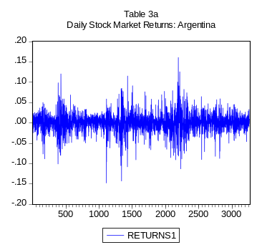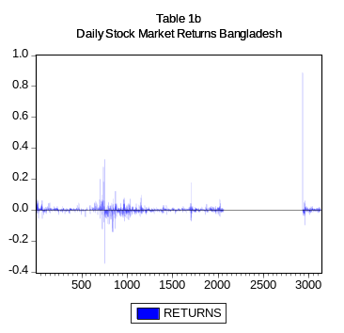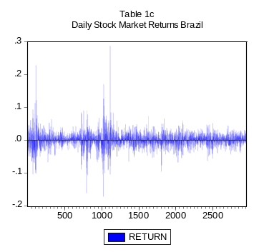
Table 3b
Daily Stock Market Returns Bangladesh

Table 3c
Daily Stock Market Returns Brazil
Table 3a
Daily Stock Market Returns Argentina

Table 3e
Daily Stock Market Returns China

Table 3f
Daily Stock Market Returns Columbia

Table 3d
Daily Stock Market Returns Chili

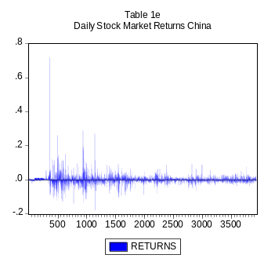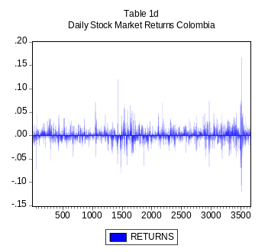
-.06
-.04
-.02
.00
.02
.04
.06
500
1000
1500
2000
2500
3000
3500
R
E
T
U
R
N
S
T
a
b
l
e

3
d
D
a
i
l
y

S
t
o
c
k

M
a
r
k
e
t

R
e
t
u
r
n
s

C
h
i
l
e

Table 3g
Daily Stock Market Returns Czech Republic

Table 3h
Daily Stock Market Returns Egypt

Table 3i
Daily Stock Market Returns Hong Kong

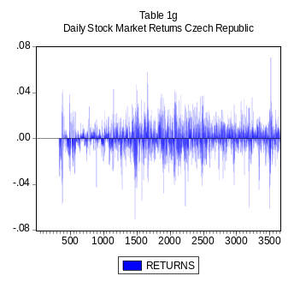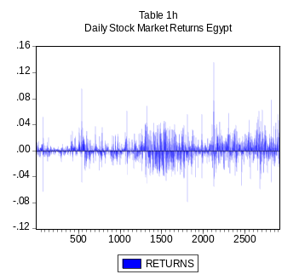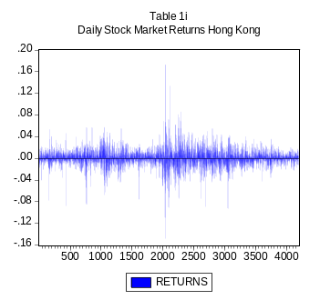

Table 3j
Daily Stock Market Returns Hungary

Table 3k
Daily Stock Market Returns India

Table 3l
Daily Stock Market Returns Indonesia

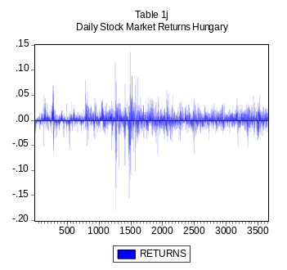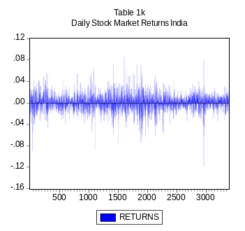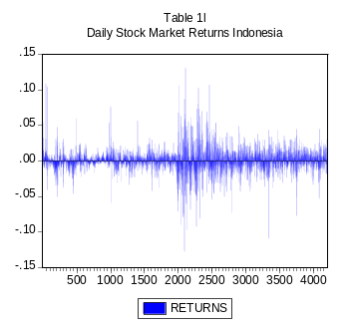

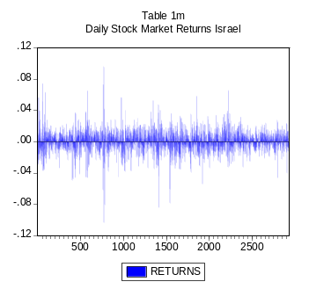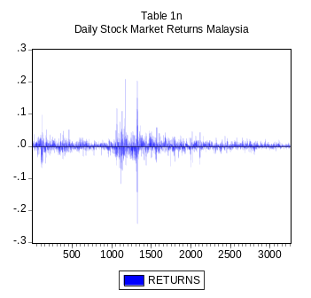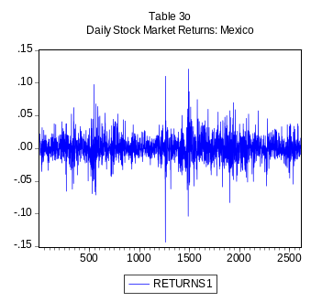
Table 3m
Daily Stock Market Returns Israel

Table 3n
Daily Stock Market Returns Malaysia

Table 3o
Daily Stock Market Returns Mexico

Table 3p
Daily Stock Market Returns Morocco

Table 3q
Daily Stock Market Returns Pakistan

Table 3r
Daily Stock Market Returns Peru

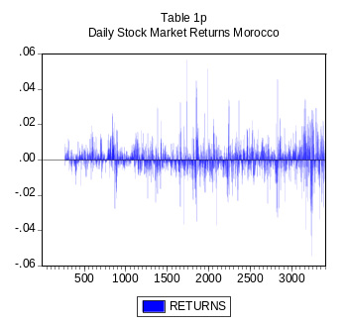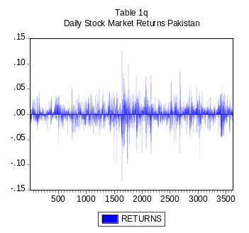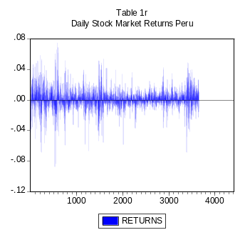

Table 3u
Daily Stock Market Returns Russia

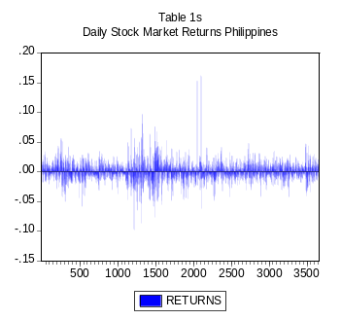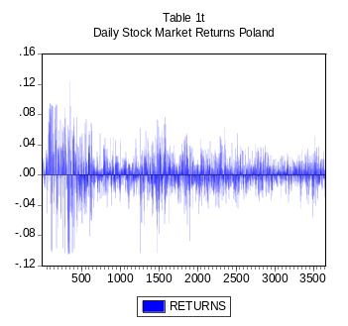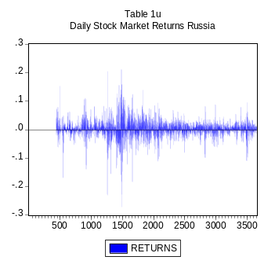
Table 3s
Daily Stock Market Returns Philippines

Table 3t
Daily Stock Market Returns Poland

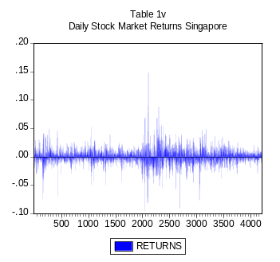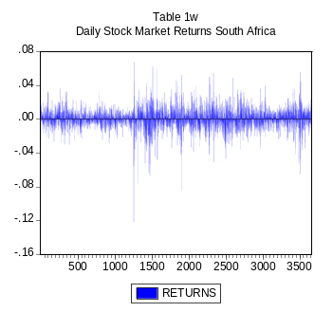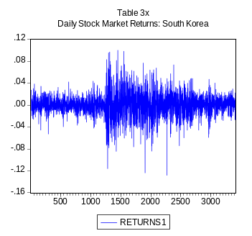
Table 3v
Daily Stock Market Returns Singapore

Table 3w
Daily Stock Market Returns South Africa

Table 3x
Daily Stock Market Returns South Korea

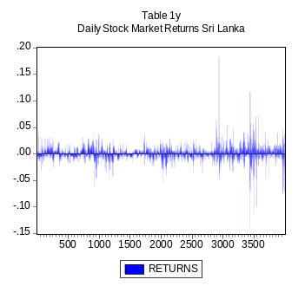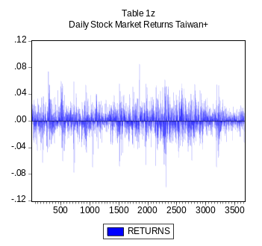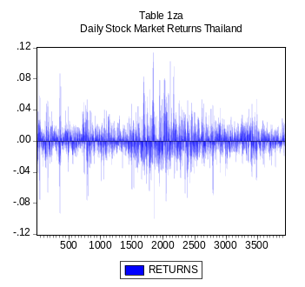
Table 3y
Daily Stock Market Returns Sri Lanka

Table 3z
Daily Stock Market Returns Taiwan

Table 3za
Daily Stock Market Returns Thailand

Table 4
Wald Tests
Country | Sample dates | H₀: P=P₁-P₂  Χ²(1)
Argentina Sample 1 | August 2, 1993-January 31, 2006 | 52.4964
Argentina Sample 2 | August 2, 1993-January 31, 2006 | 52.67628
Bangladesh | December 31, 1993-December 30, 2005 | 1262.107
Brazil Sample 1 | October 10, 1994-February 1, 2006 | 2369.426
Brazil Sample 2 | October 10, 1994-February 1, 2006 | 2794.608
Chile | January 1, 1993-December 29, 2006 | 462.42
China | January 2, 1991-January 31, 2006 | 1847.672
Columbia | January 1, 1993-Decembe 29, 2006 | 974.8568
Czech Republic | January 1, 1993-December 29, 2006 | 1696.668
Egypt | December 8, 1994-January 31, 2006 | 5103.552
Hong Kong Sample 1 | January 1, 1990-January 31, 2006 | 53616.98
Hong Kong Sample 2 | January 1, 1990-January 31, 2006 | 10370.6
Hungary | January 1, 1993-December 29, 2006 | 1213.795
India Sample 1 | January 1, 1993-December 30, 2005 | 1084.009
India Sample 2 | January 1, 1993-December 30, 2005 | 1043.169
Indonesia Sample 1 | January 1, 1990-January 31, 2006 | 2105.445
Indonesia Sample 2 | January 1, 1990-January 31, 2006 | 17509.67
Israel Sample 1 | November 15, 1994-February 1, 2006 | 138.008
Israel Sample 2 | November 15, 1994-February 1, 2006 | 19.60302
Malaysia Sample 1 | August 10, 1993-January 31, 2006 | 5130.712
Malaysia Sample 2 | August 10, 1993-January 31, 2006 | 3649.25
Mexico | January 31, 1996-February 1, 2006 | 1.902958
Morocco | December 31, 1993-December 29, 2006 | 338.3996
Pakistan Sample 1 | February 18, 1992-December 30, 2005 | 2033.883
Pakistan Sample 2 | February 18, 1992-December 30, 2005 | 1674.769
Peru | January 1, 1993-December 29, 2006 | 2408.282
Philippine | January 1, 1993-December 29, 2006 | 2493.237
Poland | January 1, 1993-December 29, 2006 | 2688.207
Russia | January 1, 1993-December 29, 2006 | 3213.73
Singapore | January 1, 1990-January 31, 2006 | 1985.26
South Africa | January 1, 1993-December 29, 2006 | 1140.507
South Korea | January 4, 1993-January 1, 2006 | 0.864578
Sri Lanka Sample 1 | September 5, 1990-December 30, 2005 | 0.0921
Sri Lanka Sample 2 | September 5, 1990-December 30, 2005 | 979.2572
Taiwan Sample 1 | January 6, 1992-January 31, 2006 | 1796.959
Taiwan Sample 2 | January 6, 1992-December 31, 2006 | 1.493996
Thailand Sample 1 | January 2, 1991-January 31, 2006 | 2175.808
Thailand Sample 2 | January 2, 1991-January 31, 2006 | 1941.566

Critical Value Χ²(1)=3.84

Table 5
F Test Results Based on Hurst Coefficient Tests

Country | Slope w/ Intercept |  | Slope Only
 | F | Critical Value F | F | Critical Value F
Argentina | -238.806857 | 4.61 | -583.6232052 | 6.63
 | -305.7482525 | 4.61 | -329.5313017 | 6.63
Bangladesh | -233.1461989 | 4.61 | -244.9086755 | 6.63
Brazil | 112.8818132 | 4.61 | 94.47066861 | 6.63
 | -239.3506691 | 4.61 | 94.47066861 | 6.63
Chile | -388.0737834 | 4.61 | -651.0810744 | 6.63
China | -283.97083 | 4.61 | -501.3872982 | 6.63
Columbia | 63.72662483 | 4.61 | 25.88561405 | 6.63
Czech | -22.06045528 | 4.61 | 118.3761113 | 6.63
Egypt | -381.057425 | 4.61 | -678.594859 | 6.63
Hong Kong | -513.6872448 | 4.61 | -1064.298006 | 6.63
 | -494.9577203 | 4.61 | -860.1947004 | 6.63
Hungary | -276.4661048 | 4.61 | -420.2094368 | 6.63
India | 51.97246884 | 4.61 | -712.4669392 | 6.63
 | 86.78837477 | 4.61 | 572.755831 | 6.63
Indonesia | -256.4121052 | 4.61 | -1294.336397 | 6.63
 | 199.343869 | 4.61 | -954.7818179 | 6.63
Israel | -129.2601742 | 4.61 | 933.1175709 | 6.63
 | -222.7151384 | 4.61 | -172.0207673 | 6.63
Korea | 270.7038706 | 4.61 | 813.6980763 | 6.63
 | 176.7930312 | 4.61 | 623.7700748 | 6.63
Malaysia | 1.136 | 4.61 | 310.36042034 | 6.63
 | 20.5553 | 4.61 | 56.561823 | 6.63
Mexico | -294.06034 | 4.61 | -590.97102 | 6.63
 | -335.751536 | 4.61 | -599.528 | 6.63
Morocco | None Available | None Available | None Available | None Available
Pakistan | 88.5341151 | 4.61 | -688.7767 | 6.63
 | -116.91654 | 4.61 | 52.88989 | 6.63
Peru | 729.778567 | 4.61 | 1185.99 | 6.63
Philippines | 513.2248 | 4.61 | 381.2594 | 6.63
Poland | -360.898 | 4.61 | 607.6000321 | 6.63
Russia | 239.343 | 4.61 | -439.974 | 6.63
Singapore | -336.574 | 4.61 | -1456.64948 | 6.63
 | 212.347 | 4.61 | 176.12501 | 6.63
South Africa | 306.32359 | 4.61 | 749.16606 | 6.63
Srilanka | -199.28487 | 4.61 | 145.029746 | 6.63
 | -199.28487 | 4.61 | 145.029746 | 6.63
Taiwan | -287.569197 | 4.61 | -104.2624 | 6.63
 | -130.512594 | 4.61 | 85.7093 | 6.63
Thailand | -360.905 | 4.61 | -1217.3311 | 6.63
 | -412.863357 | 4.61 | -729.80156 | 6.63

Table 6
BDS Results

Country | Embedding dimensions(m) | T= No. Of observations | BDS/SD Statistics
Argentina Sample 1 | 2 | 3253 | 18.806
 | 3 | 3253 | 20.101
 | 4 | 3253 | 20.469
Argentina Sample 2 | 2 | 3253 | 18.966
 | 3 | 3253 | 20.512
 | 4 | 3253 | 20.870
Bangladesh | 2 | 3123 | 25.661
 | 3 | 3123 | 28.783
 | 4 | 3123 | 30.173
Brazil Sample 1 | 2 | 2945 | 12.037
 | 3 | 2945 | 14.207
 | 4 | 2945 | 16.382
Brazil Sample 2 | 2 | 2945 | 11.840
 | 3 | 2945 | 14.013
 | 4 | 2945 | 16.374
Chile | 2 | 3347 | 15.201
 | 3 | 3347 | 17.601
 | 4 | 3347 | 19.592
China | 2 | 3926 | 25.446
 | 3 | 3926 | 30.170
 | 4 | 3926 | 33.116
Columbia | 2 | 3609 | 18.654
 | 3 | 3609 | 22.664
 | 4 | 3609 | 24.909
Czech Republic | 2 | 3279 | 11.770
 | 3 | 3279 | 16.238
 | 4 | 3279 | 19.273
Egypt | 2 | 2901 | 17.894
 | 3 | 2901 | 25.584
 | 4 | 2901 | 31.451
Hong Kong Sample 1 | 2 | 4189 | 13.558
 | 3 | 4189 | 16.799
 | 4 | 4189 | 19.613
Hong Kong Sample 2 | 2 | 4189 | 13.870
 | 3 | 4189 | 17.115
 | 4 | 4189 | 19.976
Hungary | 2 | 2302 | 88.612
 | 3 | 2302 | 11.003
 | 4 | 2302 | 12.229
India Sample 1 | 2 | 2253 | 9.9933
 | 3 | 2253 | 12.739
 | 4 | 2253 | 14.113
India Sample 2 | 2 | 2253 | 9.9933
 | 3 | 2253 | 12.739
 | 4 | 2253 | 14.113
Indonesia Sample 1 | 2 | 4189 | 20.636
 | 3 | 4189 | 25.456
 | 4 | 4189 | 29.170
Indonesia Sample 2 | 2 | 4189 | 20.908
 | 3 | 4189 | 25.862
 | 4 | 4189 | 29.562
Israel Sample 1 | 2 | 2901 | 6.5464
 | 3 | 2901 | 8.4620
 | 4 | 2901 | 10.267
Israel Sample 2 | 2 | 2767 | 5.5698
 | 3 | 2767 | 7.2010
 | 4 | 2767 | 8.8704
Korea Sample 1 | 2 | 3389 | 8.2557
 | 3 | 3389 | 10.431
 | 4 | 3389 | 12.251
Korea Sample 2 | 2 | 3275 | 7.9292
 | 3 | 3275 | 10.069
 | 4 | 3275 | 11.692
Malaysia Sample 1 | 2 | 3247 | 18.773
 | 3 | 3247 | 22.928
 | 4 | 3247 | 25.715
Malaysia Sample 2 | 2 | 3248 | 18.812
 | 3 | 3248 | 22.831
 | 4 | 3248 | 25.573
Mexico Sample 1 | 2 | 2587 | 7.5661
 | 3 | 2587 | 9.4468
 | 4 | 2587 | 10.930
Mexico Sample 2 | 2 | 2588 | 7.7756
 | 3 | 2588 | 9.5245
 | 4 | 2588 | 11.022
Morocco | 2 | 2842 | 15.564
 | 3 | 2842 | 20.297
 | 4 | 2842 | 23.480
Pakistan Sample 1 | 2 | 3611 | 19.962
 | 3 | 3611 | 24.224
 | 4 | 3611 | 27.470
Pakistan Sample 2 | 2 | 2339 | 16.004
 | 3 | 2339 | 19.739
 | 4 | 2339 | 23.185
Peru | 2 | 3604 | 17.341
 | 3 | 3604 | 20.569
 | 4 | 3604 | 23.497
Philippines | 2 | 3607 | 10.907
 | 3 | 3607 | 13.718
 | 4 | 3607 | 16.146
Poland | 2 | 3501 | 9.7376
 | 3 | 3501 | 12.890
 | 4 | 3501 | 14.846
Russia | 2 | 3176 | 18.482
 | 3 | 3176 | 23.361
 | 4 | 3176 | 26.911
Singapore Sample 1 | 2 | 4187 | 17.797
 | 3 | 4187 | 22.119
 | 4 | 4187 | 25.317
Singapore Sample 2 | 2 | 1638 | 7.0525
 | 3 | 1638 | 9.5204
 | 4 | 1638 | 11.884
Sri Lanka Sample 1 | 2 | 3990 | 23.164
 | 3 | 3990 | 27.753
 | 4 | 3990 | 30.549
Sri Lanka Sample 2 | 2 | 3990 | 23.164
 | 3 | 3990 | 27.753
 | 4 | 3990 | 30.549
South Africa | 2 | 3609 | 10.265
 | 3 | 3609 | 13.955
 | 4 | 3609 | 16.983
Taiwan Sample 1 | 2 | 3663 | 6.5229
 | 3 | 3663 | 10.605
 | 4 | 3663 | 13.554
Taiwan Sample 2 | 2 | 3663 | 6.5570
 | 3 | 3663 | 11.709
 | 4 | 3663 | 11.306
Thailand Sample 1 | 2 | 3662 | 11.876
 | 3 | 3662 | 15.248
 | 4 | 3662 | 17.467
Thailand Sample 2 | 2 | 3925 | 12.560
 | 3 | 3925 | 16.197
 | 4 | 3925 | 18.561
Critical Value (for sample >1000, with m2) is approximately 4.70-6.92 (we used 6 as a critical value in our Pacific Rim paper. Sample sizes are even larger in the current study)

References
Ahmed, Ehsan, Roger Koppl, J. Barkley Rosser, Jr., and Mark V. White. 1997. “Complex Bubble Persistence in Closed-End Country Funds.” Journal of Economic Behavior and Organization 32, 19-37.

Ahmed, Ehsan, Honggang Li, and J. Barkley Rosser, Jr. 2006. “Nonlinear Bubbles in Chinese Stock Markets in the 1990s.” Eastern Economic Journal 40, 1-18.

Ahmed, Ehsan and J. Barkley Rosser, Jr. 1995. “Nonlinear Speculative Bubbles in the Pakistani Stock Market.” The Pakistan Development Review 34, 25-41.

Ahmed, Ehsan, J. Barkley Rosser, Jr., and Jamshed Y. Uppal. 1996. “Asset Speculative Bubbles in Emerging Markets: The Case of Pakistan.” Pakistan Economic and Social Review 34, 97-118.

Ahmed, Ehsan, J. Barkley Rosser, Jr., and Jamshed Y. Uppal. 1999. “Evidence of Nonlinear Speculative Bubbles in Pacific-Rim Stock Markets.” Quarterly Review of Economics and Finance 39, 21-36.

Baumol, William J. 1957. “Speculation, Profitability, and Instability.” Review of Economics and Statistics 34, 263-271.

Bhagwati, Jagdish. 2004. In Defense of Globalization. Oxford: Oxford University Press.

Bischi, Gian-Italo, Mauro Gallegati, Laura Gardini, Roberto Leombrini, and Antonio Palestrini. 2006. “Herd Behavior and Non-Fundamental Asset Price Fluctuations in Financial Markets.” Macroeconomic Dynamics 10, 502-528.

Black, Fischer. 1986. “Noise.” Journal of Finance 41, 529-542.

Blanchard, Olivier and Mark. W. Watson. 1982. “Bubbles, Rational Expectations, and Financial Markets.” In P. Wachtel (ed.), Crises in the Economic and Financial Structure. Lexington: Lexington Books, pp. 295-315.

Bouchaud, Jean-Philippe and Marc Potters. 2003. Theory of Financial Risk and Derivative Pricing: From Statistical Physics to Risk Management. Cambridge, UK: Cambridge University Press.

Brock, William A., W. Davis Dechert, José A. Scheinkman, and Blake LeBaron. 1997. “A Test for Independence Based on the Correlation Dimension.” Econometric Reviews 15, 197-235.

Brock, William A. and Steven N. Durlauf. 2001. “Discrete Choice with Social Interactions.” Review of Economic Studies 63, 235-260.

Brock, William A. and Cars H. Hommes. 1997. “A Rational Route to Randomness.” Econometrica 65, 1059-1095.

Brock, William A., David A. Hsieh, and Blake LeBaron. 1991. Nonlinear Dynamics, Chaos, and Instability: Statistical Theory and Economic Evidence. Cambridge, MA: MIT Press.

Canova, Fabio and Takatoshi Ito. 1991. “The Time Series Properties in the Risk Premium of the Yen/Dollar Exchange Rate.” Journal of Applied Econometrics 6, 125-142.

Chiarella, Carl, Mauro Gallegati, Roberto Leombrini, and Antonio Palestrini. 2003. “Asset Price Dynamics among Heterogeneous Interacting Agents.” Computational Economics 22, 213-223.

Ciner, Cetin and Ahmet K. Kargozoglu. 2008. “Information Asymmetries, Speculation and Foreign Trading Activity: Evidence from an Emerging Market.” International Review of Financial Analysis, forthcoming.

Davidson, Paul. 1994. Post Keynesian Macroeconomic Theory: A Foundation for Successful Economic Policies for the Twenty-First Century. Aldershot: Edward Elgar.

Day, Richard H. and Weihong Huang. 1990. “Bulls, Bears, and Market Sheep.” Journal of Economic Behavior and Organization 14, 299-329.

DeLong, J. Bradford, Andrei Shleifer, Lawrence H. Summers, and Robert J. Waldmann. 1991. “The Survival of Noise Traders in Financial Markets.” Journal of Business 64, 1-19.

Elwood, S. Kirk, Ehsan Ahmed, and J. Barkley Rosser, Jr. 1999. “State-Space Estimation of Rational Bubbles in the Yen/Deutschemark Exchange Rate.” Weltwirtschaftliches Archiv 135, 317-331.

Engel, Charles and James D. Hamilton. 1990. “Long Swings in the Dollar: Are They in the Data and Do Markets Know It?” American Economic Review 80, 689-713.

Engle, Robert F. 1982. “Autoregressive Conditional Heteroskedasticity with Estimation of the Variance of United Kingdom Inflation.” Econometrica 55, 251-276.

Feller, Will. 1951. “The Asymptotic Distribution of the Range of Sums of Independent Random Variables.” Annals of Mathematical Statistics 22, 427.

Föllmer, Hans, Ulrich Horst, and Alan Kirman. 2005. “Equilibria in Financial Markets with Heterogeneous Agents: A Probabilistic Approach.” Journal of Mathematical Economics 41, 123-155.

Flood, Robert P. and Peter M. Garber. 1980. “Market Fundamentals versus Price Level Bubbles: The First Tests.” Journal of Political Economy 88, 745-776.

Hamilton, James D. 1989. “A New Approach to the Economic Analysis of Nonstationary Time Series and the Business Cycle.” Econometrica 57, 357-384.

Hommes, Cars H. 2006. “Heterogeneous Agent Models in Economics and Finance.” In Leigh Tesfatsion and Kenneth L. Judd (eds.), Handbook of Computational Finance, Vol. 2: Agent-Based Modeling. Amsterdam: North-Holland, pp. 1109-1185.

Hurst, H. Edwin.1951. “Long Term Storage Capacity of Reservoirs.” Transactions of the American Society of Civil Engineers 116, 770-799.

Jiang, J., K. Ma, and X. Cai. 2006. “Non-Linear Characteristics and Long-Run Correlations in Asian Stock Markets.” Physica A 378, 399-407.

LeBaron, Blake. 2006. “Agent-Based Computational Finance.” In Leigh Tesfatstion and Kenneth L. Judd (eds.), Handbook of Computational Economics, Vol. 2: Agent-Based Modeling. Amsterdam: North-Holland, pp. 1187-1233.

Lei, Gao and Gerhard Kling. 2006. “Regulatory Changes and Market Liquidity in Chinese Stock Markets.” Emerging Markets Review 7, 162-175.

Lim, Kian-Ping, Melvin J. Hinich, and Venus Khim-Sen Liew. 2005. “Statistical Inadequacy of GARCH Models in Asian Stock Markets.” Journal of Emerging Market Finance 4, 263-279.

Lo, Andrew W. 1991. “Long Memory in Stock Market Prices.” Econometrica 59, 1279-1313.

Lux, Thomas. 2009. “Applications of Statistical Physics in Finance and Economics.” In J. Barkley Rosser, Jr., (ed.), Handbook of Complexity Research. Cheltenham: Edward Elgar, in press.

Mandelbrot, Benoit B. 1972. “Statistical Methodology for Nonperiodic Cycles: From Covariance to R/S Analysis.” Annals of Economic and Social Measurement 1, 259-290.

Norden, Simon van and Huntley Schaller. 1993. “The Predictability of Stock Market Regime: Evidence from the Toronto Stock Exchange.” Review of Economics and Statistics 75, 505-510.

Porter, David P. and Vernon L. Smith. 1994. “Stock Market Bubbles in the Laboratory.” Applied Mathematical Finance 1, 111-128.

Ruan, Jian, Su-Lin Pang, and Wei-Qi Luo. 2005. “The Multifractal Structure Analysis of a Chinese Stock Market.” Machine Learning and Cybernetics 5, 3058-3063.

Sarkar, Niyanda and Debabrata Mukhopadhyay. 2005. “Testing Predictability and Nonlinear Dependence in the Indian Stock Market.” Emerging Markets Finance and Trade 41(6), 7-44.

Shiller, Robert J. 2005. Irrational Exuberance, 2nd edition. Princeton: Princeton University Press.

Sornette, Didier and Wei-Xing Zhou. 2005. “Predictability of Large Future Changes in Major Financial Indices.” International Journal of Forecasting 22, 154-168.

Tirole, Jean. 1982. “On the Possibility of Speculation Under Rational Expectations.” Econometrica 50, 1163-1181.

Tirole, Jean. 1985. “Asset Bubbles and Overlapping Generations.” Econometrica 53, 1499-1528.

Zeeman, E. Christopher. 1974. “On the Unstable Behavior of the Stock Exchanges.” Journal of Mathematical Economics 1, 39-44.

Ahmed and Rosser (1995) and Ahmed et al (1996) studied such phenomena in the Pakistani stock market while Ahmed et al (1997) looked at such bubbles in closed-end country funds. In addition, Ahmed et al (1999) studied the stock markets of 10 Pacific Basin economies, while Ahmed et al (2006) focused on the Chinese stock markets of the 1990s, this last paper using the methodology in this paper. The current study moves beyond the earlier ones by using both the Hamilton regime switching approach and the rescaled range analysis of Husrt, along with looking at a much larger set of countries’ stock markets.
China has stock markets in both Shanghai and in Shenzhen across from Hong Kong.
These dynamics have also happened despite China maintaining capital controls in its foreign exchange markets, something recommended even by Bhagwati (2004) who supports free trade and increased economic globalization in general.
This approach is ultimately drawn from statistical physics of interacting particle systems, with β being related to the temperature of the system and J being related to the strength of interactions between the particles.
Lo (1991) has criticized the use of the classical Hurst coefficient for studying long-term persistence in stock markets precisely because of this presence of short-term dependence for which he proposes a method for avoiding. However, this is not a problem for us because it is precisely short-term dependence that we are interested in detecting.

