GOVERNANCE ISSUES IN COMPLEX ECOLOGIC-ECONOMIC SYSTEMS

J. Barkley Rosser, Jr.
James Madison University
rosserjb@jmu.edu
July, 2012

Abstract:
This paper studies complex dynamics that can arise in fisheries, forests, and broader ecological-economic systems as a result of human-natural interactions. Implications for managing such systems, particularly when they are commons, are considered, with recommendations regarding the Scale-Matching and Precautionary Principles. These arguments are linked to ideas of Elinor Ostrom regarding how to manage commons, with her having emphasized the problems of complexity late in her career.

Dedication: This paper is dedicated to the memory of Elinor Ostrom.

Acknowledgements: I acknowledge useful comments by Sun Chang, Herbert Dawid, Werner Güth, William Hyde, Shashi Kant, Ali Khan, Hartmut Kliemt, Reinhard Selten, and Runsheng Yin. The usual caveat applies.

I Introduction: Ostrom and Complexity
The late Elinor Ostrom was the person who most clearly saw through the supposed dilemma called the “tragedy of the commons” (Hardin, 1968; Ostrom, 1990). It was widely argued that managing common property resources was an impossible proposition, that either common property is privatized in some way or else there will be an inevitable tendency for the resource to be overharvested, possibly to complete destruction or exhaustion. Such outcomes were seen as inevitable outcomes of prisoner dilemma games where agents using common property resources will fail to cooperate üwith one another and instead seek to get as much of the resource for themselves as soon as possible. However, she understood from early in her work (Ostrom, 1976) that people seek to work out arrangements for managing common property resources. As she studied this phenomenon over time she came to realize that different groups pursue different solutions. This led her to pose the concept of polycentricity and the importance of institutional diversity around the world, based on local circumstances and cultures (Ostrom, 2005, 2012).
Also over time she came to understand that the challenge of managing common property resources becomes more difficult when the governance system inevitably becomes part of a complex ecologic-economic system (Ostrom, 2010a, 2010b). Indeed, it is often the human intervention into a natural system that introduces the complexity in the system, the ecologic-economic system. This induced complexity makes those managing it that more responsible for what they do.
Complexity takes many forms. Many different definitions have been put forward, and there are debates regarding which are most appropriate for economic and political and social analysis. Among these have been computational, hierarchical, dynamic, and many others (Rosser, 2009). We shall not attempt to determine which is most correct most broadly. However, from the standpoint of considering the problems of governing ecologic-economic systems, it is the dynamic form of complexity that is the most important. Such dynamic complexities have been defined by Day (1994) as involving systems that endogenously do not converge on a point, an exponential expansion or contraction. Catastrophic discontinuities and chaotic and other erratic dynamics are the complex phenomena that can arise in ecologic-economic systems that increase the difficulties of governing them. This paper will consider examples of such dynamics in such commons systems.

II. The Intertemporally Optimal Fishery
The classic tragedy of the commons for fisheries was first posed by Gordon (1954), who incorrectly identified it as a problem of common property, while nevertheless identifying the inefficient overharvesting that can occur in an open access fishery. However, even when efficiently managed, fisheries may exhibit complex dynamics, particularly when discount rates are sufficiently high. Just as species can become extinct under optimal management when agents do not value future stocks of the species sufficiently, likewise in fisheries, as future stocks of fish are valued less and less, the management of the fishery can become to resemble an open access fishery. Indeed, in the limit, as the discount rate goes to infinity at which point the future is valued at zero, the management of the fishery converges on that of the open access case. But well before that limit is reached, complex dynamics of various sorts besides catastrophic collapses may emerge with greater than zero discount rates, such as chaotic dynamics.
We shall now lay out a general model based on intertemporal optimization to see how these outcomes can arise as discount rates vary, following Hommes and Rosser (2001). We shall start considering optimal steady states where the amount of fish harvesting equals the natural growth rate of the fish as given by the Schaefer (1957) yield function.
h(x) = f(x) = rx(1-x/k), (1)
where the respective variables are the same as in the previous chapter: x is the biomass of the fish, h is harvest, f(x) is the biological yield function, r is the natural rate of growth of the fish population without capacity constraints, and k is the carrying capacity of the fishery, the maximum amount of fish that can live in it in situation of no harvesting, which is also the long-run bionomic equilibrium of the fishery.
We more fully specify the human side of the system by introducing a catchability coefficient, q, along with effort, E, to give that the steady state harvest, Y, also is given by
h(x) = qEx =Y. (2)
We continue to assume constant marginal cost, c, so that total cost, C is given by
C(E) = cE. (3)
With p the price of fish, this leads to a rent, R, that is
R(Y) = pqEx – C(E). (4)
So far this has been a static exercise, but now let us put this more directly into the intertemporal optimization framework, assuming that the time discount rate is δ. All of the above equations will now be time indexed by t, and also we must allow at least in principle for non-steady state outcomes. Thus
dx/dt = f(x) – h(x), (5)
with h(x) now given by (9.2) and not necessarily equal to f(x). Letting unit harvesting costs at different times be given by c[x(t)], which will equal c/qx, and with a constant δ > 0, the optimal control problem over h(t) while substituting in (9.5) becomes
max ∫₀∞e^{-δt}(p – c[x(t)](f(x) – dx/dt)dt, (6)
subject to x(t) ≥ 0 and h(t) ≥ 0, noting that h(t) = f(x) – dx/dt in (9.6). Applying Euler conditions gives
f(x)/dt = δ = [c’(x)f(x)]/[p-c(x)]. (7)
From this the optimal discounted supply curve of fish will be given by
x(p,δ) = k/4{1 + (c/pqk) - (δ/r) + [(1 + (c/pqk)-(δ/r))² + (8cδ/pqkr)]^{1/2}}. (8)
This entire system is depicted in Figure 1 (Rosser, 2001, p. 27) as the Gordon-Schaefer-Clark fishery model.
The most dramatic aspect of this model is the backward-bending supply curve that arises, with Copes (1970) being the first to explain this possibility for fisheries, strongly supported by Clark (1990). One can see that a gradual increase in demand in this situation can lead to a sudden increase in price and a catastrophic collapse of output.
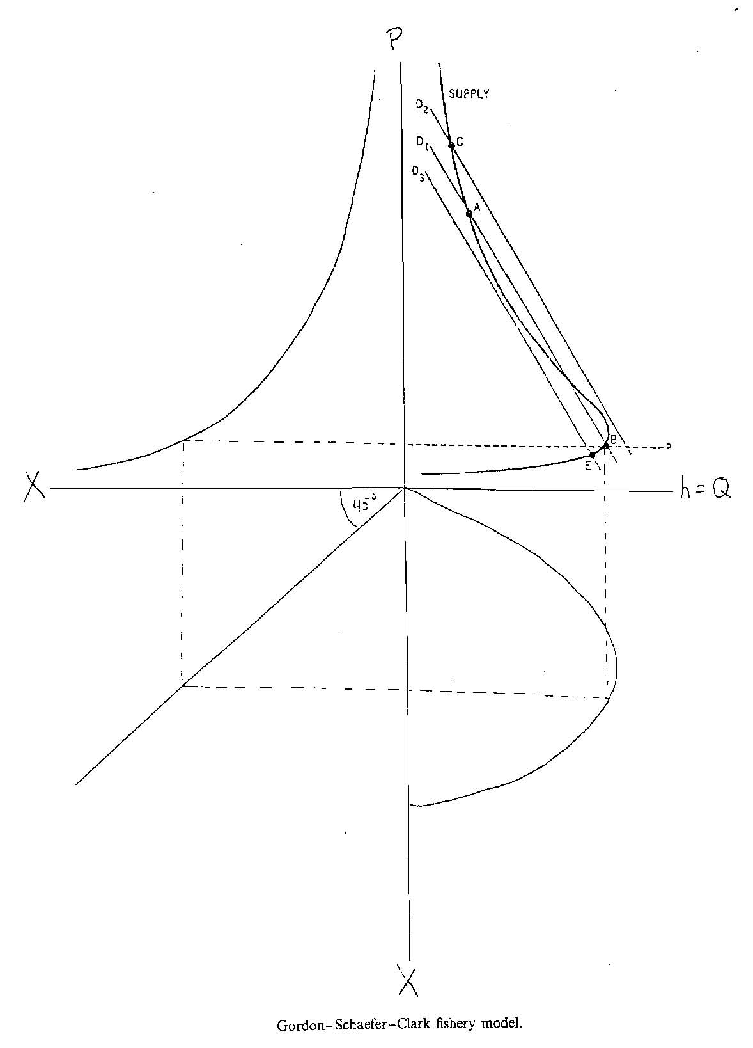

Figure 1: Gordon-Schaefer-Clark fishery model
We note that when δ = 0, the supply curve in the upper right quadrant of Figure 1 will not bend backwards. Rather it will asymptotically approach the vertical line coming up from the maximum sustained yield point at the farthest point to the right on the yield curve in the lower right quadrant. As δ increases, this supply curve will start to bend backwards and will actually do so well below δ = 2%. The backward bend will continue to become more extreme until at δ = ∞ the supply curve will converge on the open access supply curve of
x(p, ∞) = (rc/pq)(1 – c/pqk). (9)
It should be clear that the chance of catastrophic collapses will increase as this supply curve bends further backwards and the possibility for multiple equilibria increases, so that a smooth increase in demand can lead to a catastrophic increase in price and collapse of quantity. So, even if people are behaving optimally, as they become more myopic, the chances of catastrophic outcomes will increase.
Regarding the nature of the optimal dynamics, Hommes and Rosser (2001) show that for the zones in which there are multiple equilibria in the backward-bending supply curve case, there are roughly three zones in terms of the nature of the optimal outcomes. At sufficiently low discount rates, the optimal outcome will simply be the lower price/higher quantity of the two stable equilibrium outcomes. At a much higher level the optimal outcome will simply the higher price/lower quantity of the two stable equilibria. However, for intermediate zones, the optimal outcome may involve a complex pattern of bouncing back and forth between the two equilibria, with the possibility of this pattern being mathematically chaotic arising.
To study their system, Hommes and Rosser (2001) assume a
demand curve of the form
D(p(t)) = A – Bp(t), (10)
with the supply curve being given by (9.10). Market clearing is then given by
p(t) = [A – S(p(t), δ]/B. (11)
This can be turned into a model of cobweb adjustment dynamics by indexing the p in the supply function to be one period behind the p being determined, with Chiarella (1988) and Matsumoto (1997) showing chaotic dynamics in generalized cobweb models.
Drawing on data from Clark (1985, pp. 25, 45, 48), Hommes and Rosser (2001) assumed the following values for parameters: A = 5241, B = 0.28, r = 0.05, c = 5000, k = 400,000, q = 0.000014 (with the number for A coming from A = kr/(c-c²/qk)). For these values they found that as δ rose from zero at first a low price equilibrium was the solution, but starting around δ = 2% period-doubling bifurcations began to appear, with full-blown chaotic dynamics appearing at around δ = 8. When δ rose above 10% or so, the system went to the high price equilibrium.

III. Complexity Problems of Optimal Rotation in Forests
Some complexities of forestry dynamics have been discussed in the previous chapter, notably in connection with the matter of spruce-budworm dynamics (Ludwig, Jones, and Holling, 1978). In order to get at related sorts of dynamics arising from unexpected patterns of forest benefits as well as such management issues as how to deal with forest fires and patch size, as well as the basic matter of when forests should be optimally cut, we need to develop a basic model (Rosser, 2005). We shall begin with the simplest sort of model in which the only benefit of a forest is the timber to be cut from it and consider the optimal behavior of a profit-maximizing forest owner under such conditions.
Irving Fisher (1907) considered what we now call the “optimal rotation” problem of when to cut a forest as part of his development of capital theory. Positing positive real interest rates he argued that it would be optimal to cut the forest (or a tree, to be more precise) when its growth rate equals the real rate of interest, the growth rate of trees tending to slow down over time. This was straightforward: as long as a tree grows more rapidly than the level of the rate of interest, one can increase one’s wealth more by letting the tree grow. Once its growth rate is set to drop below the real rate of interest, one can make more money by cutting the tree down and putting the proceeds from selling its timber into a bond earning the real rate of interest. This argument dominated thinking in the English language tradition for over half a decade, despite some doubts raised by Alchian (1952) and Gaffney (1957).
However, as eloquently argued by Samuelson (1976), Fisher was wrong. Or to be more precise, he was only correct for a rather odd and uninteresting case, namely that in which the forest owner does not replant a new tree to replace the old one, but in effect simply abandons the forest and does nothing with it (or perhaps sells it off to someone else). This is certainly not the solution to the optimal rotation problem in which the forest owner intends to replant and then cut and replant and cut and so on into the infinite future. Curiously, the solution to this problem had been solved in 1849 by a German forester, Martin Faustmann (1849), although his solution would remain unknown in English until his work was translated over a century later.
Faustmann’s solution involves cutting sooner than in the Fisher case, because one can get more rapidly growing younger trees in and growing if one cuts sooner, which increases the present value of the forest compared to a rotation period based on cutting when Fisher recommended.
Let p be the price of timber, assumed to be constant, f(t) be the growth function of the biomass of the tree over time, T be the optimal rotation period, r be the real interest rate, and c the cost of cutting the tree, Fisher’s solution is then given by
pf’(T) = rpf(T), (12)
which by removing price from both sides can be reduced to
f’(T) = rf(T), (13)
which has the interpretation already given: cut when the growth rate equals real rate of interest.
Faustmann solved this by considering an infinite sum of discounted earnings of the future discounted returns from harvesting and found this to reduce to
pf’(T) = rpf(T) + r[(pf(T) – c)/(e^{rT} – 1)]. (14)
which implies a lower T than in Fisher’s case due to the extra term on the right-hand side, which is positive and given the fact that f(t) is concave. Hartman (1976) generalized this to allow for non-timber amenity values of the tree (or forest patch of same aged trees to be cut simultaneously), assuming those amenity values can be characterized by g(t) to be given by
pf’(T) = rpf(T) + r[(pf(T) – c)/(e^{rT} – 1)] – g(T). (15)
An example of a marketable non-timber amenity value that can be associated with a privately owned forest might be grazing of animals, which tends to reach a maximum early in the life of a forest patch when the trees are still young and rather small. Swallow et al. (1990) estimated cattle grazing amenity values in Western Montana to reach a maximum of $16.78 per hectare at 12.5 years, with the function given by
g(t) = β₀exp(-β₁t), (16)
with estimated parameter values of β₀ = 1.45 and β₁ = 0.08. Peak grazing value is at T = 1/β₁. This grazing amenities solution is depicted in Figure 2 (Rosser, 2005, p. 194).
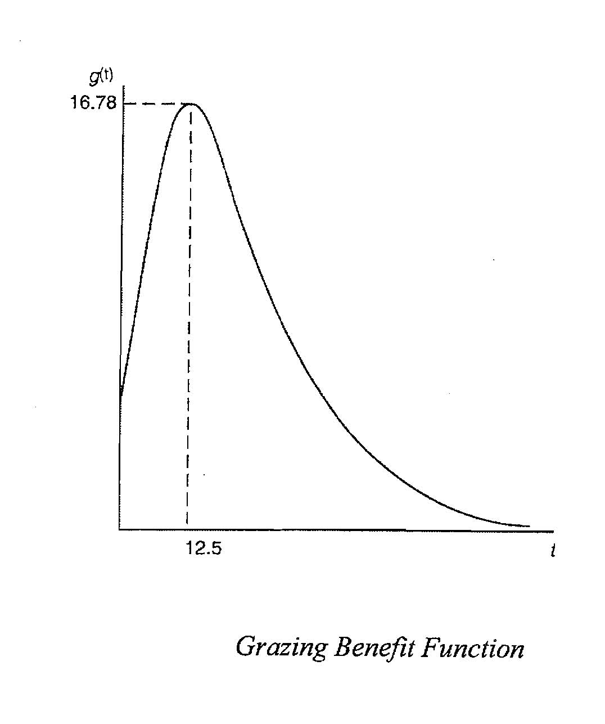
Figure 2: Grazing Amenities Function
Plugging this formulation of g(t) into the Hartman equation (17) generates a solution depicted in Figure 3 (Rosser, 2005, p. 195), with MOC representing marginal opportunity cost and MBD the marginal benefit of delaying harvest. In this case the global maximum is 73 years, a bit shorter than the Faustmann solution of 76 years, showing the effect of the earlier grazing benefits. This case has multiple local optima, and this reflects the sorts of nonlinearities that arise in forestry dynamics as these situations become more complex (Vincent and Potts, 2005).
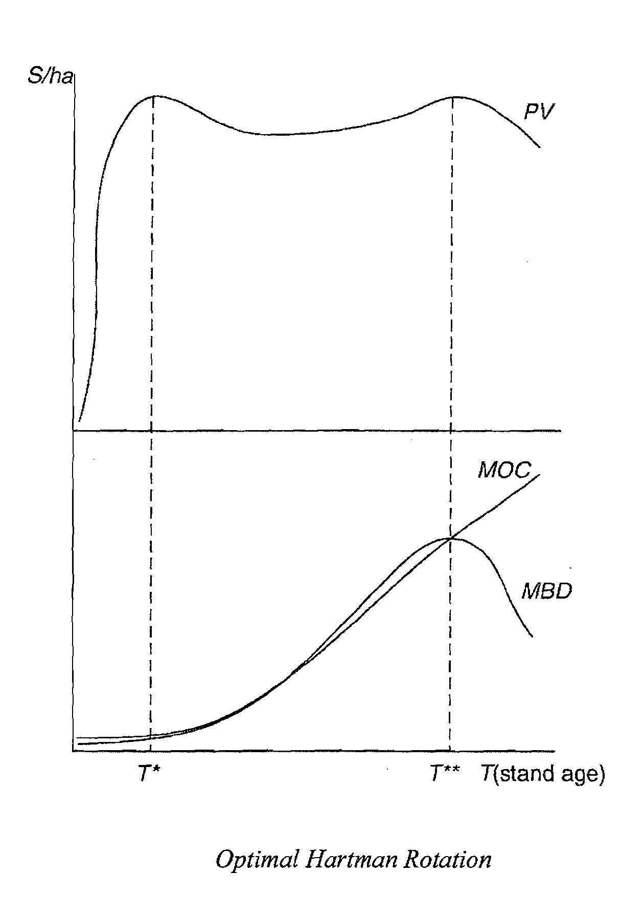

Figure 3: Optimal Hartman Rotation with Grazing
Grazing amenities from cattle on a privately owned forest can bring income to the owner of the forest. However, many other amenities may not directly bring income, or may be harder to arrange to do so. Furthermore, some of the amenities may be in the form of externalities that accrue to others who do not own the forest. All of this may lead to market inefficiencies as the g(t) are not properly accounted for, thus leading to inaccurate estimates of the optimal rotation period, which may be to not rotate at all, to leave a forest uncut so that such amenities as endangered species or aesthetic values of older trees, or prevention of soil erosion, or carbon sequestration may be enjoyed, particularly if the timber value from the trees in the forest is not all that great.
While private forest owners are unlikely to account for such externalities fully, it is generally argued that the managers of publicly owned forests, such as the National Forest Service in the US, should attempt to do so. Indeed, the US National Forest Service has been doing so now for several decades through the FORPLAN planning process to determine land use on national forests (Johnson et al., 1980; Bowes and Krutilla, 1985). In practice this is often done through the use of public hearings, with the numbers of people attending these meetings representing groups interested in particular amenities often ending up becoming the measure of the weights or implicit prices put on these various amenities.
Among the amenities for which it may be possible for either a private forest owner to earn some income or a publicly owned forest as well are hunting and fishing. Clearly for a private forest owner to fully capture such amenities involves having to control access to the forest, which is not always able to be done, given the phenomenon of poaching, with their being an old tradition of this in Europe of peasants poaching on an aristocrat’s forest (many of which have since become public forests), or of poaching of endangered species on public lands in many poorer countries. In many countries at least a partial capturing of income for these activities can come through the sale of hunting and fishing licenses. Likewise, many public forests are able to charge people for camping or hiking in particularly beautiful areas.
A more difficult problem arises with the matter of biodiversity. Here there is much less chance of having people pay directly for some activity as with hunting or fishing or camping. One is dealing with public goods and thus a willingness to pay for an existence value or option value for a species to exist, or for a particular forest or environment to maintain some level or degree of biodiversity, even if there is no specific endangered species involved. Some of these option values are tied to possible uses of certain species, such as medical uses, although once these are known, market operators usually attempt to take advantage of the income possibilities in one way or another. But broader biodiversity issues, including even the sensitive subject of endangered species, is much harder to pin down (Perrings et al. (1995).
Among some poorer countries such as Mozambique, as well as middle income ones such as Costa Rica, the use of ecotourism to generate income for such preservation has become widespread. While this can involve bringing economic benefits to local populations, some of these resent the appearance of outsiders. More generally the problems of valuing and managing forests with poorer indigenous or aboriginal populations, whose rights have often been violated in the past, is an ongoing issue (Kant, 2000; Gram 2001).
Another external amenity is carbon sequestration. This benefit tends to be strongly associated with cutting less frequently (Alig, Adams, and McCarl, 1998) or not at all, especially as in general any cutting involves burning of underbrush or “useless” branches, leading to large releases of carbon dioxide. However, the pattern of this varies, and one thing pushing for cutting sooner is that more rapidly growing trees, younger ones, tend to absorb more carbon dioxide than older, slower growing ones or alternative species that grow more rapidly (Alavalapati et al., 2002). Details of both the nature of the forest as well as such things as what it is replaced with if it is cut can also lead to possible conflicts with biodiversity initiatives (Caparrós and Jacquemont, 2003) or other amenities such as avoiding soil erosion or flooding (Plantinga and Wu, 2003).
How complicated these patterns of non-marketed amenities can be is seen by an example this author had personal experience with, the George Washington National Forest in Virginia and West Virginia, for which he was involved in the FORPLAN planning process at one time. The normal pattern of ecological succession in the eastern deciduous forests found in the George Washington tend to favor different animal species at different times as the vegetation passes through various stages, with those wishing to hunt certain species thus finding themselves supporting different policies.
The first stage after a clearcut of a section of forest involves new, small trees growing rapidly, with such an environment favoring grazing by deer, much as in the example of cattle grazing in Montana. This peaks out between about five and ten years, and deer hunters, very numerous in the area, thus tend to favor more timber harvesting. The second stage is actually associated with the greatest biodiversity as there are many shrubs and other sorts of undergrowth beneath the middle-aged trees. In terms of hunting this favors wild turkeys and grouse, peaking at around 25 years. The final stage is an old growth forest more than 60 years old, with lots of large fallen logs in which one finds bears, whose hunters tend to be highly specialized and also highly motivated, and who thus unsurprisingly oppose the deer hunters desire for more timber harvesting. Figure 4 (Rosser, 2005, p. 198) depicts the time pattern of these net amenities, and this pattern opens up the possibility of multiple equilibria and associated possible complex dynamics and capital theoretic issues, just as the case of cattle grazing in Montana did.
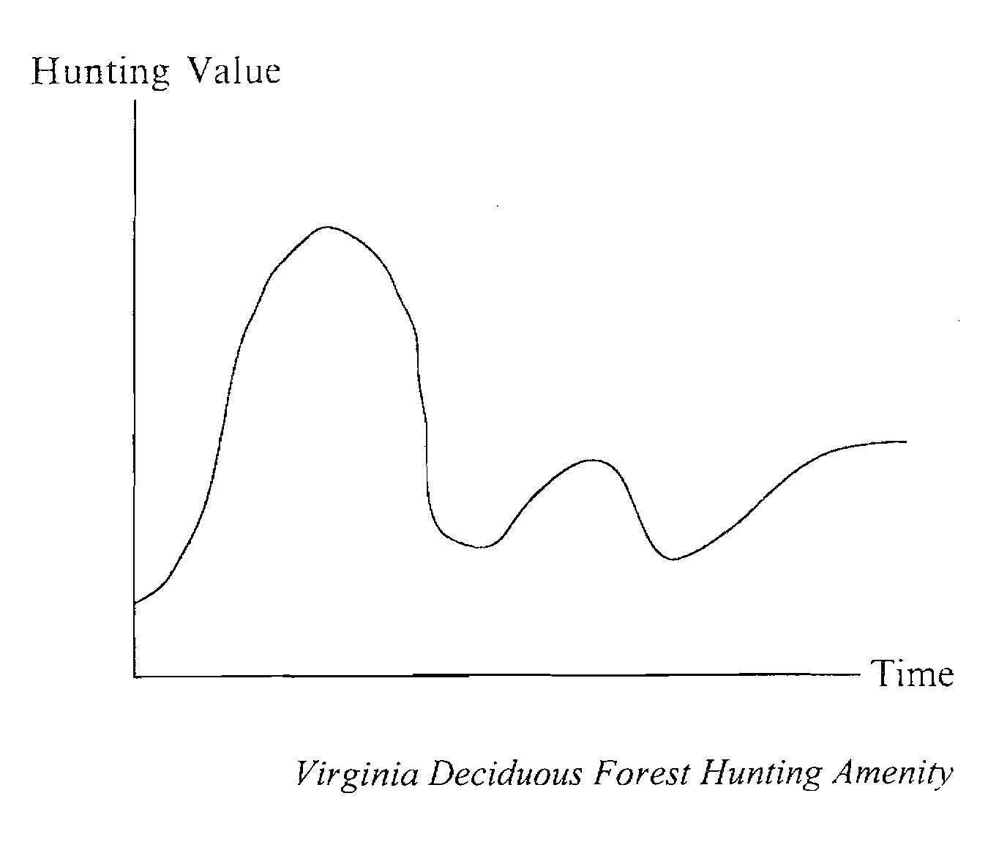

Figure 4: Virginia Deciduous Forest Hunting Amenity

If a forest is not strictly a subsistence one and thus has at least one product sold in a market, then for a fixed land area, a forest may a backward-bending long-run supply curve for that product, particularly if it is timber. Empirical observations support the possible existence of such situations, including a study of smallholder timber sales from the edge of the Amazon rain forest (Amacher et al. 2009). They found strongly negative and statistically significant elasticities of supply for timber in their sample for plots with secure tenure, although for one with insecure tenure the curve slopes upward. The author offer little argument for why this result should occur, partly as they are mostly concerned with other issues such as the role of credit and the presence or not of the Transamazonian highway. The little explanation they do provide invokes the model of the backward-bending supply curve of individual labor rather than that of fisheries. “The timber price effect follows from the fact that the smallholder may have predetermined revenue targets that timber sales are intended to help meet” (Amacher et al., 2009, p. 1796).
As it is, theoretical models of the possibility of backward-bending supply curves of timber have been developed in the past, inspired in particular by the work of Colin Clark on such curves for fisheries. The first to do so was Hyde (1980). Even more strongly inspired by Clark, Binkley (1993) developed a formal model based on the Faustmann model, also presenting tentative evidence in support of it from the long run supply of loblolly pines in the US Southeast. Needless to say, these cases open up the possibility of the sort of complex dynamics already discussed for the fishery case.
Using the variables already defined, we present Binkley’s model below, adding π(t) for the net present value of the future stream of timber receipts, which the forest owner will seek to maximize. In contrast to our earlier discussion, price will be allowed to change, although we shall eschew using option theory. This forest may contain trees or stands of varying ages. In any given year, some tree or stand will reach the optimal rotation age, T, and will be harvested. Supply will be in per unit land area terms.
The forest owner seeks to maximize
π(t) = -c + pf(t)e^{-rt} + π(t)e^{-rt}. (17)
The first order condition for solving this is to find dπ/dt = 0, which is given by
f’(t)/[f(t) – c/p] = r/(1 – e^{-rt}). (18)
This implies a long-run supply relationship between price and optimal rotation age, T, as given by
S(p) = f(T(p))/T(p). (19)
From this one gets a non-monotonic supply curve as a function of T that goes from zero to zero as T increases, with a maximum sustained yield (MSY) at an intermediate value of T given by
1/T = f’(T)/f(T). (20)
From this it is possible to derive the relationship between price and optimal rotation age, T, that appears in (20) as given by
p = c/{f(T) – f’(t)[(1 – e^{-rt})/r]}. (21)
This is summarized in Figure 5.

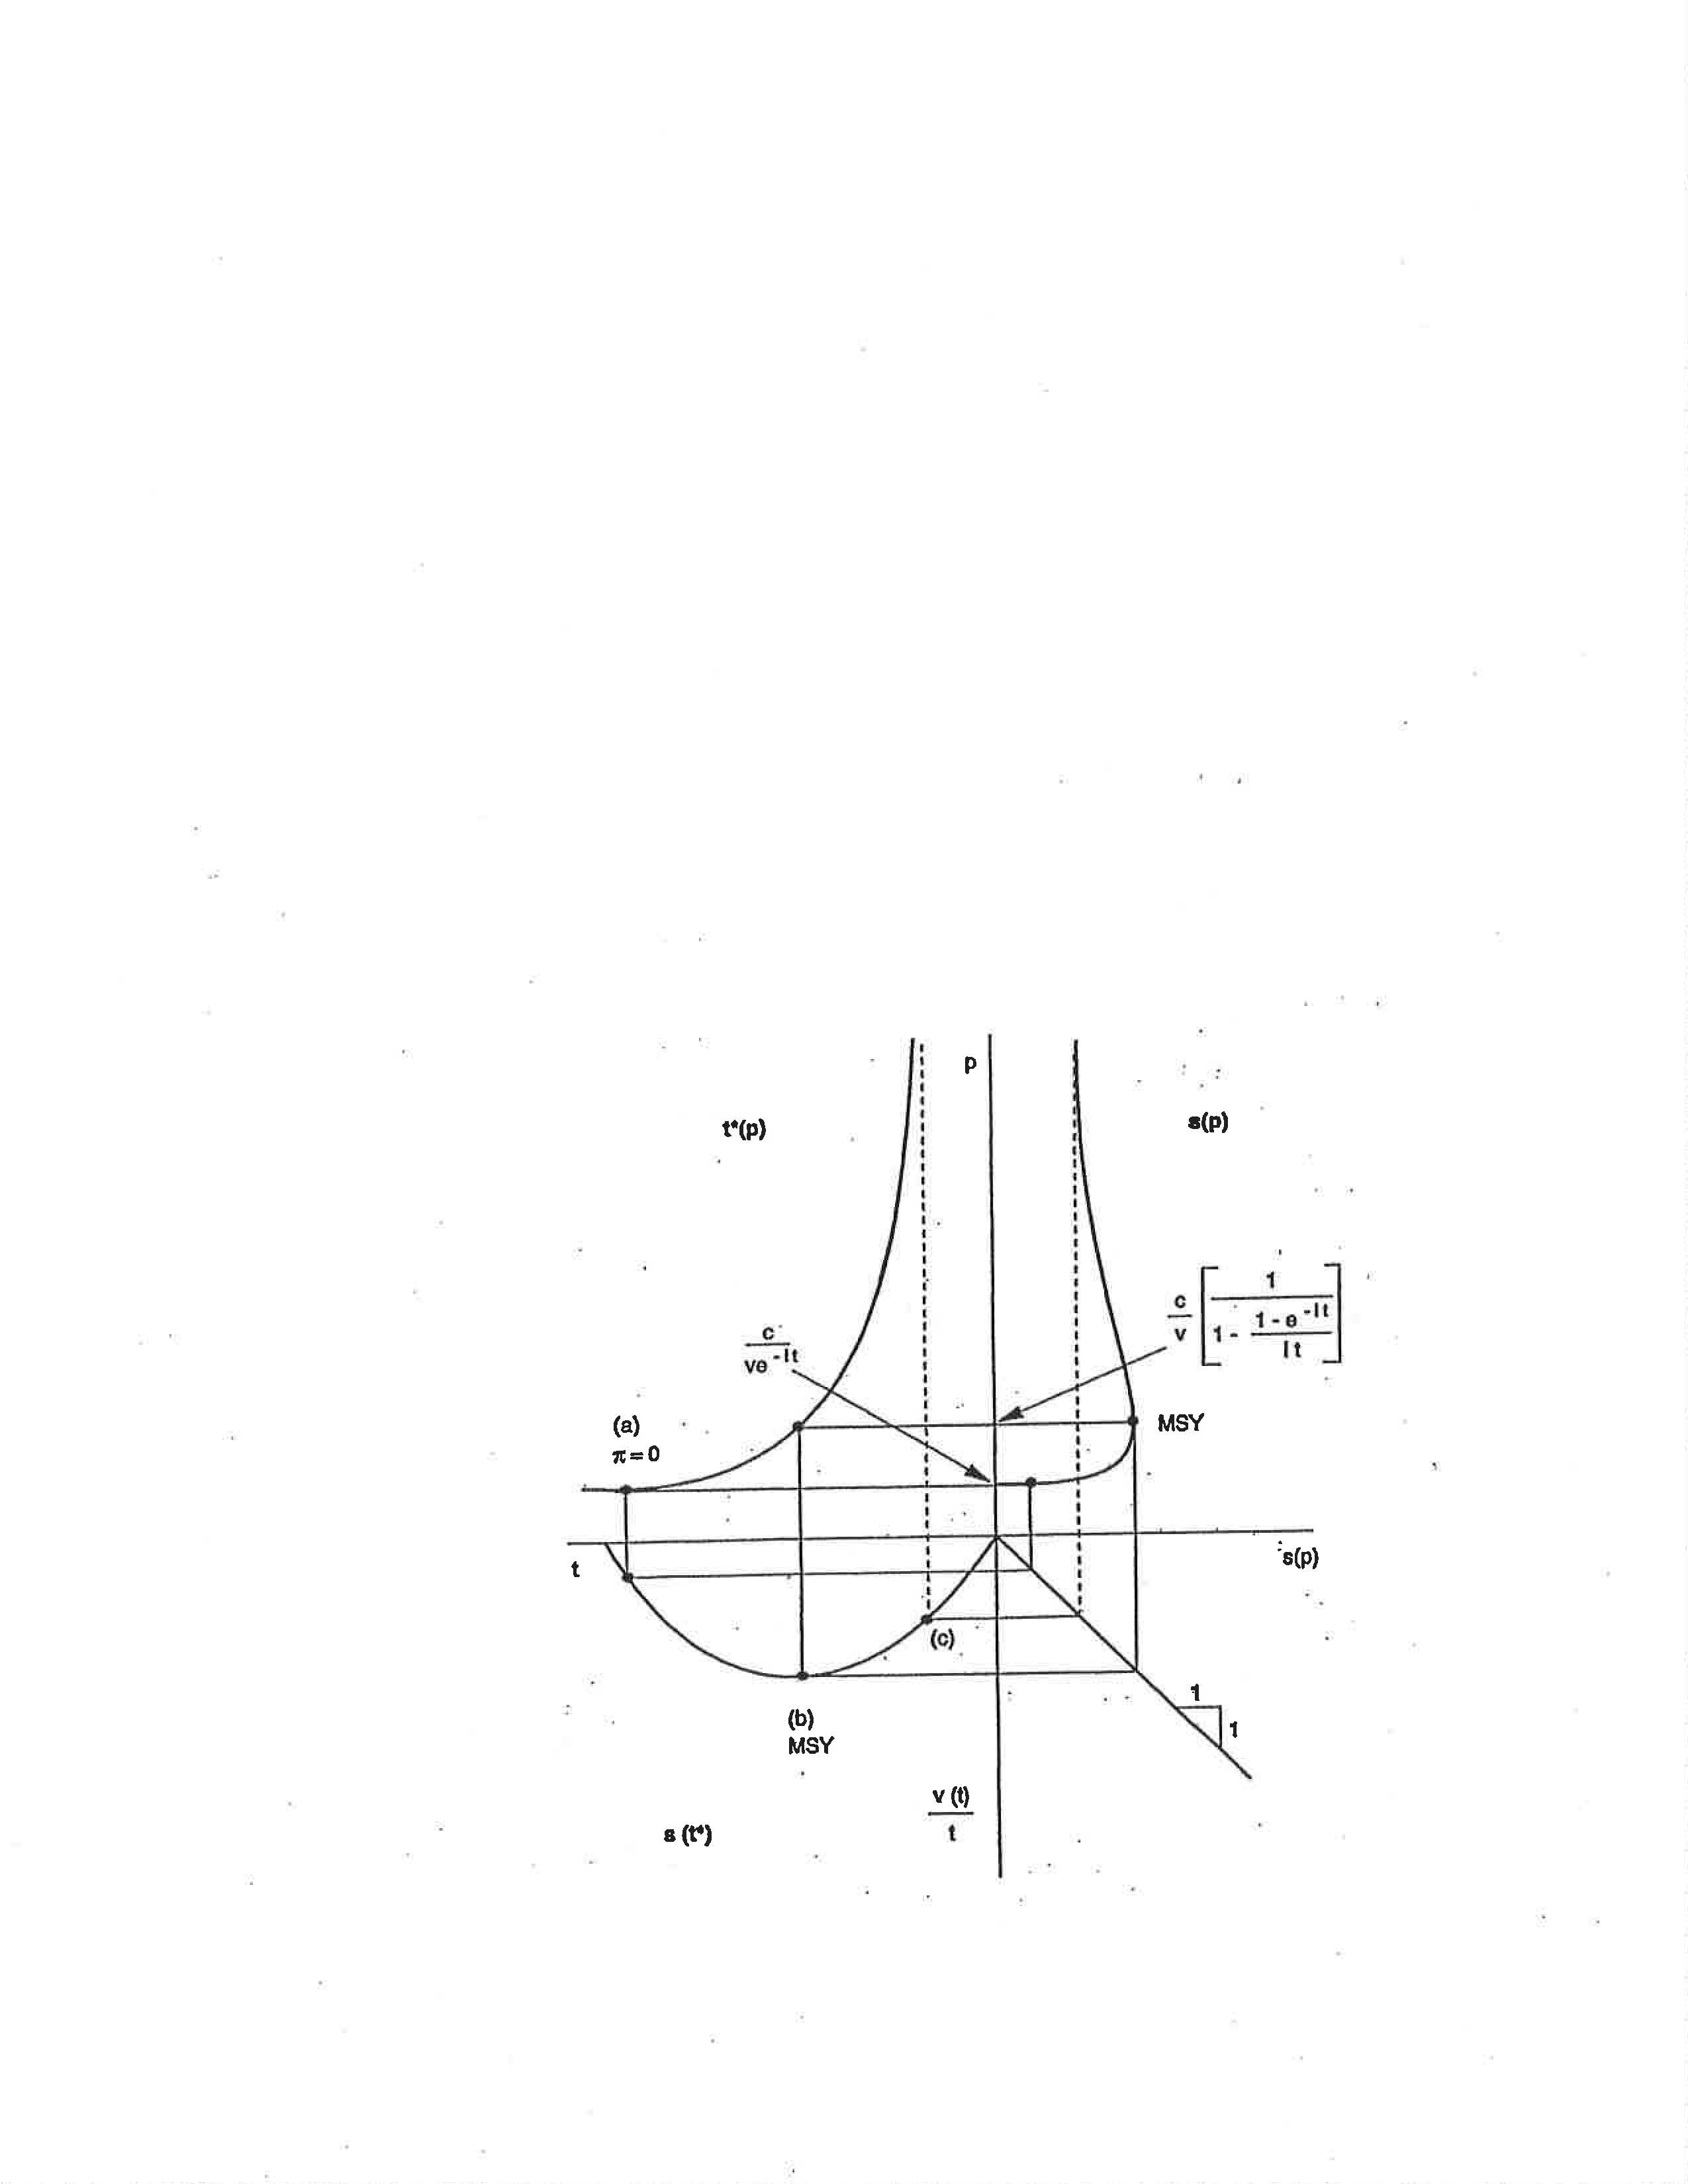

Figure 5: The Backward-Bending Long-Run Supply of Timber

There are parallels to the backward-bending supply curve of fish presented above, but also some differences. Crucial to both is the assumption of a maximum carrying capacity. Both effectively have only three figures, with one quadrant just a 45 degree line, between rotation age for the forest and fish biomass for the fishery. Both have a non-monotonic function that lies behind the backward bend of the supply curve, the Schaefer yield function of steady state harvest and fish biomass for the fishery and between rotations age and timber supply for the forest. In both, the maximum supply point is associated with the MSY point.
In both the upward sloping portion of the supply curve is associated with the “outer” portion of the relevant yield function beyond the MSY point. For the fishery there are lots of fish there, easily caught at low prices. For the forest this is the longer rotation periods when the trees are larger. On the other side of MSY is the backward-bending portion of the supply curve. For the fishery there are few fish, thus expensive to catch. For the forest, thisis associated with a much shorter rotation period in which the trees are small when cut, thus producing less timber over time.
Binkley summarizes the situation in his conclusion thusly (p. 178):
“High stumpage prices imply not only that the output from the forest has a high value, but also that capital in the form of growing stock has a high opportunity cost. At high prices, it is optimal to conserve on the use of capital and therefore to reduce the growing stock inventory by reducing the rotation age.”

IV. Stability and Resilience of Ecosystems Revisited
In the early portion of the previous chapter we encountered a discussion of the sources of stability within ecosystems. Whereas it was argued for quite some time that there is a relationship between the diversity of an ecosystem and its stability, this was later found not to be true in general, with indeed mathematical arguments existing suggesting just the opposite. It was then suggested by some that the apparent relationship between diversity and stability in nature was the other way around, that stability allowed for diversity. More broadly, it was argued that there is no general relationship, with the details of relationships within an ecosystem providing the key to understanding the nature of the stability of the system, although certainly declining biodiversity is a broad problem with many aspects (Perrings et al., 1995).
Out of this discussion came the fruitful insight by C.S. Holling (1973) of a deep negative relationship between stability and resilience. This relationship can be posed as a conflict between local and global stability: that greater local stability may be in some sense purchased at the cost of lesser global stability or resilience. The palm tree is not locally stable as it bends in the wind easily in comparison with the oak tree. However, as the wind strengthens, the palm tree’s bending allows it to survive, while the oak tree becomes more susceptible to breaking and not surviving. Such a relationship can even be argued to carry over into economics as in the classic comparison of market capitalism and command socialism. Market capitalism suffers from instabilities of prices and the macroeconomy, whereas the planned prices and output levels of command socialism stabilize the price level, output, and employment. However, market capitalism is more resilient and survives the stronger exogenous shocks of technological change or sudden shortages of inputs, whereas command socialism is in greater danger of completely breaking down, which indeed happened with the former Soviet economic system.
This recognition that ecosystems involve dynamic patterns and do not remain fixed over time, led Holling (1992) to extend his idea to more broadly consider the role of such patterns within maintaining the resilience of such systems, and also to consider how the relationships between the patterns would vary over time and space within the hierarchical systems (Holling and Gunderson, 2002; Holling et al., 2002; Gunderson et al., 2002). This resulted in what has come to be called the “lazy eight” diagram of Holling, which is depicted in Figure 6 (Holling and Gunderson, 2002, p. 34) and shows a stylized picture of the passage of a typical ecosystem through four basic functions over time..
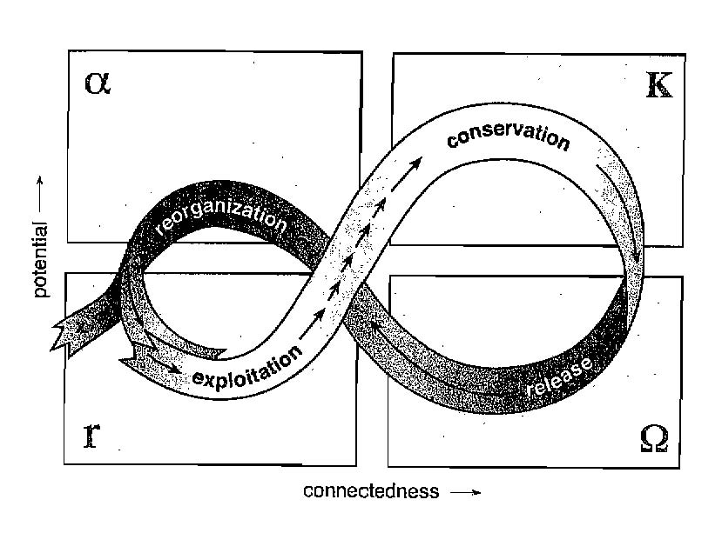
Figure 6: Cycle of the Four Ecosystem Functions
This can be thought of as representing a typical pattern of ecological succession on a particular plot of land. Conventional ecology focuses on the r and K zones, corresponding to r-adapters and K-adapters. So, if an ecosystem has collapsed (as in the case of a forest after a total fire), it begins to have populations within it grow again from scratch, doing so at an r rate through the phase of exploitation. As it fills up, it moves to the K stage, wherein it reaches carrying capacity and enters the phase of conservation, although as noted previously, succession may occur in this stage as the precise set of plants and animals may change at this stage. Then there comes the release as the overconnected system now become low in resilience collapses into a release of biomass and energy in the Ω stage, which Gunderson and Holling identify with the “creative destruction” of Schumpeter (1950). Finally, the system enters into the α stage of reorganization as it prepares to allow for the reaccumulation of energy and biomass. In this stage soil and other fundamental factors are prepared for the return to the r stage, although this is a crucially important stage in that it is possible for the ecosystem to change substantially into a different form, depending on how the soil is changed and what species enter into it, with an example of the shift from buffalo-grass and grama to rattlesnake bush and tumbleweed in the US Southwest a possibility as described by Leopold (1933) .
This basic pattern can be seen occurring at multiple time and space scales within a broader landscape as a set of nested cycles (Holling, 1986, 1992). An example drawn on the boreal forest and also depicting relevant atmospheric cycles is depicted in Figure 7 (Holling, et al., 2002, p. 68). One can think in terms of the forest of each of the levels operating according to its own “lazy eight” pattern as described above. Such a pattern is called a panarchy.

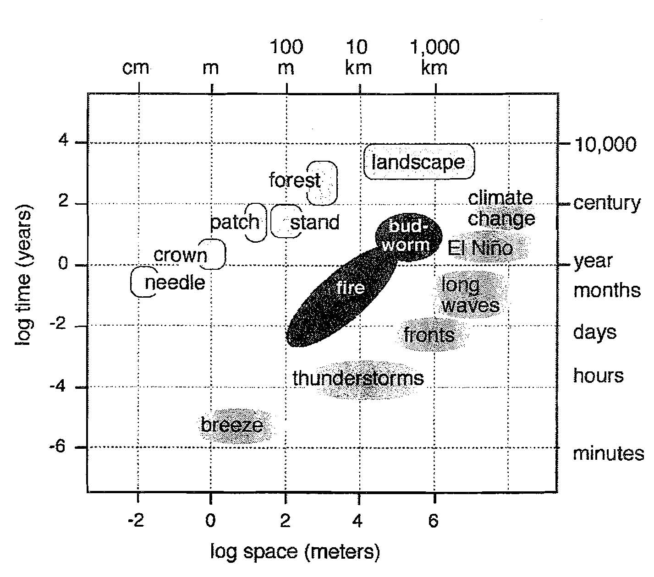
Figure 7: Time and Space Scales of the Boreal Forest and the Atmosphere
Increasingly policymakers come to understand that it is resilience rather than stability per se that is important for longer term sustainability of a system. In the face of exogenous shocks and the threat of extinction of species (Solé and Bascompte, 2006), special efforts must be made to approach things adeptly. Costanza et al.(1999) propose seven principles for the case of oceanic management: Responsibility, Scale-Matching, Precautionary, Adaptive Management, Cost Allocation, and Full Participation. Of these, Rosser (2001) suggests that the most important are the Scale-Matching and Precautionary Principles.
Scale-matching means that the policymakers operate at the appropriate level of the hierarchy of the ecologic-economic system. Following Ostrom (1990) and Bromley (1991), as well as Rosser (1995) and Rosser and Rosser (2006), the idea is to align both property and control rights at the appropriate level of the hierarchy. Managing a fishery at too high a level can lead to the destruction of fish species at a lower level (Wilson et al., 1999).
Assuming that appropriate scale-matching has been achieved, and that a functioning system of property rights and control has been established, the goal of managing to maintain resilience may well involve providing sufficient flexibility for the system to be able to have its local fluctuations occur without interference while maintaining the broader boundaries and limits that keep the system from collapsing. In the difficult situation of fisheries, this may involve establishing reserves (Lauck et al., 1998; Grafton et al., 2009) or system of rotational usage (Valderarama and Anderson, 2007). Crucial to successfully doing this is having the group that manages the resource able to monitor itself and observe itself (Sethi and Somanathan, 1996), with such self-reinforcement being the key to success in the management of fisheries for certain as in the case of the lobster gangs of Maine (Acheson, 1988) and the fisheries of Iceland (Durrenberger and Pálsson, 1987). Needless to say, all of this is easier said than done, especially in the case of fisheries where the relevant local groups are often quite distinct socially and otherwise from those around them and thus tending to be suspicious of outsiders who attempt to get them to organize themselves to do what is needed (Charles, 1988).
Property rights and control rights may not coincide (Ciriacy-Wantrup and Bishop, 1975), with control of access being the key to governing the commons. Without control of access, property rights are irrelevant. The work of Ostrom and others makes clear that property rights may take a variety of forms. While these alternative efforts often succeed, sometimes they do not, as the failure of an early effort to establish proprety rights in the British Columbia salmon fishery demonstrates (Millerd, 2007). Some common property resouces have been managed successfully for centuries, as in the case of the Swiss alpine grazing commons (Netting, 1976), whose exisitence has long disproven the simple version of the “tragedy of the commons” as posed by Garrett Hardin (1968).

V. Conclusions
As it is, it has been Elinor Ostrom who has most thoroughly and relentlessly investigated the many puzzles and situations and contingencies that can arrive in the effort to effectuate successful management of common property resources. She has done this through theoretical investigation, laboratory experiments, as well as an exhaustive and encyclopedic study around the world of many actual such systems in practice in their native habitats. This effort has included a realization that polycentric approaches are best also for dealing with the dynamic complexities that can arise in ecologic-economic commons. This noble effort has changed the way the world thinks about these problems, and for this all social scientists and policymakers should be grateful to her for her great achievements.

References

Acheson, J.M. (1988), The Lobster Gangs of Maine, Durham: University Press of New England.

Alavalapati, J.R.R., G.A. Stainback and D.R. Carter (2002), “Restoration of the longleaf pine ecosystem on private lands in the US South”, Ecological Economics 40, 411-419.

Alchian, A.A. (1952), Economic Replacement Policy, Santa Monica: RAND Corporation.

Alig, R.J., D.M. Adams and B.A. McCarl (1998), “Ecological and economic impacts of forest policies: Interactions across forestry and agriculture”, Ecological Economics 27, 63-78.

Allen, J.C., W.M. Schaffer and D. Rosko (1993), “Chaos reduces species extinction by amplifying local population noise”, Nature 364, 229-232.

Amacher, G.S., F.D. Merry and M.S. Bowman (2009), “Smallholder timber sale decisions on the Amazon frontier”, Ecological Economics 68, 1787-1796.

Arrow, K.J. and A.C. Fisher (1974), “Preservation, uncertainty and irreversibility”, Quarterly Journal of Economics 87, 312-319.

Asheim, G.B. (2008), “The occurrence of paradoxical behavior in a model where economic activity has environmental effects”, Journal of Economic Behavior and Organization 65, 529-546.

Barbier, E.B. (2001), “The economics of tropical deforestation and land use: An introduction to the special issue”, Land Economcs 77, 155-171.

Binkley, C.S. (1993), “Long-run timber supply: price elasticity, inventory elasticity, and the use of capital in timber production”, Natural Resource Modeling 7, 163-181.

Bowes, M.D. and J.V. Krutilla (1985), “Multiple Use Management of Public Forestlands”, in: A.V. Kneese and J.L. Sweeny (eds.), Handbook of Natural Resources and Energy Economics, Amsterdam: Elsevier, 531-569.

Bromley, D.W. (1991), Environment and Economy: Property Rights and Public Policy, Oxford: Basil Blackwell.

Caparrós, A. and F. Jacquemont (2003), “Conflicts between biodiversity and carbon sequestration”, Ecological Economics 46, 143-157.

Charles, A.T. (1988), “Fishery socioeconomics: A survey”, Land Economics 64, 276-295.

Chiarella, C. (1988) “The cobweb model and its instability”, Economic Modelling 5, 377-384.

Ciriacy-Wantrup, S.v. and R.C. Bishop (1975), “’Common property’ as a concept in natural resources policy”, Natural Resource Economics 15, 36-45.

Clark, C.W. (1985), Bioeconomic Modelling and Fisheries Management, New York: Wiley-Interscience.

Clark, C.W. (1990), Mathematical Bioeconomics, 2nd edn., New York: Wiley-Interscience.

Copes, P. (1970), “The backward-bending supply curve of the fishing industry”, Scottish Journal of Political Economy 17, 69-77.

Costanza, R., F. Andrade, P. Antunes, M. van den Belt, D. Boesch, D. Boersma, F. Catarino, S. Hanna, K. Limburg, B. Low, M. Molitor, J.G. Pereira, S. Rayner, R. Santos, J. Wilson and M. Young (1999), “Ecological economics and sustainable governance of the oceans”, Ecological Economics 31, 171-187.

Day, R.H. (1994), Complex Economic Dynamics: An Introduction to Dynamical Systems and Market Mechanisms: Volume I. Cambridge: MIT Press.

Doveri, F., M. Scheffer, S. Rinaldi, S. Muratori and Yu. A. Kuznetsov (1993), “Seasonality and chaos in a plankton-fish model”, Theoretical Population Biology 43, 159-183.

Durrenberger, E.P. and G. Pálsson (1987), “Ownership at sea: Fishing territories and access to sea resources”, American Ethnologist 14, 508-522.

Faustmann, M. (1849), “Berechnung des werthes, weichen waldboden, sowie noch nicht haubare holzbestande für die waldwirtschaft besitzen”, Allgemeine Forst und Jagd-Zeitung 25, 441-455.

Fisher, I. (1907), The Rate of Interest, New York: Macmillan.

Foroni, I., L. Gardini and J.B. Rosser, Jr. (2003), “Adaptive and statistical expectations in a renewable resource market”, Mathematics and Computers in Simulation 63, 541-567.

Gaffney, M. (1957), “Concepts of financial maturity of timber and other assets”, Agricultural Economics Information Series 62, Raleigh: North Carolina State College.

Gordon, H.S. (1954), “Economic theory of a common-property resource: The fishery”, Journal of Political Economy 62, 124-142.

Grafton, R.Q., T. Kampas and P.V. Hu (2009), “ Cod today and none tomorrow: The economic value of a marine reserve”, Land Economics 85, 454-469.

Gram, S. (2001), “Economic valuation of special forest products”, Ecological Economics 26, 109-117.

Hardin, G. (1968), “The tragedy of the commons”, Science 162, 1243-1248.

Hartman, R. (1976), “The harvesting decision when a standing forest has value”, Economic Inquiry 14, 52-58.

Holling, C.S. (1965), “The functional response of predators to prey density and its rolel in mimicry and population regulation”, Memorials of the Entomological Society of Canada 45, 1-60.

Holling, C.S. (1973), “Resilience and stability of ecological systems”, Annual Review of Ecology and Systematics 4, 1-24.

Holling, C.S. (1986), “The Resilience of Terrestial Ecosystems: Local Surprise and Global Change”, in: W.C. Clark and R.E. Munn (eds.), Sustainable Development of the Biosphere, Cambridge: Cambridge University Press, 292-317.

Holling, C.S. (1992), “Cross-scale morphology, geometry, and dynamics of ecosystems”, Ecological Monographs 62, 447-502.

Holling, C.S. and L.H. Gunderson (2002), “Resilience and Adaptive Cycles”, in: L.H. Gunderson and C.S. Holling (eds.), Panarchy: Understanding Transformations in Human and Natural Systems, Washington: Island Press, 25-62.

Holling, C.S., L.H. Gunderson and G.D. Peterson (2002), “Sustainability and Panarchies”, in: L.H. Gunderson and C.S. Holling (eds.), Panarchy: Understanding Transformations in Human and Natural Systems, Washington: Island Press, 63-112.

Hommes, C.H. and Rosser, J.B., Jr. (2001), “Consistent expectations equilibria and complex dynamics in renewable resource markets”, Macroeconomic Dynamics 5, 180-203.

Hyde, W.F. (1980), Timber Supply, Land Allocation, and Economic Efficiency, Baltimore: Johns Hopkins University Press.

Johnson, K.N., D.B. Jones and B.M. Kent (1980), A User’s Guide to the Forest Planning Model (FORPLAN), Fort Collins: USDA Forest Service Land Management Planning.

Kahn, J. and A. Rivas (2009), “The Sustainable Economic Development of Traditional Peoples”, in: R.P.F. Holt, S. Pressman and C.L. Spash (eds.), Post Keynesian and Ecological Economics: Confronting the Environmental Issues, Cheltenham: Edward Elgar, 254-278.

Kant, S. (2000), “A dynamic approach to forest regimes in developing countries”, Ecological Economics 32, 287-300.

Kant, S. (2003), “Extending the boundaries of forest economics”, Journal of Forest Policy and Economics 5, 39-58.

Kant, S. (2005), “Post-Newtonian Economics and Sustainable Forest Management”, in: S. Kant and R.A. Berry (eds.), Economics, Sustainability, and Natural Resources: Economics of Sustainable Forest Management, Dordrecht: Springer, 253-267.

Khan, M.A. and A. Piazza (2011), “Optimal cyclicality and chaos in the 2-sector RSS model: An anything-goes construction”, Journal of Economic Behavior and Organization 80, 397-417.

Lauck, T., C.W. Clark, M. Mangel and G.R. Munro (1998), “Implementing the precautionary principle in fisheries management through marine reserves”, Ecological Applications 8, S72-S78.

Leopold, A. (1933), “The conservation ethic”, Journal of Forestry 33, 636-637.

Ludwig, D., D.D. Jones and C.S. Holling (1978), “Quality analysis of insect outbreak systems: The spruce budworm and the forest”, Journal of Animal Ecology 47, 315-332.

Matsumoto, A. (1997), “Ergodic cobweb chaos”, Discrete Dynamics in Nature and Society 1, 135-146.

Millerd, F. (2007), “Early attempts at establishing exclusive rights in the British Columbia salmon fishery”, Land Economics 83, 23-40.

Mitra, T. and H.J. Wan, Jr. (1986), “On the Faustmann solution to the forest management problem”, Journal of Economic Theory 40, 229-249.

Netting,R. (1976), “What alpine peasant have in common: Observations on communal tenure in a Swiss village”, Human Ecology 4, 134-146.

Nishimura,K. and M. Yano (1996), “On the least upper bound of discount factors that are compatible with optimal period-three cycles”, Journal of Economic Theory 69, 306-333.

Ostrom, E. (1976), The Delivery of Urban Services: Outcomes of Change (ed.), Urban Affairs Annual Reviews, vol. 10, Beverly Hills: Sage.
,
Ostrom, E. (1990), Governing the Commons: The Evolution of Institutions for Collective Action, New York: Cambridge University Press.

Ostrom, E. (2005), Understanding Institutional Diversity, Princeton: Princeton University Press.

Ostrom, E. (2010a), “Beyond markets and states: Polycentric governance of complex economic systems”, American Economic Review 100, 641-672.

Ostrom, E. (2010b), “The challenge of self-governance in complex contemporary environments”, Journal of Speculative Philosophy 24, 316-332.

Ostrom, E. (2012), “Coevolving relationships between political science and economics”, Rationality, Markets and Morals 3, 51-65.

Perrings, C., K.-G. Mäler, C. Folke, C.S. Holling and B.-O. Jansson (eds.) (1995), Biodiversity Loss: Economic and Ecological Issues, Cambridge: Cambridge University Press.

Plantinga, W.J. and H.R. Clarke (2003), “Co-benefits from carbon sequestration in forests: Evaluating reductions in agricultural externalities from an afforestation policy in Wisconsin”, Land Economics 79, 74-85.

Prince, R. and J.B. Rosser, Jr. (1985), “Some implications of delayed environmental costs for benefit-cost analysis: A study of reswitching in the western coal lands”, Growth and Change 16, 18-25.

Ramsey, F.P. (1928), “A mathematical theory of saving”, Economic Journal 38, 543-549.

Reed, W.J. and H.R. Clarke (1990), “Harvest decision and asset valuation for biological resources exhibiting size-dependent stochastic growth”, International Economic Review 31, 147-169.

Rosser, J.B., Jr. (1995), “Systemic crisis in hierarchical ecological economies”, Land Economics 71, 163-172.

Rosser, J.B., Jr. (2001), “Complex ecologic-economic dynamics and environmental policy”, Ecological Economics 37, 23-37.

Rosser, J.B., Jr. (2005), “Complexities of Dynamic Forest Management Policies”, in: S. Kant and R.A. Berry (eds.), Economics, Natural Resources, and Sustainability: Economics of Sustainable Forest Management, Dordrecht: Springer, 191-206.

Rosser, J.B., Jr. (ed.) (2009), Handbook of Complexity Research, Cheltenham: Edward Elgar.

Rosser, J.B., Jr. (2011a), Complex Evolutionary Dynamics in Urban-Regional and Ecologic-Economic Systems: From Catastrophe to Chaos and Beyond, New York: Springer.

Rosser, J.B., Jr. (2011b), “Post Keynesian perspectives and complex ecologic-economic dynamics”, Metroeconomica 62, 96-121.

Rosser, J.B., Jr. and M.V. Rosser (2006), “Institutional evolution of environmental management under global economic growth”, Journal of Economic Issues 40, 421-429.

Samuelson, P.A. (1976), “Economics of forestry in an evolving society”, Economic Inquiry 14, 147-169.

Schaefer, M.B. (1957), “Some considerations of population dynamics in relation to the management of marine fisheries”, Journal of the Fisheries Research Board of Canada 14, 669-681.

Schumpeter, J.A. (1950, Capitalism, Socialism, and Democracy, 3rd edn., New York: Harper and Row.

Sethi, R. and E. Somanathan (1996), “The evolution of social norms in common property use”, American Economic Review 86, 766-788.

Solé, R.V. and J. Bascompte (2006), Sefl-Organization in Complex Ecosystems, Princeton: Princeton University Press.

Swallow, S.K., P.J. Parks and D.N. Wear (1990), “Policy-relevant non-convexities in the production of multiple forest benefits”, Journal of Environmental Economics and Management 19, 264-280.

Valderarama, D. and J.L. Anderson (2007), “Improving utilization of the Atlantic sea scallop resource: An analysis of rotational management of fishing grounds”, Land Economics 83, 86-103.

Wilson, J., B. Low, R. Costanza and E. Ostrom (1999), “Scale misperception and the spatial dynamics of a social-ecological system”, Ecological Economics 31, 243-257.

Yin, R. and D.H. Newman (1999), “Long-run timber supply and the economics of timber production”, Forest Science 43, 113-120.

Zimmer, C. (1999), “Life after chaos”, Science 284, 83-86.

For further discussion, see Rosser (2001, 2011a. Chap. 9), and Foroni et al. (2003).
This is below the range that chaotic dynamics emerge in Golden Rule growth models (Nishimura and Yano, 1996). Chaotic dynamics appear in the non-optimizing model of a halibut fishery with a backward-bending supply curve (Conklin and Kohlberg, 1994). Doveri et al, (1993) showed this for more generalized multiple-species aquatic ecosystems. Zimmer (1999) argued that chaotic cycles are more likely to appear in laboratories due to noise in natural environments, while Allen et al, (1993) argue that chaotic dynamics in a noisy environment may help a species to survive..
?? See also Holling (1965) for a foreshadowing of this argument. For broader links, Holling (1986) argued that these spruce-budworm systems in the Canadian forests could be affected by “local surprise” or small events in distant locations, such as the draining of crucial swanps in the US Midwest on the migratory paths of birds that feed on the budworms.
This is a nontrivial assumption, with a large literature existing on the use of option theory to solve for optimal stopping times when the price is a stochastic process (Reed and Clarke, 1990). Arrow and Fisher (1974) first suggested the use of option theory to deal with possibly irreversible loss of uncertain future forest values.
A more general model based on Ramsey’s (1928) intertemporal optimization that solves for the optimal profile of a forest was initiated by Mitra and Wan (1986),. This approach took seriously Ramsey’s invocation of a zero discount rat in which case management converges on the maximum sustained yield solution, with Khan and Piazza (2011) studying this from the standpoint of classical turnpike theory.
The existence of these multiple equilibria opens the possibility for capital theoretic paradoxes as the real rate of interest varies (Rosser, 2011b). Prince and Rosser (1985) studied the implications of this for benefit-cost analysis, with this holding potentially for the George Washington National Forest case discussed in this paper below. See Asheim (2008) for an application to the case of nuclear power.
Fr more detailed discussions of the special problems of tropical deforestation and rights of indigenous peoples, see Barbier (2001); Kahn and Rivas (2009).
From personal conversation in 1980 with the then Superintendent of the George Washington National Forest revealed that he found the conflict between the deer hunters and the bear hunters to be the most difficult that he had to deal with in terms of the strength of the pressure groups involved.
Yin and Newman (1997) confirmed the basic model, although also showing that aggregate supply curves allowing for variable land will be upward-sloping.
Variables in the figure are those used by Binkley, translating to this paper as v = f, t = T, and l = r.
We note here the definition often used of an “ecosystem” as being a set of interrelated biogeochemical cycles driven by energy. In terms of scale, these can range from a single cell to the entire biosphere. Thus we have a set of nested ecosystems that may operate at various levels of aggregation.

