COB 191
Demonstrations I
Dr. Scott Stevens

My intent in writing these demonstrations is to show you how to integrate statistical concepts and techniques, Excel, and (in some cases) my Excel templates to solve COB 191 problems. Many of the writeups include a discussion of the key ideas or common mistakes. I have tried to organize them in a sensible order, but topics can be read in any order, except where noted.

I hope that they help!

Scott

Demonstrations I

- Bar Chart (Histogram)
- Pie Chart
- Relative Frequency Bar Chart (Relative Frequency Histogram)
- Line Graph (Time Series)
- Pareto Chart
- Stem and Leaf Display
- Frequency Distribution
- Cumulative Frequency Distributions, Relative Cumulative Frequency Distributions, Frequency Polygons, and Ogives
- Contingency Tables
- Multiple Graphs on One Chart
- Scatter Plots
- Analyzing Graphs
- Chart Errors and Chart Junk

A: Bar Chart (Histogram)

Problem: Use a bar chart to display these data from a 1996 survey of 64 college students (roughly half male and half female) on the number of biological children they expect to have during their lifetimes.

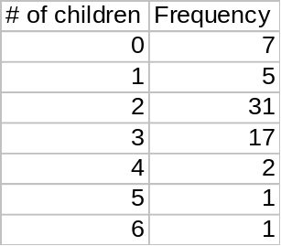

It's quite easy to generate this graph in Excel. First, enter the table as shown above.

To create a bar chart for this data in Excel:

- Click on the Chart Wizard button (the one with the blue, yellow and red vertical bars). Excel will give you a choice of chart types. The first category, column charts, which is what you want, although you can see that many choices are available. (Column charts are what Berensen and Levine (your text) call histograms. Some texts use a broader definition of histogram.) The first chart subtype is highlighted, and this is fine for our purposes. Note that the second choice of chart, the bar chart, can also be used for categorical data.

- Press the Next button.

- Excel will ask you for your data range. Highlight the second column of numbers, from 7 down to 1. (If you mess up, just clear the contents of the data range box and try again.) You should see 7 bars, with labels across the bottom running from 1 to 7. Excel numbered our bars for us, but these aren't the labels that we want for our columns! We'll fix this now.

- Click on the Series tab…it's the little tab sticking up like the tab on a filing cabinet folder. Toward the bottom of the requestor, you'll see a box that says Category (X) axis labels. Click in this box. Now take your mouse and highlight the numbers 0 to 6 in the first column of our data table. If you do it correctly, your graph should now show 7 bars, labelled 0 to 6. If this doesn't happen, clear the box, and try step 4 again.

- Click on the Next button. This will bring up a window where you can enter the name of your chart and the titles for each of your axes. I'll use my column headings as my axes titles, and name my graph Expected Number of Children.

- Click on Finish. If you've done it right, you should have a chart that looks like this:

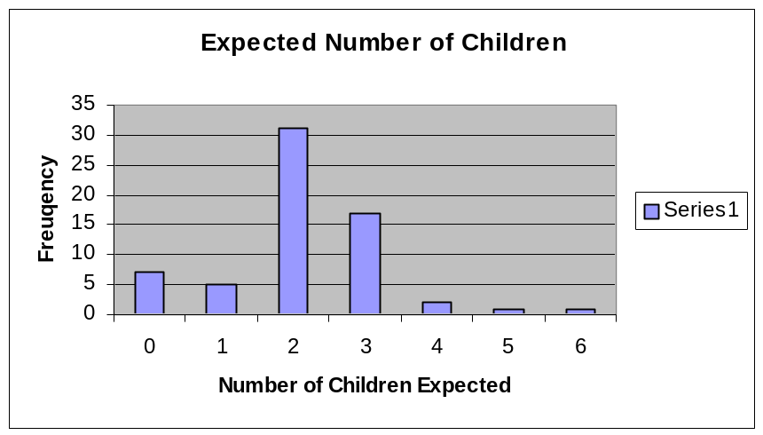

You'll see that we have a rather useless legend, "Series 1", on the right hand side. You could have avoided this by clicking on the Legend tab of the Chart Options screen and clearing the Show Legend checkmark (by clicking on it).

B: Pie Chart

Problem: The 1980 census found that more than half of the people in Massachusetts identified with a single ancestry group. These single ancestry people were divided as shown in the table below. Use a pie chart to display this information, and then explain why a pie-chart may not be an effective presentation choice.

We'll again use Excel to do the work for us, by putting the data into a table and using the Chart Wizard. The work is identical to the Excel work in the problem above, except that we choose Pie Chart from the list of available chart types. Here's the result:
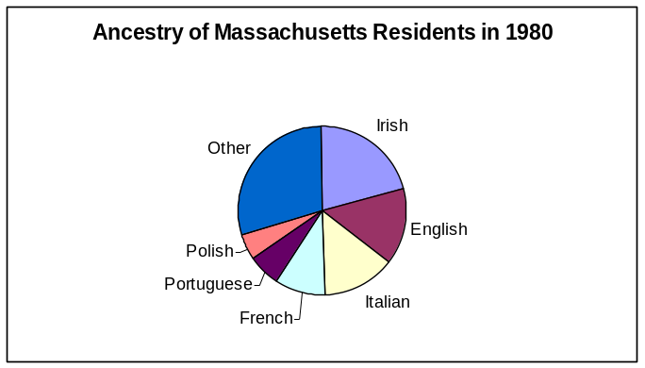

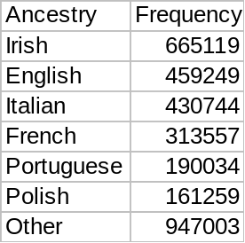

You'll note that my pie chart doesn't include a legend—instead, it has each section of the pie labeled with its corresponding ethnic group. As above, I did this by clicking on the Legend tab of the Chart Options screen and clearing the Show Legend checkmark (by clicking on it). Then I chose the Data Labels tab, and clicked on the Show labels radio button. (Those little circles are called "radio buttons", because they work like the buttons on an old time car radio. When you select one, it "deselects" the others.)

A pie chart may not be the best choice for these data because of the large number of categories. Since charts are intended to make it easier to quickly understand data, this is an obstacle.

Pie Charts by Hand: If you wanted to do this problem without Excel, you would need to use not the frequencies given in the problem, but rather the relative frequencies of each group. These would be obtained by dividing the frequency of each category by the total number of people in all categories. The relative frequencies are shown below.

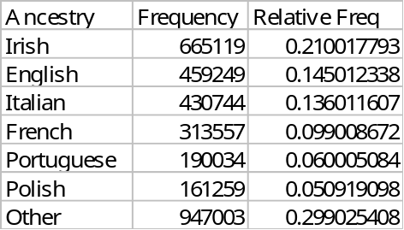

So, for example, the Irish category should be represented by about 21% of the circle. You can get Excel to include the percentages, too, if you want. It's another of the options available under the Data Labels tab.

C: Relative Frequency Bar Chart (Relative Frequency Histogram)

Problem: The table in yellow below records the age of US women who gave birth in 1993. Use it to create a relative frequency bar chart to display these data.

We'll find the relative frequency for each class by dividing the number of women in that class by the total number of women, then graph as in A.

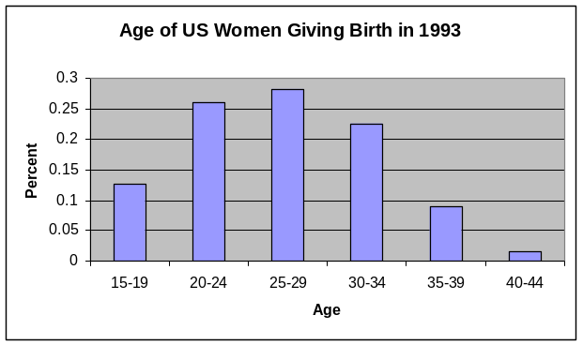

Age | Frequency  (thousands) | Relative  Frequency
15-19 | 501 | 0.1256584
20-24 | 1038 | 0.2603461
25-29 | 1129 | 0.2831703
30-34 | 901 | 0.2259844
35-39 | 357 | 0.089541
40-44 | 61 | 0.0152997

As a check, of course, the relative frequency column should sum to 1 (ignoring roundoff errors.)

Summarizing the chart's important information requires us to decide what is important. Here's one such summary:

About 12.5% of all women giving birth in 1993 were between 15 and 19 years of age. Women from 20 to 34 make up roughly ¾ of all women giving birth, with the middle 25-29 year span being slightly more common than the 20-24 or 30-34 ranges. The oldest mothers, 40-44, made up only 1.5% of the women giving birth in 1993.

Note that the categories here are actually ranges of numeric values. This is actually required for a histogram. Technically, this same kind of chart with categorical labels on the columns is a bar chart. We’ll have a lot more to say about the selection of ranges for a table like this in Topic G: Frequency Distribution.

D. Line Graph (Time Series)

Problem: Below, in yellow, you’ll see the number of foreign and domestic cars sold in the United States in the years 1980 to 1995. Make two time series graphs, one showing total sales (domestic and foreign) and the other showing the foreign percentage of total sales. Do you see any patterns?

Again, we'll put the data into Excel, and compute two extra columns.

Year | Domestic  (millions) | Foreign  (millions) | Total Sales (millions) | % Foreign
1980 | 6.581 | 2.398 | 8.979 | 0.2671
1981 | 6.209 | 2.327 | 8.536 | 0.2726
1982 | 5.759 | 2.224 | 7.983 | 0.2786
1983 | 6.795 | 2.387 | 9.182 | 0.2600
1984 | 7.952 | 2.439 | 10.391 | 0.2347
1985 | 8.205 | 2.838 | 11.043 | 0.2570
1986 | 8.215 | 3.245 | 11.46 | 0.2832
1987 | 7.081 | 3.196 | 10.277 | 0.3110
1988 | 7.526 | 3.004 | 10.53 | 0.2853
1989 | 7.073 | 2.699 | 9.772 | 0.2762
1990 | 6.897 | 2.404 | 9.301 | 0.2585
1991 | 6.137 | 2.038 | 8.175 | 0.2493
1992 | 6.277 | 1.937 | 8.214 | 0.2358
1993 | 6.742 | 1.776 | 8.518 | 0.2085
1994 | 7.255 | 1.735 | 8.99 | 0.1930
1995 | 7.129 | 1.506 | 8.635 | 0.1744

The last column is obtained by dividing the number of foreign cars for a year by the total number of cars for that year. So, for example, 2.398/8.979 = 0.2671. We graph the results just as in A, except that we choose line graph instead of column graph as the chart type.
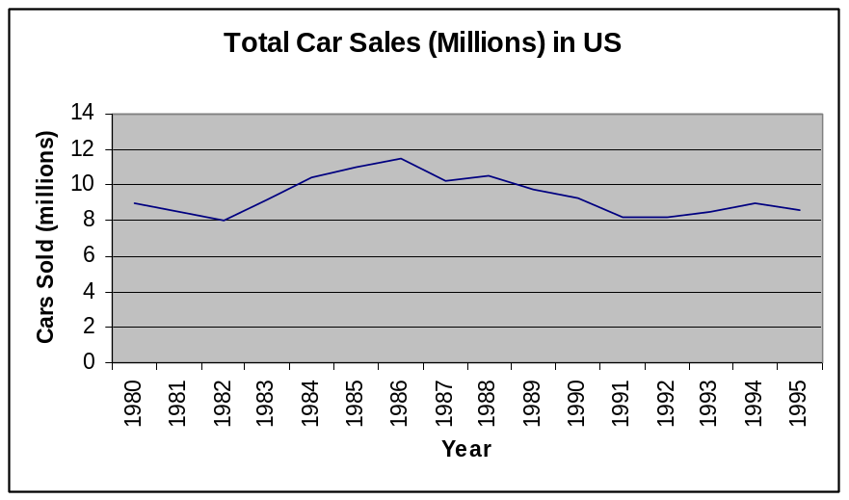

Total sales show no long term pattern. They peaked around 1986, declined until about 1991, and have been more or less stable since then.

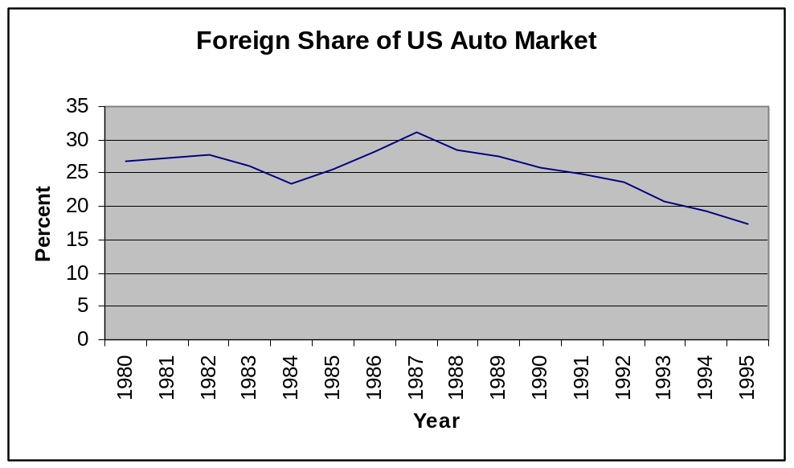

Foreign car sales reached their peak market saturation in 1987, at about 31% of the market. Since then, the foreign market share has been steadily (almost linearly) declining.

Multiple time series on one graph: There are other interesting ways of presenting this information graphically. For example, here's a chart we can get from Excel that shows the domestic and foreign sales together.

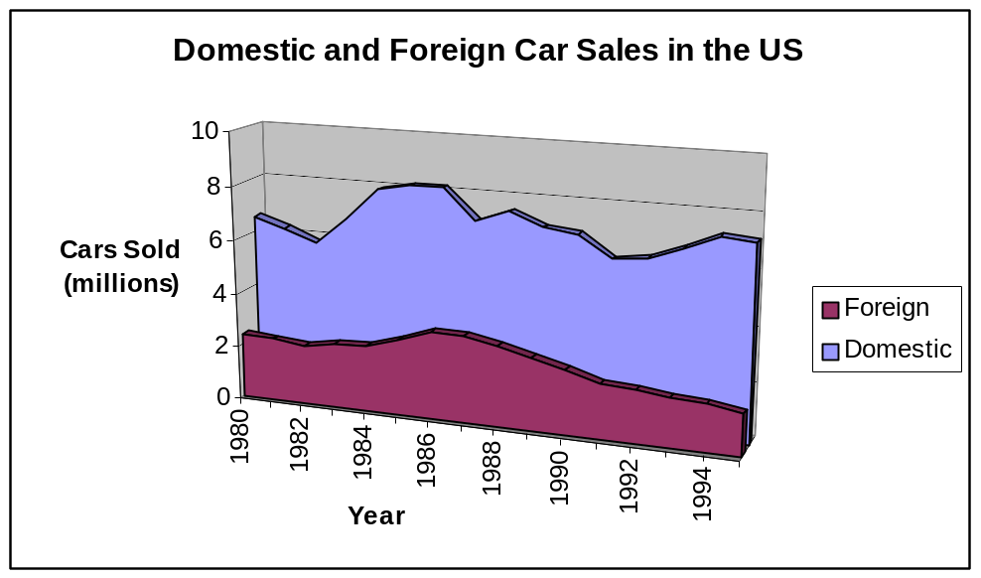

From this we can see that, not only has foreign market share been dropping, but actual number of cars sold is decreasing as well. (The blue area in this graph is the same as the line graph for domestic cars that appears above.) I chose the 3-D presentation since I found it pleasing to the eye—one can do the same thing in a 2-D plot.)

E. Pareto Chart
(Topics A and D are needed to do this without my template.)

Problem: The 1980 census found that more than half of the people in Massachusetts identified with a single ancestry group. These single ancestry people were divided as shown in the table to the right. Use a Pareto chart to display this information.
Ancestry | Frequency
Irish | 665119
English | 459249
Italian | 430744
French | 313557
Portuguese | 190034
Polish | 161259
Other | 947003

Again, there is an easier and a harder way to do this in Excel. The easier way is to use my Pareto Diagram template. Just enter the data into the first two columns (no need to sort it), and it cranks out the diagram. You may want to edit it to remove unneeded categories. Click on the About tab on the spreadsheet to learn how to do this. The result of the template is shown below. (I got rid of the extra categories in the template by clicking on the graph, choosing Source Data, then changing all of the data ranges to refer to rows 4 to 10, rather than rows 4 to 14.)

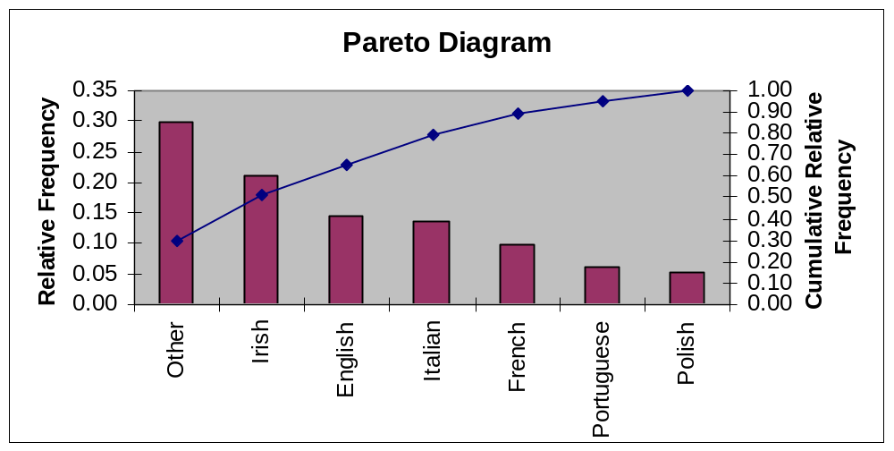

From this we can see, for example that about 50% of all people identifying with a particular ancestral ethnic group were English, Italian, French, Portuguese, or Polish (since about 50% were “other” or “Irish”.)

Pareto charts are especially useful when your categories are at the nominal level of measurement (no natural order), and will not generally be used with interval or ratio data.

The harder way: without the template. We begin by sorting the data in descending order and creating its cumulative relative frequency distribution. (The cumulative relative frequency is just a running total of the relative frequency column. Here, for example, 0.0509 = 0.2990 + 0.2100, then 0.6541 = 0.2990 + 0.2100 + 0.1450, and so on.)

We then create a chart that combines a bar chart (A) with a line graph (D). If you do this yourself, you’ll need to use the Custom tab in the chart wizard, then pick Line-Column or Line-Column on Two Axes as the graph type. As you can see on the next page, for this demonstration I simply chose the Line-Column graph type. The resulting graph has only one vertical scale, which compresses the vertical bars a bit.
Ancestry | Frequency | Relative Freq | Cum Rel Freq
Other | 947003 | 0.2990 | 0.2990
Irish | 665119 | 0.2100 | 0.5090
English | 459249 | 0.1450 | 0.6541
Italian | 430744 | 0.1360 | 0.7901
French | 313557 | 0.0990 | 0.8891
Portuguese | 190034 | 0.0600 | 0.9491
Polish | 161259 | 0.0509 | 1.0000

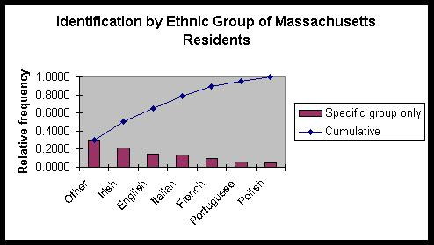

F. Stem and Leaf Plot

Problem: Treasury bond percentage returns are given in the table below, for the years 1971 to 1995. (The data appears in lexicographic [row by row] order.) Make a stem and leaf plot of these data.

13.2 | 5.7 | -1.1 | 4.4 | 9.2
16.8 | -0.7 | -1.2 | -1.2 | -4.0
1.9 | 40.4 | 0.7 | 15.5 | 31.0
24.5 | -2.7 | 9.7 | 18.1 | 6.2
19.3 | 8.1 | 18.2 | -7.8 | 31.7

First, we need to look at the data, and see the range of values appearing. The largest is 40.4; the smallest is –7.8. In doing our stem and leaf charts, let’s make the "stem" everything up through the 10s digit, and the "leaf" the 1s digit, rounded to the nearest integer. I'll shade the stem, to make it stand out. Here's what we get:

Treasury bonds
-0 | 8 | 4 | 3 | 1 | 1 | 1
0 | 1 | 2 | 4 | 6 | 6 | 8 | 9
1 | 0 | 3 | 6 | 7 | 8 | 8 | 9
2 | 5
3 | 1 | 2
4 | 0

So, for example, the 8 in the "-0" row represents "-8", the nearest integer to the –7.8 appearing for T-bonds in 1994. The chart is not a complete reflection of the data table, but it does make clear that t-bonds had a pretty big dispersion—they were a fairly risky investment. On the other hand, the t-bonds show a high maximum rate of return—about 40%.

I created this plot by sorting my data in Excel, creating the stem and leaf plot by hand, and then pasting it here. If you wanted to do a lot of stem and leaf work, you'd probably want to use a program like SPSS, which will create them automatically. Excel doesn’t have nice stem and leaf capability.

Note that, unlike your author, I listed the first row with the "8" closer to the stem than “4”. That's because –08 is smaller than –04, so an "8" in the "-0" row appears closer to the stem than a "4". Whether you do this is a matter of taste.

While it’s common to have the stem on a stem-and-leaf plot be the first (n-1) columns of data whose largest value is n digits long, there are other possibilities. Figure 2.7 in your text shows one, where the numbers starting with a given digit are split into two different rows. One includes all of the numbers with a ones digit of less than 5, the other includes all of the number with a ones digit of 5 or more.

G. Frequency Distribution

Problem: A postman notices that most of his residential deliveries seem to be junk mail and bills. On March 1st, for fun, he decides to keep records for the 35 houses on Blanchard Street, and to record how many delivery days pass before each house receives a piece of mail that appears to be personal correspondence. His results are shown below.

3 | 20 | 3 | 9 | 5
3 | 3 | 11 | 5 | 10
12 | 12 | 3 | 11 | 11
33 | 5 | 22 | 23 | 18
14 | 49 | 3 | 28 | 7
5 | 4 | 5 | 16 | 44
3 | 34 | 36 | 21 | 35

Create a 5 category frequency distribution from these data.

We were told how many categories (“classes”) to use. We need to decide
- how wide should each class be? (the “class width”)
- where should the first class start? (the first “lower class limit”)

The data values run from 3 to 49 days, which is a range of 49 – 3 = 46 days. Since we are supposed to use 5 categories, each category must include at least 46/5 = 9.2 days. Starting a new category every 9.2 days is messy, though. It’s always good to make your class width a little bigger if it gives you a nicer number. Here, we’ll choose 10. With a class width of 10, our categories will cover a range of 5 × 10 = 50, while the data covers a range of only 46, as we have seen. This means that we have 50 – 46 = 4 units of “slack” left over. If you like, imagine putting a rod 46” long in a 50” long box:

46 inch long rod

This slack gives us a bit of flexibility as to where we start the first category. Since the smallest entry in the data is 3, the start point of the first category must be at least 3. We can start earlier, though, if we want. Any start point between -1 (which is 3 – 4) and 3 and still results in categories that include all of the data.

We generally choose a start point (a “lower class limit”) with the intent of making the cutoffs “nice”, if possible. Here, starting the first category at 0 or 1 would be good. If we choose 0, the categories start at 0, 10, 20, 30, and 40. If we choose 1, the categories start at 1, 11, 21, 31, and 41. (If there isn’t a “nice” start point, it’s common to split the “slack” more or less evenly between the first class and the last class. In our example, 1 would be a good choice for this, too.)

Once you know the lower class limit for the first class (say, 1) and the class width (here, 10), you can find the beginning of each class by simple addition: 1 + 10 = 11, 11 + 10 = 21, 21 + 10 = 31, 31 + 10 = 41. Properly, each class ends right before the next begins. This means that the first class would start at 1 and extend up to (but not including) 11. We write this as “1 to 11⁻”, where the little minus sign means “not including”. In our problem, the data is discrete: the postman records how many days until a private letter is received, and this is always a whole number. This means that we could write the first class at “1 to 10” instead of “1 to 11⁻”, since they’d mean exactly the same thing. We can get away, then, with the classes “1 to 10”, “11 to 20”, “21 to 30”, “31 to 40” and “41 to 50”. Note that these classes would not be okay if the data were continuous. If a value like 10.25 were possible, it would fall outside of all of the classes.

Once you’ve set up the classes, all that remains is to count how many observations fall in each class. While this is conceptually simple, it’s tedious with a large data set. It’s better to let Excel do it for you. There is a fast way and a slower way to accomplish this. We’ll look at both.

The Fast Way: Template for Frequency Distribution, Histogram, and Modified Boxplot

Go to my website and choose the Distribution, Histogram, and Box and Whisker Plot template from my Excel templates. It’ll open a window in Excel. Your job is to fill in the required information in the yellow cells. The first column contains the raw data (shown above), and you’ll also need to tell it that you want to start the first class at 1, with a class width of 10. It computes a number of statistics on the top of the page and displays the frequency distribution at the bottom. See next page.

You can “wing it” with this template, trying different values of start point and class width to get a good pair of values. (Try using “8” for class width and “0” for start point, for example. Do you think that this is as good as our original choices?) If you choose values that don’t allow you to graph all of the data, a warning appears (try “7” for class width to see this). The default number of categories shown in this template is 7, but you can increase or decrease the number of categories appearing, if you wish. Click on the About tab on the sheet to see directions on how to do this.

The Slower Way: Excel’s Histogram Function

Excel has a built in histogram function, but it is inconvenient to us in three ways.

- Excel has you identify the ranges for each category by specifying the largest value that is included in a category. When we’re working with continuous data, our categories (like 10 to 20⁻) do not include their upper limit. If you’re going to use the built-in Excel histogram, then, you have to lower the limits slightly (like using 19.99 instead of 20).

- When Excel prints the frequency table (by using its histogram function), that table is no longer linked to the data. This means that even if you correct an error in your data, the frequency table will not change in response. You’d have to create a new table.

- When Excel prints its table (by using the histogram function), it specifies its upper limit of each category. If you’re doing a nice histogram, this isn’t the label you really want associated with that histogram.

Let me show you what I mean with all of this, by putting the data above into a single column in an Excel sheet. On a separate part of the sheet, I must specify my bin range—that is, the upper (Excel) limit of each of my categories. Then I choose Data Analysis from the Tools menu, and select Histogram. I tell Excel where the data is and where the bin range is, and let it go. For the sake of completeness, I’ll check the box that asks Excel to make a graph. The results of all of this appear on the next page.

3 |  | mean, x-bar | 15.02857143 | =AVERAGE(range)
3 |  | smallest entry | 3 | =MIN(range)
12 |  | largest entry | 49 | =MAX(range)
33 |  | number of observations | 35 | =COUNT(range)
14
5 |  | median | 11 | =MEDIAN(range)
3 |  | 1st quartile | 5 | =QUARTILE(range, 1)
20 |  | 3rd quartile | 21.5 | =QUARTILE(range, 3)
3 |  | IQR | 16.5 | = 3rd quartile - 1st quartile
12 |  | lower whisker | 3 | = 1st quartile - 1.5 * IQR or smallest val
5 |  | upper whisker | 46.25 | = 3rd quartile + 1.5 * IQR or largest val
49 | outlier
4
34
3 |  | Frequency Table for Histogram
11 |  | suggested # of cats | 5
3 |  | category size | 10
22 |  | At least… | …but less than… | frequency
3 |  | 1 | 11 | 16
5 |  | 11 | 21 | 9
36 |  | 21 | 31 | 4
9 |  | 31 | 41 | 4
5 |  | 41 | 51 | 2
11 |  | 51 | 61 | 0
23 |  | 61 | 71 | 0
28 |  | 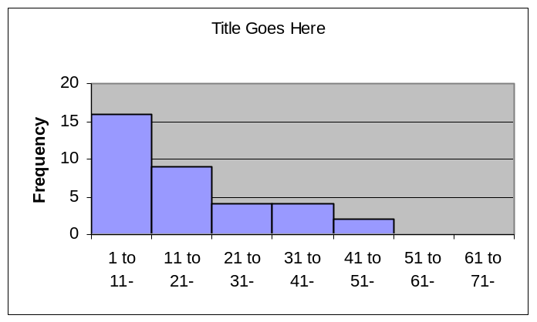
16
21
5
10
11
18
7
44
35

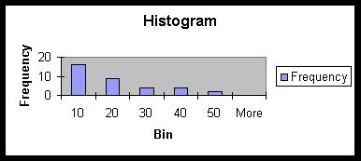
3 |  | upper limits
3 |  | 10
12 |  | 20
33 |  | 30
14 |  | 40
5 |  | 50
3
20 |  | Bin | Frequency
3 |  | 10 | 16
12 |  | 20 | 9
5 |  | 30 | 4
49 |  | 40 | 4
4 |  | 50 | 2
34 |  | More | 0
3
11
3
22
3
5
36
9
5
11
23
28
16
21
5
10
11
18
7
44
35
Well, the histogram above isn’t dreadful, but it needs some work. It would be much better to label the categories 1 to 10, 11 to 20, and so on. The “more” category can be eliminated entirely, as can the useless legend. The horizontal axis should be labeled with something more informative than “bin”, and the chart should be titled with something more informative than “histogram”. You can do all of these things, as described in A: Bar Chart (Histogram).

Note that in this particular example, I could use an upper limit of 10 (rather than, say, 10.99) for my first category, since my data was discrete. Values bigger than 10 had to be 11 or more.

Once the data is compiled into a frequency distribution, it’s easy to create cumulative frequency distributions, relative frequency distributions, and cumulative relative frequency distributions. And once you have these, you can graph any of these things. All of these topics have sections in the Demonstrations.
H. Cumulative Frequency Distributions, Relative Cumulative Frequency Distributions, Frequency Polygons, and Ogives

(Uses Topics C, G and J.)

Problem: The table below shows (in yellow) the frequency distribution of lightbulb lifetimes (in hours) for two 40 bulb samples, one from Manufacturer A and one from Manufacturer B. Create cumulative frequency distributions, relative frequency distributions, and relative cumulative frequency distributions for each sample. Use these to create the frequency polygon graph and ogive. Discuss.

Lifetime  (hours) from | to | Manu. A frequency | Manu. B frequency
600 | 675 | 0 | 0
675 | 750 | 3 | 0
750 | 825 | 2 | 1
825 | 900 | 12 | 3
900 | 975 | 14 | 9
975 | 1050 | 6 | 13
1050 | 1125 | 3 | 9
1125 | 1200 | 0 | 4
1200 | 1275 | 0 | 1
1275 | 1350 | 0 | 0

You’ll note that I’ve included two extra rows in the table above—one “before the beginning” and one “after the end”. Ignore them for now—we’ll see why we need them, later.

The Easy Way: I’ve created a template to do this, too. See the Common Frequency Polygons and Ogives sheet on the website. Note that my graphs are of the “<” type. (See below.) Note that, since the data above is already collected into a frequency distribution, I’d need to manually type those frequencies in Columm F of my template. The template does not superimpose two graphs. If you want to do that, see ***.

The Harder Way: The cumulative distribution is obtained from the frequency distribution simply by keeping a running total of the frequency column in the frequency distribution. The relative frequency distribution is obtained (see C) by dividing each frequency in the frequency distribution by the total number of observations represented in the frequency column. In this problem, both frequency columns (Manu. A and Manu. B) have a total of 40 observations, so we divide the observed frequencies by 40 to get the relative frequencies. Finally, the cumulative relative frequency is obtained by keeping a running total of the relative frequency column. Let’s do all of that here.

 |  | Manufacturer A |  |  |  | Manufacturer B
Lifetime  (hours) from | to | freq | cum freq | rel freq | cum rel freq | freq | cum freq | rel freq | cum rel freq
600 | 675 | 0 | 0 | 0 | 0 | 0 | 0 | 0 | 0
675 | 750 | 3 | 3 | 0.075 | 0.075 | 0 | 0 | 0 | 0
750 | 825 | 2 | 5 | 0.05 | 0.125 | 1 | 1 | 0.025 | 0.025
825 | 900 | 12 | 17 | 0.3 | 0.425 | 3 | 4 | 0.075 | 0.1
900 | 975 | 14 | 31 | 0.35 | 0.775 | 9 | 13 | 0.225 | 0.325
975 | 1050 | 6 | 37 | 0.15 | 0.925 | 13 | 26 | 0.325 | 0.65
1050 | 1125 | 3 | 40 | 0.075 | 1 | 9 | 35 | 0.225 | 0.875
1125 | 1200 | 0 | 40 | 0 | 1 | 4 | 39 | 0.1 | 0.975
1200 | 1275 | 0 | 40 | 0 | 1 | 1 | 40 | 0.025 | 1
1275 | 1350 | 0 | 40 | 0 | 1 | 0 | 40 | 0 | 1

The “cum” column must total to the total number of observations in the sample. The “cum rel freq” column must have 1 as its last entry. Be sure you see why. Note that the easiest way to obtain the “cum freq” column in Excel is to say: the first entry in the “cum freq” is the same as the first entry in the “freq” column. Thereafter, each “cum freq” entry is the “cum freq” entry above it, plus the “freq” value in its row. Thus, for example, the “cum freq” value of 17 for Manufacturer A was obtained by 5 + 12. A completely parallel process gives you the “cum rel freq” column from the “rel freq column”.

We are now supposed to use this data to create frequency polygons and ogives. The presentation will be more useful if the graphs for A and B are both plotted on the chart. We do that here. (For more on plotting multiple data sets in the same chart, see J.)

Ogives Ogives are line graphs that record the fraction of all observation that are less than or equal to a set of cutoffs, and so their values are plotted from the “cum rel freq” column. Here’s an example. We see that, by the time we finish with the 750 to 825 category, 12.5% of the bulbs in the sample from Manufacturer A have been counted—12.5% of the bulbs in this sample lasted less than 825 hours. The ogive should use the line graph option, with upper class limit giving the values on the horizontal axis, and the relative cumulative frequency distribution on the vertical. You’ll probably need to clean up the resulting chart—for example, the vertical axis should run from 0 to 1, or 0% to 100%. On the next page, you’ll see the ogives for our data. Note that the “empty” categories on the beginning and end of our data table made our ogives start at 0 and extend to 1 on the vertical axis, as they should.

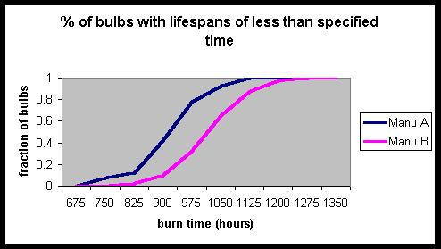
So, for example, we can see that no bulb had a burn time of less than 675 hours, and that half of the bulbs in sample A burnt out by about 900 hours.

Relative Frequency Polygon To create the relative frequency polygon, we proceed as with ogives, but this time plot the relative frequency on the vertical axis. There is one other difference as well. Our categories should not be labeled with the upper class limits, since our values represent the fraction of all observations which fall within the given category. The horizontal axis may be labeled either with the complete category range, or with the midpoint of the category range. Thus, in our graph, the first value could be labeled either “600 to 675⁻“ or “637.5”. Your book prefers the midpoint approach, and my template uses that as well. Here’s the result for our data.

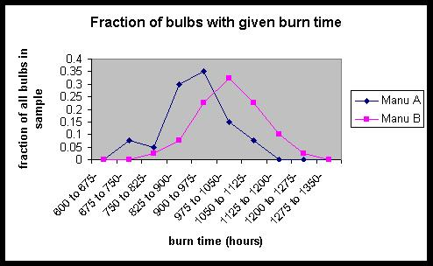

Again, we see that the bulbs from Manufacturer B generally show longer burn times. Note that the “empty rows” in the data table were necessary to make the two ends of the relative frequency polygon touch the horizontal axis, as they should.

There is a nice relationship between the percentage polygon and the relative frequency histogram. For each bar in the histogram, draw a dot on the middle of its top edge. Connect the dots, and you have the relative frequency polygon!

Relative frequency polygons are sometimes called “probability polygons”.

I: Contingency Tables

Problem: 13% of the female American population is black. If one American woman in 800 tests HIV positive and 53% of all female American HIV carriers are black, what is the probability that a nonblack American woman test HIV positive? To simplify your work, assume that there are 10,000,000 American women.

We can do a problem like this one without assuming 10,000,000 women to begin. Nonetheless, let's do the problem as instructed. Here are the numbers.

 | black | nonblack | total
HIV | 6625 | 5875 | 12500
no HIV | 1293375 | 8694125 | 9987500
total | 1300000 | 8700000 | 10,000,000
So the chance that a nonblack woman has HIV
is 5875/8,700,000, or |  | 0.000675
This is about 1 in 1500.

The funky color-coding is so that I can walk through the logic with you. We begin by building the frame for the problem, writing the headings, and recording the fact that there are a total of 10,000,000 women under consideration (pink square). Next, 13% of these women are black (orange square = .13 * pink). The rest of these women are nonblack (yellow square = pink – orange).

Now 1/800 of all women have HIV (green square = 1/800 × pink), and the rest of the women do not have HIV (sky blue square = pink – green). We've now filled out everything in the "total" rows and columns. We need one more number. We're told that 53% of all female American HIV carriers are black. Remembering that "of all" means "times", we find the number of black HIV carriers by (.53 × total HIV). (Dark blue square = 0.53 × green).

The rest is easy. The rest of the HIV carriers must be nonblack (purple = green – dark blue). Similarly, the rest of the blacks must be HIV negative (red = orange – dark blue). This finally leads to the final, white cell—nonblack women who do not carry HIV. It can be obtained either of two ways. (white =
sky blue – red, or white = yellow – purple) The table is now complete.

So what is the problem asking for? We want to know the probability that a nonblack woman is HIV positive. Well, the number of nonblack women is in the yellow cell. The number of these women with HIV is in the purple cell. So the answer to the question is purple/yellow = 5875/8700000, or about 0.0675%.

Why did we divide by yellow, and not by green? The green total is the total number of HIV victims. Black HIV victims divided by total HIV victims would tell us the fraction of HIV victims that are black (53%). This isn't what we want.

This kind of contingency table work is wonderfully easy in a spreadsheet. It's also quite important for other work. For much more on them, see Writeup on Probability and Expected Value at my website.

J. MultipleGraphs on One Chart

Problem: The table shown in yellow below gives the number of households (in millions) that consisted of a one person, two people, and so on in the years 1890 and 1990. Construct a relative frequency bar chart for this data. Do not include the “7 or more category” on your chart. You should have separate bars for the two data sets. Interpret your results.

Size of household | 1890 | Rel. Freq. | 1990 | Rel. Freq.
1 | 0.457 | 0.036013 | 23 | 0.245203
2 | 1.675 | 0.131994 | 30.2 | 0.321962
3 | 2.119 | 0.166982 | 16.1 | 0.171642
4 | 2.132 | 0.168006 | 14.6 | 0.15565
5 | 1.916 | 0.150985 | 6.2 | 0.066098
6 | 1.472 | 0.115997 | 2.2 | 0.023454
7 or more | 2.919 | 0.230024 | 1.5 | 0.015991
 |  | 1 |  | 1

First, I added columns for the relative frequencies (see C). Note that, as always, the relative frequencies add to 1. Now the bar charts. Highlight all of the data that you want in your graph, then click on the Chart Wizard button. The two columns that we want are the two relative frequency columns, and they are not adjacent.

To select nonadjacent cells in Excel, hold down the control key while you select the cells you want.

So in this case, select the first 6 numbers in the first relative frequency column, hold down the control key, and select the first 6 numbers in the second relative frequency column. If you've done this, you should see all 12 cells highlighted. Now, click the Chart Wizard button and proceed as in A. Note that, since there are two series, you can click on the Series tab in the Chart Wizard and enter information about each individual series. (Click on the series you want to work with in the Series box, then enter it's name in the Name box. I did that here, calling my series "1890" and "1990". These appear in my legend.)

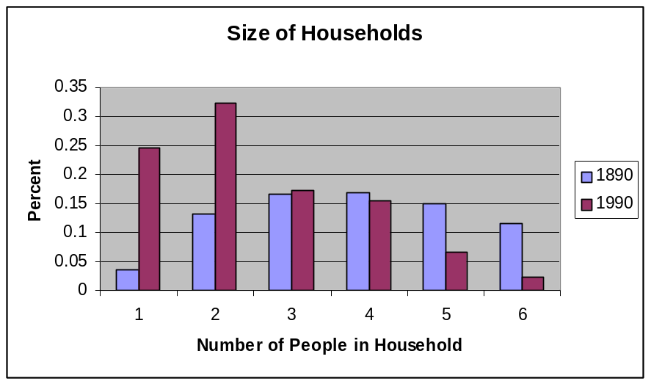

The chart shows that smaller households are much more common in 1990 than in 1890. People living alone or in couples constitute over half of all households, as opposed to making up only about 17% of households in 1890. The relative frequency of 3 and 4 person households, interestingly, is about the same in both time periods.

K. Scatter Plot

Problem: The table shown in yellow below shows the return (in percent) on treasury bills for the period from 1971 to 1994. Make a scatter plot with T bill return in the current year on the horizontal axis and T bill return next year on the vertical axis. Essentially, we’re creating a graph that will allow us to examine the question of whether T-bill returns for one year are a good predictor of T-bill returns for the following year. Analyze the resulting graph.

We'll enter the data into Excel:

Note that we created an additional column to the given data—the additional column is simply the t-bill return rate, shifted by one year. So, for example, in 1971, the return rate was 4.4%, and for the following year, it was 3.8%.
Year | T bills this year | T bills next year
1971 | 4.4 | 3.8
1972 | 3.8 | 6.9
1973 | 6.9 | 8
1974 | 8 | 5.8
1975 | 5.8 | 5.1
1976 | 5.1 | 5.1
1977 | 5.1 | 7.3
1978 | 7.3 | 10.4
1979 | 10.4 | 11.2
1980 | 11.2 | 14.7
1981 | 14.7 | 10.5
1982 | 10.5 | 8.8
1983 | 8.8 | 9.9
1984 | 9.9 | 7.7
1985 | 7.7 | 6.2
1986 | 6.2 | 5.5
1987 | 5.5 | 6.4
1988 | 6.4 | 8.4
1989 | 8.4 | 7.8
1990 | 7.8 | 5.6
1991 | 5.6 | 3.5
1992 | 3.5 | 2.9
1993 | 2.9 | 3.9
1994 | 3.9 | 5.6

Plotting these two columns by using the scatter chart type, we get the chart below. (Note that, by convention, we always put our explanatory variable on the x-axis.)

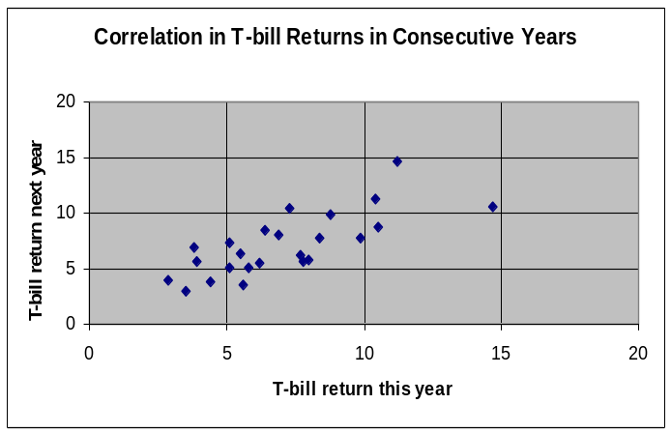

The resulting chart shows a positive relationship, as indicated by the general upward trend of the data points. Interpretation: Years of low return tend to be followed by years of low return, while years of high return tend to be followed by years of high return. We'll see later how we can use such a diagram to predict returns for successive years. Assuming that these data represent a random sample drawn from data that "belongs" on a straight line, our techniques will give us the formula NR = 0.7397R + 1.8916, where R is the return this year, and NR is the expected return next year. So, for example, if the return is 10% this year,
our best guess for next year would be a return of 0.7397(10) + 1.8916, or about 9.3%.

The computation needed to obtaining this equation is beyond us for now. We can certainly see, though, that the graph carries the message that trends (good or bad) tend to continue from year to year. If you want Excel to show the trendline, you can do it like this:

Scatter Plots and Trendlines in Excel

- Highlight all of the (numerical) data, then click Chart Wizard.

- Choose scatter as chart type. Follow the normal process to get appropriate axis labels, etc. (See A for details.) You'll need to adjust the x-axis scale to make it run from 1500 to 2200. See F for details on how to do this.)

- Once your scatter plot is graphed, point your cursor to one of the points in the graph. Right click on the point. All of the data points should become highlighted, and a menu should appear.

- Left click on add trendline, and choose linear from the menu that appears.

L. Examples of Analyzing Graphs

Problem: The graph below shows the number of US motor vehicle deaths per 100,000 miles driven for the time period from 1960 to 1994. Here are some possibly relevant facts. In 1974, Congress passed a law making the national speed limit 55 miles per hour. As time passed, motorists disregarded this limit, and in 1987, the speed limit on the interstates system was increased to 65 miles per hour. What can you make of the information given?

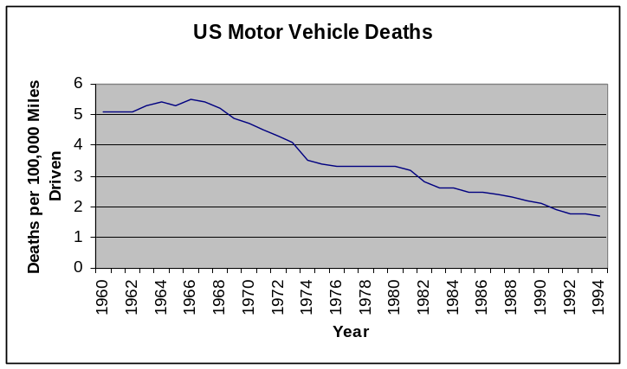
I'll spare you the data table this time—it's a bit long. The Excel (line) graph is shown to the right.

The behavior in 1974 and the years following certainly shows a drop in 1974 itself, followed by a plateau that lasts until 1981. If one fits a straight line to the date from 1966 to 1994 (as was described in K), one gets the chart below.

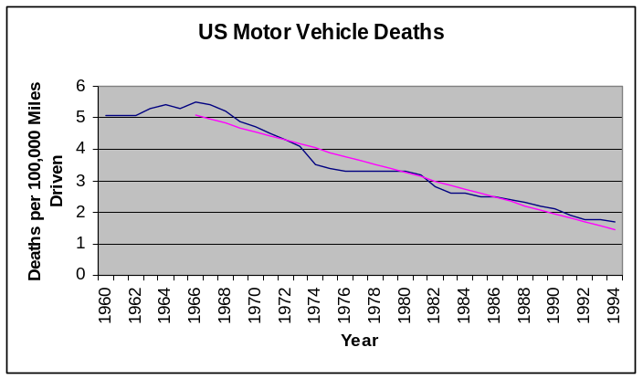
The suggestion is that fatalities per mile are declining steadily, but that the 1974 speed limit reduction resulted in a significant reduction in fatalities per mile. In the subsequent years, as people increasingly ignored the limit, the underlying trend of steady decrease was almost perfectly balanced by increasing fatalities from higher speeds. This explanation suggests that by about 1980, people were ignoring the speed limit, or at least treating it as a higher one. The 1987 law's affect on fatalities per mile seems to be minimal.

This attractive explanation fits the observations, but is by no means proven by them. More evidence would be needed before we could conclude that this was what "really happened". We'd need, for example, to learn the distribution of driving speeds over the years in question, and also to gain an understanding of why the observed steady decrease in fatalities per mile is occurring. (It may, for example, have to do with increasing commuting distance over well-maintained highways, improved medical care for accident victims, or safer automobile construction standards.)

Problem: Modern day British women experience a pronounced loss of bone density as they grow older. During the restoration of a London church in the 1990s, a crypt was opened that contained the skeletons of more than 100 persons buried between 1729 and 1852. A scatter plot of the female skeletons from this sample (who died between 15 and 45 years of age) shows virtually no relationship between age at death and bone density. Discuss this result.

The data points are scattered, apparently randomly, with no evident positive or negative relationship. Conclusion: we see no evidence of decreasing bone density with increasing age in the excavated skeletons.

When drawing conclusions, as we'll see later in the course, we'll need to be careful to control for other factors that could explain the results. Here are a couple of thoughts here:

- These skeletons were taken from a church crypt. Only the upper class is generally buried in the church itself. These people probably therefore had a more nutritious diet than the common folk. Their behavior pattern could be dramatically different as well.

- The age ranges examined were from 15 to 45 years of age. At what point does osteoporosis set in in modern British women? 45 may have been a ripe old age 250 years ago, but it is not considered so today.

- All of the skeletons examined had something obvious in common—they were of dead people. Why does this matter? Well, suppose average female lifespan was 35. Then the young skeletons observed might have tended to be sickly, and had lower bone density than the general populous. The older skeletons may have lived to a ripe old age, suggesting good general health. Such people might be expected to have higher than usual bone density. In other words, these women may not be representative of the bone densities of their age groups, even for their time.

- We are actually interested in how a particular woman's bone density changes over time—does it decrease? The data that we have gives us 1 data point for each woman. If the natural variation in bone density among women is significantly greater than the change in bone density due to aging, the decrease in density with age could be masked.

As an example to clarify this point, imagine that I have a stack of 50 identical books, and I remove 1 page from the top book, 2 pages from the second, and so on. You'd easily be able to detect that someone had removed pages, and that the further down the stack, the more pages were removed. You're essentially getting 50 observations of the "same book".

But now suppose that we have a stack of 50 different books—some with 100 pages, some with 260, some with 500, and so on. I now remove pages as before—1 from the top book, 2 from the second, and so on. When I'm done, I show you this stack. Now you're going to have much more trouble identifying my page ripping behavior. Does a book toward the bottom look skinny because it's had a lot of pages removed, or because it was a skinny book to begin with?

Problem: Below you’ll see a bar graph of the age distribution of German Jews in the years 1928 and 1959. Also shown is the distribution one would expect from the “stationary model”, in which the total population is neither expanding nor contracting. Discuss the graph.

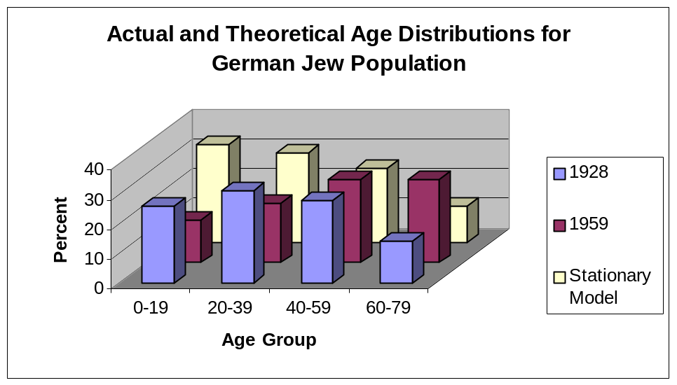

I’ve presented the data as a 3-D multiple bar graph, since I can now compare either the distribution for a single year (color group), or for one age cohort (age range). (To get the angle that I got here, I chose the 3-D column chart subtype, then finished my graph. When I was done, I right clicked on the floor of the 3-D graph, chose 3-D view, and clicked the box next to right angle axes.)

Conclusions: The population in 1928 was comparable to what is predicted by the stationary model, although there were slightly fewer young people than the model predicts. In the post-war year of 1959, the distribution is shifted radically toward the older age cohorts, with young people comprising less than half of the population proportion predicted by the stationary model.

In and of itself, statistics can never answer the question "Why?". The data is consistent with the idea that children and young adults were slaughtered in WW II. It is also consistent with the hypothesis that many German Jews emigrated from Germany between 1928 and 1959. It is even consistent with the hypothesis that German Jews reduced both their birth and death rates during the 1928-1959 period, so that people moved into older age groups and remained part of the population, while fewer new children were added to the population. It's also consistent with a massive influx of older Jews into Germany between 1928 and 1959. As usual, we need more data to explore these hypotheses.

Moral: A graph can support or contradict a theory, but it will almost never “prove” the theory. Be careful in the conclusions that you draw!

M. Chart Errors and Chart Junk

Problem: (Including 0 on the vertical axis.) The table below shows the highest monthly mean level of the water in Lake Michigan. For example, in the years from 1860 to 1870, the highest monthly mean level of the Lake was 583.3 feet. Create time series graphs for this data, using a vertical axis of 0 to 600. Create another whose vertical axis runs from 579 to 584. Comment on the results.

I'll again used Excel for the gruntwork. Simply asking Excel for the line graph (as done in D) gives us the result below. We’ll modify this.
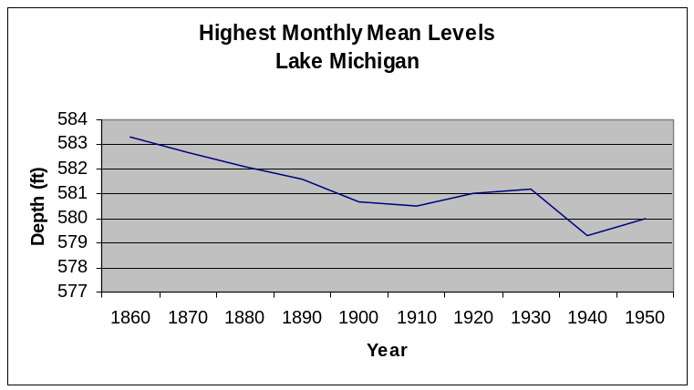
Year | Highest Monthly  Mean Level
1860 | 583.3
1870 | 582.7
1880 | 582.1
1890 | 581.6
1900 | 580.7
1910 | 580.5
1920 | 581
1930 | 581.2
1940 | 579.3
1950 | 580

We'll need to modify what Excel gives us to satisfy the requirements of the problem. As you can see, the vertical axis doesn't have the required range.

Changing the scale on a graph axis: To change this, right-click on one of the numbers on the vertical axis, like 577. This will open a menu. Choose format axis from this menu. Click on the tab that says Scale. You'll see that everything is checked for "automatic". We're going to change this. Click on the first two checkmarks (for "minimum" and "maximum") to clear the "auto" option. Now fill the "minimum" box with 0 and the "maximum" box with 600. The graph you get appears below.
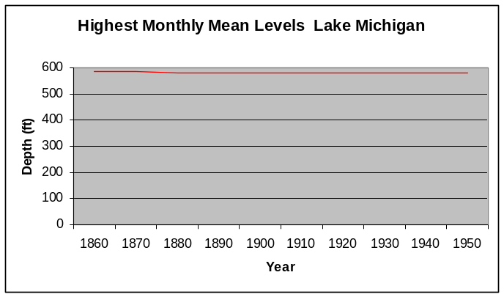
The graph is a nearly horizontal line, just below 600 feet. (I clicked on the line and chose format data series to change its color to red. I wanted to be sure you could see it.) The message: the depth of the lake hardly changes at all.

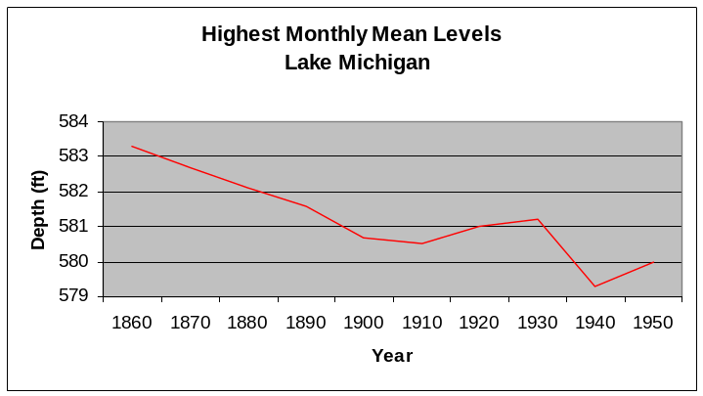
Now let’s click again on the vertical axis, and again change the scale. This time, you should change the "minimum" box to 579 and the "maximum" box to 584. Here's what it looks like now:

Wow! Lake levels are plummeting!

So which is right?

Well, it depends on what you're trying to say. Certainly the amount that the lake has dropped is nothing compared to its total mean depth—a few feet in 600. So if you're worried about, say, how much drinking water there is in Lake Michigan, then the first graph shows you that you have nothing to worry about. But…

This graph is of the mean depth. While a few feet of difference makes little difference over most of the lake, it could be highly significant near the shore. Depth of shipping passages, location of lakefront property, and conservation of existing wetlands are only three examples that come to mind. If we're interested in these issues, the second graph is more informative than the first.

Chart Junk (continued)

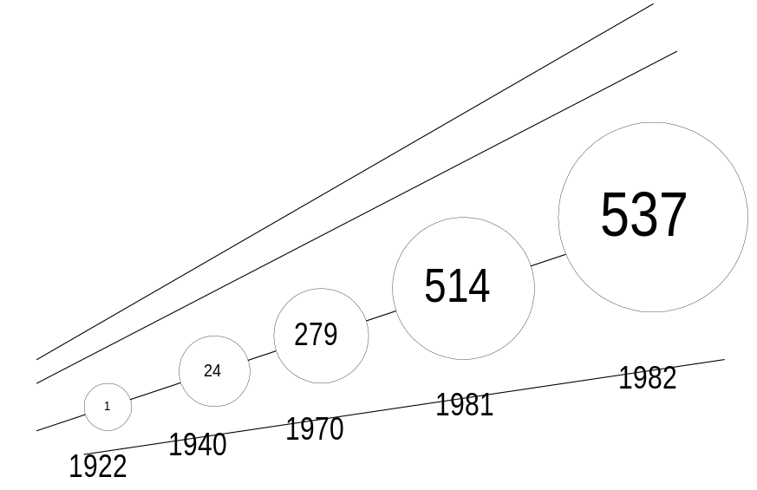
Problem: Here’s a graph from Pravda in 1982. What’s wrong with it?

The first observation is that there's no indication of what the graph represents, nor of the units in which the effect is measured. I'm willing to grant Pravda the benefit of the doubt, and assume that this information was supplied in the original article. What else is wrong?

First, the benchmark dates used are not equally separated in time…18 years separate the first two, then 30 years, then 11 years, then only 1 year. Second, the circles are meant to communicate the relative size of the effect in different years, so their areas should be proportional to those values. If the little circle is taken as having an area of 1 unit, then the last circle should have an area of 537 units. In the scale used above, this circle would be about 5" in diameter—wider than the entire graph! If we judged the number that belonged in the largest circle by comparing its area with the smallest circle, we'd guess a value of about 22 units, not 537.

A better representation of these data would be from the line graph, on the next page.

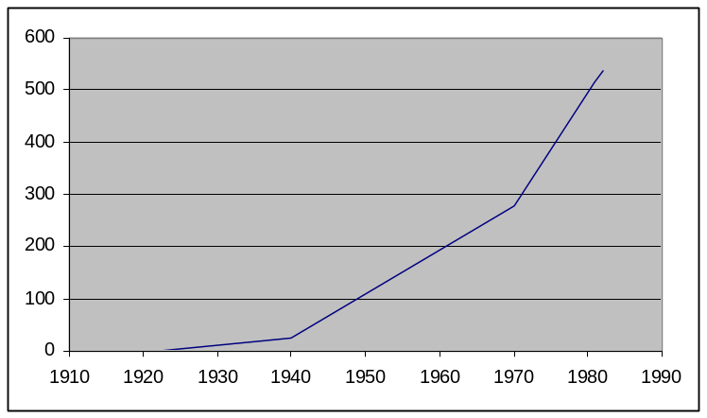
It's rather ironic that this chart conveys a more impressive rate of growth than Pravda's original flawed one. (By the way, I had to use the scatter chart chart type in Excel to do this, since I have observations for unequally spaced years. See K, above.)

Unless otherwise noted, all demonstrations are based on problems given in Introduction to Statistical Reasoning by Gary Smith, McGraw Hill, 1998. The solutions are my own. -- Scott Stevens
Based on a problem from Berensen and Levine, Basic Business Statistics, 7th Edition, Prentice-Hall, 1999.
People also use ogives for “less than” the cut-off, rather than “less than or equal to”. While it generally makes only a small difference with large data sets and continuous data, you should always be sure that you know which kind of ogive you’re dealing with. In our current example, which type of ogive we end up with depends on exactly what the source data means. If a light bulb that lasts exactly 675 hours is counted in the first class, then we’re doing “<” graphs. If a 675 hour light bulb is counted in the second class, our graphs are of the “<” type. Does this make sense to you?

