Demonstrations III
Dr. Scott Stevens

- The Binomial Distribution
- The Standard Normal Distribution, or How to Handle z-scores
- Arbitrary Normal Distributions and z-scores (or, Samples of Size 1)
- Sampling from a Known Normal Distribution (or, Samples of Size of More than 1)
- Additional Useful Excel Functions: NORMSINV, NORMDIST, NORMINV, STANDARDIZE
- Sampling: Proportion problems and the Normal Approximation to the Binomial
- Errors in Experimental Design and Interpretation

- The Binomial Distribution

Problem: After an Iraqi missile hit the U.S. frigate Stark, , novelist Tom Clancy wrote that

It’s quite possible that the Stark’s radar did not see the weapons separate from the launching aircraft. I have seen radar miss an aircraft carrier sitting in plain view on the horizon. The same radar will “paint” the blip nine times out of 10, but the laws of statistics mean that occasionally it will miss on two or three consecutive passes.

Assuming that the binomial model applies with p = 0.1, what is the probability of 2 or more misses in 3 trials?

The binomial model assumes that each trial is independent from the others with a fixed probability of success. In this problem, that means that each radar sweep has the same base chance of detecting a ship, and that the success or failure of one sweep has no effect on the likelihood of success on another sweep. Assuming these things, we can obtain the answer in two different ways.

First: by hand

The formula for the binomial model is P(X = x) = $\left(\begin{matrix}n \\ x\end{matrix}\right)$p^{x} (1-p)^{n –x}. The logic of this is: we’re trying to find the chance of exactly x successes in n trials. If we said that all of the successes had to happen first, then all of the failures, the probability would be p for each of the x successes and (1-p) for each of the n – x failures. Since the events are independent, the chance that all of them happen (first, x successes, and n – x failures after that) would be p^{x} (1-p)^{n –x}, by the multiplication rule for independent events. But that’s the chance of the x successes all happening first. In fact, the x successes could be scattered anywhere among the n trials. The number of different ways to pick the x “success slots” out of the n available “trial slots” is symbolized as C(n, x), or as $\left(\begin{matrix}n \\ x\end{matrix}\right)$. Mathematically, $\left(\begin{matrix}n \\ x\end{matrix}\right)$ = $\frac{n!}{x!(n−x)!}$.

n!, of course, is “n factorial”, which means 1 × 2 × 3 × …× (n-1) × n. So 4! = 1 × 2 × 3 × 4 = 24. (The one tricky one is 0!, which is 1, by definition.)

Okay, with all of that in mind, let’s do the problem. In this problem, p = 0.1, n = 3, and
x = 2 or 3. Because we have two different values of x which are of interest, we need to apply the book's formula twice—once with x = 2, and once with x = 3. (The formula only tells you the chance of exactly x successes.) In this problem, since we’re counting misses, a miss is a “success”.

P( 2 misses) = C(3,2) × .1² × .9¹ = 3! × .01 × .9 = 3 × .01 × .9 = .027
2! 1!

P (3 misses) = C(3,3) × .1³ × .9⁰ = 3! × .001 × 1 = 1 × .001 × 1 = .001
3! 0!

So, in three sweeps, the chance of 2 misses is 2.7%, and the chance of 3 misses is 0.1%. This means the probability of two or three misses is 2.7% + 0.1% = 2.8%.

This calculation highlights a number of important points.

- The number $\left(\begin{matrix}n \\ x\end{matrix}\right)$, read "n choose x", is also written C(n,x). (It's easier to type.)
- The calculation of C(n,x) uses factorials. Remember that, by definition, 0! = 1.
- The binomial model talks about "successes", but a success is merely whatever it is that you are looking for. In this problem, not seeing the ship was counted as a "success". (Incidentally, we would have gotten the same answer if we had call detecting the ship a success, said that p = 0.9 (90% success rate), and asked for the probability of at most one success.)

- Remember that any positive number to the zeroth power is 1.

- The binomial formula gives the probability of exactly x successes. If you want to know the probability of, say, between 8 and 11 successes, you need to find the probability of 8, 9, 10, and 11 successes, then add them together.

- The last point made is a special case of a general probability law. If you want to know the probability that A or B or …or L occurs, you can just find the individual probabilities of A, B, …L and add up all of these probabilities. You can do this so long as it is impossible for more than one of A, B, …L to occur in the same experiment. In that case, A, B, …L are called mutually exclusive events, since they "mutually exclude" one another.

If I flip one coin, then flipping a head and flipping a tail are mutually exclusive. If I flip two coins, like a penny and a nickel, then flipping a head on the penny and flipping a tail on the nickel are not mutually exclusive. That's why I can say for sure that a single coin flip is certain to give me a head or a tail (0.5 + 0.5 = 1), but I can't say that my double coin flip is guaranteed to get me either a head on the penny or a tail on the nickel.

The second approach to solving the problem: Using Excel.

Excel has a built-in function, BINOMDIST, which is very useful for binomial problems.

Working with binomial probability distributions in Excel

The function BINOMDIST in Excel can be used to solve most binomial distribution problems. It has two forms.

To find the probability of exactly x successes in n trials, with a probability p of success on each trial:

= BINOMDIST(x, n, p, FALSE)

To find the probability of x successes or less in n trials, with a probability p of success on each trial:

=BINOMDIST(x, n, p, TRUE)

You'll notice that BINOMDIST doesn't have a form for x successes or more. It doesn't need one. Think of it this way. If you conduct a binomial experiment, either the number of successes will be 8 or more, or the number of successes will be 7 or less. (There's nothing magical about "8" here—it's just easier to make this point with numbers.) That means P(7 or less successes) + P(8 or more successes) = 1. Rearranging this equation gives

P(8 or more successes) = 1- P(7 or less successes)

This is just common sense—if 22% of the time I have 7 or less successes, then the rest of the time—78%--I have 8 or more successes. Get it?

Okay, let's put all of this together to solve our problem using Excel. We want

P(2 or more misses) = 1 – P(1 or less misses) = 1 – BINOMDIST(1, 3, 0.1, TRUE)
I've typed = 1 – BINOMDIST(1, 3, 0.1, TRUE) into a cell in Excel, and the answer comes back 0.028, agreeing with our earlier answer.

BINOMDIST makes binomial problems very easy. The only problem is that the exact calculation of the BINOMDIST value becomes large as n gets large. If n is bigger than 1029, you may get a #NUM error. We’ll talk in Topic Y about how to handle such large cases.

Note that if we wanted to compute the probability of, say, between 10 and 20 successes in 50 trials with a 30% chance of success on each trial, we could compute it by first finding the probability of 20 successes or less, then subtracting off the probability of 9 successes or less. That is,

P(10 < X < 20) = BINOMDIST(20,50,0.3,TRUE) – BINOMDIST(9,50,0.3,TRUE)

See it?

U. The Standard Normal Distribution, or How to Handle z-scores

Problem: Suppose that z is distributed as a standard normal variable. That is, the distribution of z is a normal curve with a mean of 0 and a standard deviation of 1. Find the probabilities of each of the following events, and shade the portion of a sketch of the normal curve corresponding to that event.

a. z > 0 b. z < -1.5 c. z > 1.75 d. –0.5 < z < 1.3

We can certainly use a Table E.2a or E.2b in Appendix E of your book for this problem—I’ll show you how. Then I’m going to demonstrate how to use the Excel equivalent of Table E.2b. In modern life, it is more likely that you will have Excel available than that you will have a copy of Table E.2b lying at your fingertips. For this reason, we'll do these problems both ways, and I'll show you a step-by-step way of doing all such problems in Excel. Hereafter, when faced with a problem like this, we'll use Excel.

By the way, when we have a variable that is normally distributed with a mean of 0 and a standard deviation of one, we call it a standard normal variable, and we almost always represent it by z. This usage is so universal that whenever we talk about a z-score, it always refers to a variable like this. This will be important in section V.

Okay, let’s solve some problems.

- We're dealing with the "standard normal curve", which has a mean of 0 and a standard deviation of 1. (That's what makes the standard normal curve, "standard".) We're asked to find the probability that z is positive; that is, P(z > 0). When we deal with a continuous probability distribution, like the normal distribution, it makes no difference if an inequality for a variable is strict or not, so P(z > 0) is exactly the same as P(z > 0).

The picture looks like this:
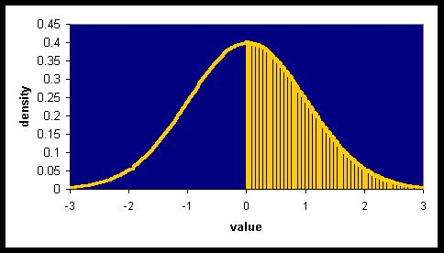
We're being asked what fraction of the area under the curve is shaded. It's pretty obvious in this problem that the answer is 0.5, or 50%. We can, however, easily use Table E.2b to get this answer.

Table E.2b tells you the area under the standard normal curve which lies to the left of a given z value. Here, the z value we want is 0. Looking in row .0, column .00 if Table E.2b gives us the fraction of the area to the left of z = 0.00, which is reported as 0.5000. So the “blue part” of our area is 0.5, which means that the shaded part of our curve, to the right of z = 0, also has an area of 0.5. (The total area under any probability density function is 1. A “probability density function” is the equivalent of a relative frequency distribution for a continuous variable—it’s what we’ve got in the picture above.)

In a moment, we'll look at how to solve this problem in Excel.

- P( z < -1.50). Here's the picture.

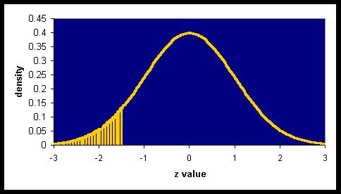
This one is really easy, because we're looking for a lower, rather than an upper, tail, which is what Table E.2b is built for. We just look in row –1.5, column 0, and get 0.0668.

- P(z > 1.75). Here's the picture.
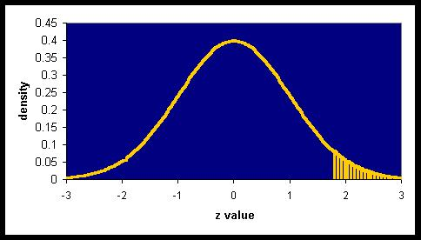

Since Table E.2b tells us the area of a “ left part “ of the normal curve, we need to use it to find the blue area. Subtracting that from 1 will tell us the area of the yellow region. In Table E.2b, the entry in the 1.7 row, 5 column is .9599, so the area of the yellow tail is 0.0401. That is, there’s only about a 4% chance that the value of z will be 1.75 or bigger.

- P(-0.5 < z < 1.30). Note that it doesn’t matter whether the inequalities are "<" or "<”, as we pointed out in part a. The distribution is continuous, and the probability of a continuous variable coming up exactly any value—like exactly 1.50000000000000000000000000000…. to an infinite number of decimals—is zero. (This doesn't mean it couldn't happen—it just means that it's infinitely unlikely.) Anyway, here's the picture.
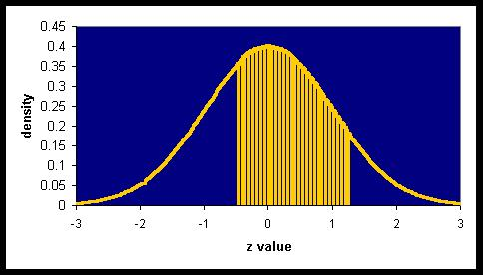

Again, we can do this by using Table E.2b, but the work is a little more complicated. This time, we’ll take all of the area to the left of 1.3, then subtract off all of the area to the left of –0.5.
P( z < 1.3) = 0.9032 (This problem is just like part b)

P(z < -0.5) = 0.3085 (Another “part b” problem.)

yellow area = 0.9032 – 0.3085 = 0.5947 which is the end of part d.

Now how can we do this in general, using Excel?

Using Excel to find standard normal curve probabilities

To use Excel to solve these problems, you need to understand that Excel provides exactly the same information as Table E.2b in the back of your book. You give it a z value, and Excel tells you how much of the distribution is equal to or below that value, as shown in the picture below, for a z value of 1.1.

The command in Excel to find the shaded region above =NORMSDIST(z), where you replace z with the cutoff value you want to use. For example, the area of the yellow region above is given by =NORMSDIST(1.1). "NORMSDIST" is an abbreviated form of "normal (standard) distribution".

I'd like you to learn two (easy) NORMSDIST values that Excel can't handle. I hope you see that NORMSDIST(∞) should equal 1, since if the yellow region goes on forever, it includes 100% of the area under the curve. I also hope that you see that NORMSDIST(-∞) should be 0. Negative infinity would mean that we don’t want to include any points at all in our shaded region, and so the area of the shaded region should be zero.

Okay, we're finally ready to give our procedure for doing sampling problems!

Finding Standard Normal Curve Probabilities in Excel

What you need:

• the upper and lower cutoff values

What you get:

• the probability that a randomly selected member of the standard normal population will have a value
that falls between the cutoffs.

- Shade the region of the normal curve that the question asks for. (It'll either be everything between your two cutoffs, everything larger than your one cutoff, or everything smaller than your one cutoff.) If you have no upper cutoff, use ∞ for the upper cutoff. If you have no lower cutoff, use -∞ for the lower cutoff.

- Your answer is
NORMSDIST(upper z cutoff) – NORMSDIST(lower z cutoff).

Since you can't enter ∞ in Excel, remember that NORMSDIST(∞) = 1 and NORMSDIST(-∞) = 0.

If you don't like having to compute NORMSDIST on your own for ∞ and -∞, you can get away with using a very large number in place of ∞, and a very negative number in place of -∞.

Let's demonstrate these techniques by reworking our current problem in Excel. Every one of the problems is done by using the formula in step 2 above. Since we've already sketched the graphs for each of these problems, I won't reproduce them here.

- P(z > 0). Upper cutoff = ∞, lower cutoff = 0. Calculation: NORMSDIST(∞) – NORMSDIST(0). In Excel, type = 1 – NORMSDIST(0), or if you prefer, =NORMSDIST(99999) – NORMSDIST(0). Answer: 0.5.

- P(z < -1.5). Upper cutoff = -1.5, lower cutoff = -∞. Calculation:
NORMSDIST(-1.5) – NORMSDIST(-∞). In Excel, type = NORMSDIST(-1.5) – 0, or
= NORMSDIST(-1.5), or, if you prefer, =NORMSDIST(-1.5) – NORMSDIST(-99999).
Answer: 0.066807229.

- P( z > 1.75). Upper cutoff = ∞, lower cutoff = 1.75. Calculation:
NORMSDIST(∞) – NORMSDIST(1.75). In Excel, type = 1 – NORMSDIST(1.75), or if you prefer, =NORMSDIST(99999) – NORMSDIST(1.75). Answer: 0.040059114.

- P(-0.5 < z < 1.3). Upper cutoff = 1.3, lower cutoff = -0.5. Calculation: In Excel, type
=NORMSDIST(1.3) – NORMSDIST(-0.5). Answer: 0.594661918

Get the idea? Every problem is the same! You're essentially saying: shade everything from -∞ to the upper cutoff. Then erase everything from -∞ to the lower cutoff. This leaves the stuff between the lower and upper cutoff.

Get comfortable with the problems in this section—they'll be the basis of more advanced work later.
- Arbitrary Normal Distributions and z-scores (or, Samples of Size 1)

Problem: Each package of Country Cow butter says net weight 16 oz. In fact, the net weight is normally distributed with a mean of 16.05 ounces and a standard deviation of 0.05 ounces. If a government agency tests randomly selects one carton, what is the probability that thenet weight of the selected package will be less than 16 ounces?

Be sure you read and understand section U before proceeding.

This is our first problem in sampling. By that, we mean that we are told all about the population, and we're asked a question about a sample drawn at random from the population. In this section, we have the simplest kind of sample—a sample consisting of only one observation. Here, that means one carton of butter. Before we solve this problem, it will be worthwhile for use to spend a bit of time getting a better grip on what the heck that “bell shaped curve” is really telling us. I’d encourage you to read this section carefully, since the ideas developed here will be use for every part of the remaining course.

We're told that the population is normally distributed, with a mean of 16.05 ounces and a standard deviation of 0.05 ounces. What that means is that the probability density function looks like this:
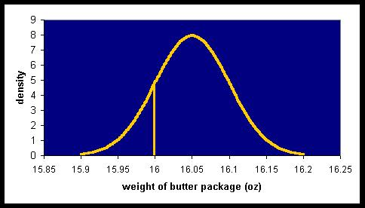
Here are some things to note:

- As with all probability density functions, the total area under this curve is 1, or 100%. That’s why the numbers on the vertical “density” scale are what they are—they’re just the right size to make the total area lying between the curve and the x-axis exactly equal to 1. (You can see that the amount of “stuff” in this “lump” is about 1 by noticing approximating it with a triangle. The triangle would have a height of about 8 and a base of a bit less than 0.3. The area of a triangle with height 8 and base 0.3 is ½ × 8 × 0.3, or 1.2, so you can see that we’re in the ballpark.)

- The mean is corresponds to the mode, which, as you can see, is 16.05.

- What you may not see right away is that the standard deviation is 0.05. Let me tell you how you can see this, by teaching you a little trick that most text books do not include. Look again as the graph above. I've marked the point 16 on the horizontal axis, which happens to be one standard deviation (0.05) from the mean of 16.05. There's something useful to notice here. Imagine that the normal curve were a highway, being viewed from above. Your car starts near the number 15.9. As you drive along the road, you'd first need to turn your wheel to the left, then straighten your wheel, then turn to the right to go around the "corner" at 16.05, and so on. At the point on the highway corresponding to 16, your wheel would be perfectly straight. It would be perfectly straight again at 16.1, before you had to start turning your wheel to the left again to handle the curve up toward 16.2.

Where is the standard deviation on a normal curve?

Mathematically, the points where your wheel is straight are called points of inflection, and for any normal curve, the points of inflection are always exactly 1 standard deviation from the mean. So if I showed you the normal curve above, you could have told me, just from looking at it, that the mean is 16.05 and the standard deviation is very close to .05, since the inflection points are 0.05 away from the mean.

This interpretation of standard deviation works for any normal curve, but it doesn't work for other curves, so keep that in mind.

So that’s what we see in the graph. But what does this kind of continuous curve really mean? Please read the answer carefully, because it’s incredibly important to everything that follows.

I'd like you to imagine that I have an absolutely huge number of cartons of Country Cow butter. What I'm going to do is this. I'm going to take a package of butter at random and weigh it. Let's say it weighs 16.16 ounces. I'll write 16.16 ounces on it, and set it aside. Now I'll take another package of Country Cow and do the same thing. If it weighs 15.98 ounces, I'll write 15.98 ounces on it, and set it aside. Got it?

I'm going to keep doing this for a very, very long time. Just for purposes of imagination, imagine I did this for a year. I'd have a ton of cartons, each with a number.

Now I'm going to arrange these cartons along a very long number line (say, along the goal line of a football field), putting my 16.16 ounce block at "16.16" on the line, and so on. If two blocks have the same weight, I'll stack them on top of one another. When I'm done sorting, arranging, and stacking my blocks, they'll make a big heap along the number line. The stack will be so tall in places that I might have to back away (say, to the far end of the football field where I stacked this stuff) to see it all. At that range, the individual cartons are all but invisible—I’ll just see a huge wall of yellow butter boxes. What will the wall look like? Like this:

Look familiar? This little carton stacking game is really what we mean when we say that the population distribution looks like this. Now, with only a million cartons, the contour of our heap might be a bit ragged—not exactly as high as it “should” be in some places. But if you continued this process of measuring and stacking all of the Country Cow butter boxes that ever were, and could ever be, the final wall would look just like the picture above. It's showing you what you get when you draw things from the population, one at a time, and measure them. Many boxes have numbers close to 16.05, and very few blocks have number bigger than 16.2 or smaller than 15.9, and so on.

Let's see if we can now answer the question. It asks: if you take one package of Country Cow butter, how likely is it that it will weigh less than 16 ounces? In our graph, we're looking for the fraction of the boxes that fall in the yellow shaded area below.

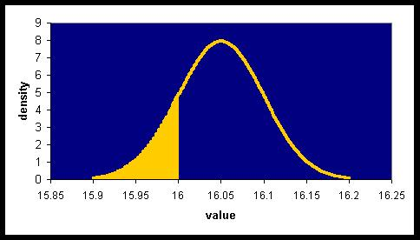

The total area under this bell curve is 1, and the area of the shaded region is the number we want. That's where all of the cartons with numbers less than 16 are, right?

So how do we find what fraction of the area under the curve is yellow in the picture above?
To answer that, let me show you another picture:

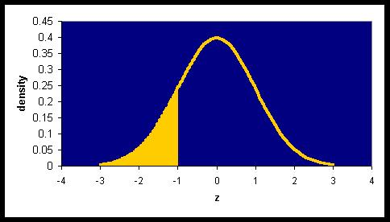

Looks identical, doesn’t it?

Well, yes…as long as you don’t look at the axes. When you compare the two graphs, you’ll notice three things:
- The center of the top graph is at 16.05, while the center of the bottom one is at 0.
- The standard deviation of the top graph is 0.05, while the standard deviation of the bottom graph is 20 times greater—1.
- The vertical (density) scale runs to 9 on the top graph, while on the lower graph, it is only 1/20 as tall—0.45.
The lower graph is, of course, the standard normal curve that we used in section U. And it’s the key to solving our problem. Why? Because the graphs for the standard normal curve and any other normal curve look exactly the same, provided we rescale the axes. Looking at our graphs, we can see that the fraction of the “butter weight” distribution which is less than 16 ounces, is the same as the fraction of the standard normal curve that is less than –1…and we know how to find this from section U. It’s just =NORMSDIST(-1), or 0.158655. So about 16% of both graphs are yellow, which means that there’s about a 16% chance that a randomly selected carton of butter will weigh less than 16 ounces.

But we were really lucky here. Our “cutoff value” of 16 ounces was exactly 1 standard deviation (0.05) below the mean (16.05), and that’s why it corresponded exactly to a z score of –1. But how about if our cutoff had been, say, 16.12 ounces?

No problem. There is a general procedure we can follow to find the corresponding value on the standard normal curve. That corresponding value is called the z-score for that value. To find the z-score for any observation, follow this two step procedure: 1) subtract the mean of the population from the observation value, then 2) divide the result by the standard deviation of the population. In symbols,

z = (x -μ)/σ

So if we want the z-score for a 16 ounce carton of butter, it’s z = (16 – 16.05)/0.05 = -1, as we used above. If we want the z-score for a 16.12 ounce carton of butter, it’s z = (16.12 – 16.05)/0.05 = 1.4. Get the idea?

What’s it good for?

Well, it turns every problem involving a normal distribution into a problem that can be solved using the techniques of section U. Just find the z-scores of the value of interest, then use the =NORMSDIST function (or Table E.2b, if you prefer). So I could show the solution to the problem in this section in the two lines below. Make sure you understand where it’s all coming from. The calculation of the z-score is new to this section. The rest is section U, which is how you handle z scores.

Z = (16 – 16.05)/0.05 = -1, so

P(x < 16) = NORMSDIST(-1) – NORMSDIST(-∞) = NORMSDIST(-1) – 0 = NORMSDIST(-1) = 0.158655.

So there's about a 15.8% chance that a randomly selected carton will weigh less than 16 ounces.

Combining this old stuff with the new gives us a step by step way to solve problems which take a single observation from a normally distributed population. You’ll see it on the box on the next page.

Finding Normal Curve Probabilities in Excel

What you need:

• the upper and lower cutoff values
• the mean of the normal distribution
• the standard deviation of the normal distribution

What you get:

• the probability that a randomly selected member of the given normal population will have a value
that falls between the cutoffs.

- Shade the region of the normal curve that the question asks for. (It'll either be everything between your two cutoffs, everything larger than your one cutoff, or everything smaller than your one cutoff.) If you have no upper cutoff, use ∞ for the upper cutoff. If you have no lower cutoff, use -∞ for the lower cutoff.

- Find the z-value for each cutoff. Do this by this formula:

z value = (cutoff – mean)/(standard deviation)

The z value for ∞ is ∞. The z value for -∞ is −∞.

- Your answer is
NORMSDIST(upper z cutoff) – NORMSDIST(lower z cutoff).

Since you can't enter ∞ in Excel, remember that NORMSDIST(∞) = 1 and NORMSDIST(-∞) = 0.

For a slightly shorter way of accomplishing this, see =NORMDIST is section X.

- Sampling from a Known Normal Distribution (or, Samples of Size of More than 1)

Problem: Recall the Country Cow problem of section V. Each package of Country Cow butter says net weight 16 oz. In fact, the net weight is normally distributed with a mean of 16.05 ounces and a standard deviation of 0.05 ounces. Now suppose that a government agent randomly selects 4 cartons and computes their average weight. How likely is it that the average will be less than 16 ounces? How about if the agent selected 16 cartons randomly, and averaged their weights? Why does the size of the sample make a difference?

Be sure you read and understand section V before proceeding.

Okay. We’re going to take four cartons, and average their weights. What happens?

Well, remember how we got the population distribution graph in section U? We imagined taking a carton of Cow Country butter, weighing it, and writing that weight on the carton. We did this for a huge number of cartons, then took our labeled cartons and sorted them by their numbers. We stacked these blocks along the number line, and when we did so, the pile of blocks would generate the silhouette of the normal curve we've been working with so far—the population distribution. I'll reproduce it here for reference.

The silhouette obtained for weight of cartons of butter
(Or, more properly, the population distribution for the weight of a carton of butter)

Each carton had on it the number for the weight of a single carton, and so the distribution that we got by stacking the cartons was the distribution for the weight of single cartons. We call this the population distribution because it shows how the weights of the individual population members are distributed. Choosing a random carton from this collection obviously corresponded to choosing a random carton of butter.

But now, we're talking about something different. We want to know what the average weight of a sample of four randomly selected cartons would be. How can we address this question by using modifying the approach just discussed? Like this:

Take a random sample of four cartons of Country Cow butter. Weigh each, add up the four weights, and divide by four. This, obviously, is the average weight of a carton of butter in this sample. Suppose the weights of your sample cartons were 16.05, 16.07, 16.01, and 15.99 grams. These four values average out to 16.03 grams, so that's the average weight of the sample. Now I have to write this down.

In section V, I wrote this on the carton itself. This time, since this is a number associated with four blocks, I’ll write it somewhere else. Specifically, I’ll pick up a children's building block, write "16.03" on it, and set it aside. Notice that the whole sample only gets one block, and one number. The number—the block—represents this whole sample. Specifically, it's the mean of the sample.

You know what comes next. I'm going to take another random sample of four cartons, average their weights, and write the average weight of this second sample on a second child's block. Again, I'll set it aside. I keep doing this for an incredibly long time, each time selecting a random sample of four cartons, finding the average weight for cartons in that sample, writing that average on a block, and setting the block aside.

This is going to be incredibly important for the rest of the course, since it lead to a fundamental, essential, and potentially confusing idea—the sampling distribution. Reread the last three paragraphs to be sure you understand what I’m proposing.

Now I'm going to arrange these blocks along a number line, putting my 16.03 ounce block at "16.03" on the line, and so on. If two blocks have the same weight, I'll stack them on top of one another. When I'm done sorting, arranging, and stacking my blocks, they'll make a big heap along the number line. This had better sound familiar to you—it's exactly what I did with my cartons in section V. In fact, the whole procedure I just described differs in only one way from the work in section V. The numbers on the blocks there each represented the weight of 1 randomly selected carton. Here, each number represents the average weight of four randomly selected cartons.

And here's where the important part comes in. When I stack up all of my new blocks—the ones with numbers from samples of size four—the silhouette of the stack looks like this.

The child's block silhouette obtained for mean weight of samples of four cartons of butter
(Or, more properly, the sampling distribution of mean butter carton weight with n = 4.)

Let's see what the picture tells us. Notice how the curve peaks at 16.05, and falls off in a nice normal curve to either side. That means that the values we wrote on our blocks cluster around 16.05. Values close to 16.05 are relatively common, but values less than 16 or more than 16.1 are relatively rare.

And what does this mean? Remember that each block represented a sample of four cartons. Specifically, it was the average weight of those four cartons. So what the distribution shows you is this: if you take four randomly selected cartons of Country Cow Butter and find the average weight of the four of them, the value that you get will most likely be close to 16.05, and is quite unlikely to be less than 16.0 or more than 16.1. We can make these ideas of "most likely" and "quite unlikely" by finding the area under parts of this normal curve. If, say, 40% of all of our children's blocks had numbers bigger than 16.07 on them, then 40% of the area in the silhouette above would be to the right of the number 16.07 on the number line.

What we're being asked in this problem is: What fraction of the area is to the left of the "16" shown on the number line above? As you can see, it isn't much. If I choose my vertical axis so that the area under the whole normal curve is 1 (100%), then I'm asking for the area of the yellow tail shown below.
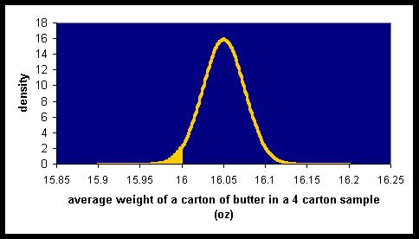

We know how to compute areas under normal curves—see section V if you forget. We need to know only three things. What's the mean for the normal curve? What's its standard deviation? And what are the cutoffs?

For our problem, the mean is 16.05…it's where the normal curve peaks. The cutoffs are also easy—16 for the upper limit and -∞ for the lower limit. What's the standard deviation?

You might be tempted to say "0.05", since that's what was given in the original problem. But it's obviously wrong. We're not talking about the population distribution here, because that distribution has "blocks" whose numbers represent the weight of a single carton. We're talking about the average weight of four cartons, and the picture for that one is the one on the bottom of the previous page. Recall that in section V, we learned how to estimate a standard deviation of a normal distribution from a graph. The distance from the mean to an inflection point is one standard deviation. I'll show the inflection points on the curve, below.

Stars are at the points of inflection of the curve.
Vertical lines extended downward from these stars would touch the horizontal axis
at points that are 1 standard deviation from the mean of 16.05.

Eyeballing it, the left star seems to be about halfway between 16 and 16.05. As it turns out, this estimate is exactly correct. That being the case, the standard deviation of this normal curve can be computed. The mean is at 16.05 and an inflection point is at 16.025, so the standard deviation is the difference between these two, or 0.025.

So we're all set…we know the mean (16.05) and the standard deviation (0.025) of the quantity that we're looking at (which is the mean weight of a random sample of four cartons of butter). We know our cutoffs (-∞ and 16). Now we can use our section V formula box to find our answer.

Yeah…great. But how were you supposed to do this? I skipped a step, didn’t I? I just told you that the sampling distribution would look like the graph above. How did you know that the mean of the sampling distribution was at 16.05? How did you know that the sampling distribution would even be normal? And how were you supposed to know that the standard deviation of the sampling distribution was 0.025? You were given information about the population, but what you need to answer this question isn't the population distribution, but rather a distribution whose "children's blocks" correspond to samples of size four. You need the sampling distribution of the sample mean with n = 4.

Well, mathematicians have proved three results connecting a population distribution and a sampling distribution of the mean. You don't need to prove them, but you need to know them and understand them, so take your time with what follows. (I’ve reproduced the graphs from section V and from earlier in this section so that you could look at them easily.)
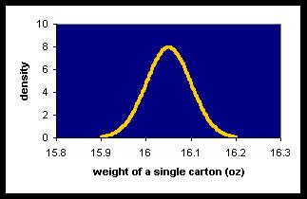
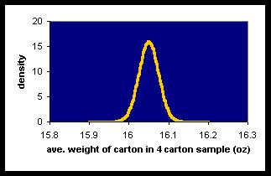

- The two distributions have the same mean.

Each “observation” in the graph on the left is a single carton, and the mean of this graph is 16.05. This means that the average weight of a carton is 16.05 ounces.

In the graph on the right, each “observation” is a sample of 4 cartons. The mean of this sampling distribution is also 16.05. What exactly does this mean? Well, we’re now to the point where normal English becomes tangled. It's easiest to think of it in two steps.

- Take a sample, find the average value for the sample, and write down this number.
- Do this for every sample, then average all of the numbers you have written down.

What you are doing, you see, is finding the average for each sample of four cartons, then averaging all of the averages. Because we don’t want to write a paragraph every time we want to communicate this idea, we just say that the mean of the sampling distribution for n = 4 is 16.05.

GET COMFORTABLE WITH THIS TERMINOLOGY NOW. TAKE 10 MINUTES TO DO IT. IT’S AN IDEA THAT WE’LL USE OVER AND OVER, AND IT’S HARD TO MAKE IT STAY IN YOUR HEAD.

Saying that these two distributions have the same mean corresponds roughly to something that you already know. If you want to find the average for a whole population, you can take the average of a sample. The average of the sample won’t necessarily be exactly equal to the population mean, but it should be close. And if you take a bunch of samples and average their averages, the “grand average” should be pretty darned close to the population mean.

- If the population distribution is normal, then the sampling distribution of the mean is normal.

That is, if the graph on the left is normal, so is the graph on the right. This means that we can use the section V techniques to answer questions about the sampling distribution.

As it turns out, even if the population is not normal, the sampling distribution of the mean may still be almost perfectly normal. We'll talk more about this later.

Now, the tricky one.

- The standard deviation of the sampling distribution of the mean is equal to the standard deviation of the population distribution, divided by the square root of the sample size. In symbols,

standard deviation of the sampling distribution of the mean = $σ/\sqrt{n}$

If you wanted to know the average weight of a carton of butter, you could check a single carton's weight, and use that for your guess. Alternatively, you could find the average weight of four different cartons. Common sense says that getting more data should generally give you a better idea of what's going on, and this impression is correct. Rule 3 says that the larger the sample is, the less difference you expect to see between the population mean and the mean of the particular sample you draw.

You might think that a sample that is four times as big as another is four times "better" than the other. This isn't true. The improvement (as measured by standard deviation) is measured by the square root of the sample size, so a sample that is 4 times bigger results in a standard deviation that is only 2 times smaller—because √4 = 2. That's what we saw in our discussion—when we took samples of size 4, we got a standard deviation that was ½ has large as the population's standard deviation.

Okay, we're finally ready to give a general procedure for sampling problems. Next page, please.

Sampling Problems

What you need:

• The mean of the population, μ
• The standard deviation of the population, σ
• The sample size, n
• The upper and lower cutoff values

What you get:

• The probability that a randomly selected sample of size n will have a mean falling between the two
cutoffs.

1. Find the mean of the sampling distribution. This is easy. It's just the mean of the population
distribution, μ.

2. Find the standard deviation of the sampling distribution. This is just $σ/\sqrt{n}$

3. Verify that the sampling distribution is normal by one of the following criteria:
• the population is normal, or
• the population is roughly normal and n >10, or
• the population is roughly symmetric and n > 20, or
• n is very large—say, n > 100

4. This normal distribution describes the distribution you are interested in. It has mean μ and standard
deviation $σ/\sqrt{n}$. Use these values in the box on Finding Normal Curve Probabilities in section V.
Note that this means that standard deviation you must use is the one you just computed in
step 2: $σ/\sqrt{n}$.

So let’s finally solve the problem for this section! How likely is it that a random selection of 4 butter cartons has an average weight of less than 16 ounces?

The population has μ = 16.05 and σ = 0.05. We want to know the probability that a randomly selected sample of 4 cartons has an average weight of less than 16 ounces. We're going to be getting one number—the average weight of our four box sample. This represents one "block" in the distribution that we're interested in. Hence, the distribution that we're interested in is the sampling distribution of the mean for samples of size 4. We use the box on the previous page.

Since the population mean μ is 16.05, the sampling distribution of the mean also has mean 16.05. Since the population standard deviation is 0.05, the standard deviation of the sampling distribution is 0.05/√n = 0.05/√4 = 0.05/2 = 0.025.

The population is normal, so the sampling distribution is normal. Since we're interested in all sample means that are less than 16, our cutoffs are -∞ and 16. Now we use the box on from section V.
The z-score for -∞ is -∞. The z-score for 16 is (16-16.05)/0.025 = -2.

The answer to the question is NORMSDIST(-2) – NORMSDIST(-∞) = NORMSDIST(-2) = 0.02275

where I got the value 0.02275 by typing =NORMSDIST(-2) into Excel.

Interpretation:
There is a 2.275% chance that a sample of four cartons of butter will have a mean weight of less than 16 ounces.

Now, how about if we take a sample of nine cartons instead?

We play the same game, this time with n = 9.

The population has μ = 16.05 and σ = 0.05. We want to know the probability that a randomly selected sample of 9 cartons has an average weight of less than 16 ounces.
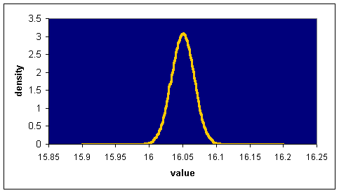
Sampling Distribution of Mean for n = 9 Cartons

Since the population mean μ is 16.05, the sampling distribution of the mean also has mean 16.05. Since the population standard deviation is 0.05, the standard deviation of the sampling distribution is 0.05/√n = 0.05/√9 = 0.05/3 = 0.016667

The population is normal, so the sampling distribution is normal. Since we're interested in all sample means that are less than 16, our cutoffs are -∞ and 16. I've shaded the lower tail of values less than 16 in the graph above, but it's so small you can't easily see it!

Now we use the box in section V.

The z-score for -∞ is -∞. The z-score for 16 is (16-16.05)/0.016667 = -3.
The answer to the question is NORMSDIST(-3) – NORMSDIST(-∞) = NORMSDIST(-3) = 0.001350
where I got the value 0.001350by typing =NORMSDIST(-3) into Excel.

Interpretation:
There is a 0.1350% chance that a sample of nine cartons of butter will have a mean weight of less than 16 ounces.

Note that as the sample size climbed from 1 to 4 to 9, the number 16 had its z-score change from –1 to –2 to –3. A value of 16 on a single box is not so strange…it's only one standard deviation below the mean weight of a carton. But for a sample of 4 boxes to have a mean weight of 16 is much less common…it's two standard deviations below the mean of its distribution. And for a sample of size nine, 16 is three standard deviations below the mean of its distribution. Values more than 3 standard deviations from the mean are quite uncommon.

- Additional Useful Excel Functions: NORMSINV, NORMDIST, NORMINV, STANDARDIZE

Problem: Here is the script for a psychology study:

“Thanks for being a test subject for this study. All that I want you to do is to tell me when you think that a minute has passed, by saying the word ‘now’. Ready? Okay, the minute starts…NOW.”

Define a “subjective minute” as the amount of time that actually passes during this experiment (from “now” to “now”). Suppose that subjective minutes are normally distributed with a mean of 50 seconds and a standard deviation of 12 seconds.

  - What is the probability that a subject underestimates the length of a minute?

  - Half of the people have subjective minutes shorter than 50 seconds. Only one person in a thousand, on the average, will have a subjective minute longer than a certain threshold value. What is that value?

Answer to a): We are asked for P(X < 60), where X is the number of seconds that actually passes during a single subject’s subjective minute. This is a question about an observation drawn at random from the population itself, so we can solve it using the techniques of section V, recorded in the box on page 12. It would look like this:

μ = 50, σ = 12, upper x cutoff = 60, lower x cutoff = -∞, so
upper z cutoff = (60-50)/12 = .8333, lower z cutoff = -∞, so answer is
=NORMSDIST(0.8333) – 0 = 0.7977, so there is about a 79.77% chance that the subject will underestimate the length of a minute.

To do this, we needed to identify the mean and standard deviation of the sampled population, determine the upper and lower cutoffs, convert those cutoffs to z scores, then use the NORMSDIST function to find the probability corresponding to those z-score cutoffs. We can simplify this process in Excel in two ways.

First, Excel has a built in function, =STANDARDIZE, which will compute the z-score. You tell Excel the value of your X cutoff, along with the mean and standard deviation of the population which is being sampled, and it comes back with the z-=score for that cutoff. For our problem, then, we could have used =STANDARDIZE(60,50,12), and Excel would return 0.8333333. z-scores are pretty easy to compute, anyway, so this function doesn’t really save you that much effort.

But a second new function is more useful: =NORMDIST. NORMDIST combines the NORMSDIST (with which you’ve been working) with STANDARDIZE. The result: You tell NORMDIST your x cutoff, along with the mean and standard deviation of the sampled population, and it return the probability of obtaining an X value less than that cutoff. Saying this another way, NORMDIST works just like NORMSDIST, but can be used for ANY normal curve, not just the standard one. Its form is =NORMDIST(cutoff, mean, standard deviation, TRUE).

So we can solve problem a) as follows:

=NORMDIST(60, 50, 12, TRUE) – 0 = 0.7977

Answer to b): This problem is “backward” from those we have looked at so far. Generally, we are given the mean and standard deviation of the sampled population, along with two cutoff values, and we are asked the probability that an observation’s value will fall between these cutoffs. In this problem, we are given the probability, and asked for the cutoff. Such a “backward” problem requires that we use an inverse function. (The inverse of an operation is just the operation that “undoes” the original operation. Hence, “square” and “square root” are inverses of one another.) Excel has two functions which can be useful in this regard: =NORMSINV and = NORMINV

Solving b using =NORMSINV: NORMSINV is the “perfect opposite” of NORMSDIST. =NORMSDIST(z-cutoff) says, “Give me a z-score, and I’ll tell you what fraction of the standard normal curve lies below that z-score.” =NORMSINV(probability) does just the reverse. =NORMSINV(0.9), for example, would return the z-score of a point that has 90% of the standard normal curve to its left. Saying all of this one more way, if p* = NORMSDIST(z*), then z* = NORMSINV(p*).

So how can we use this? Well, we’re looking for a “subjective minute” duration which is exceeded by only 1 person in 1000. That is, we want a test time, x*, which is longer than 0.999 of the observed test times: P(X < x*) = 0.999. Well, the z-score for this time (we’ll call it z*) is =NORMSINV(0.999), or 3.090. So our cutoff should have a z-score of 3.090.

Since μ = 50 and σ = 12, this means that z* = (x* - μ)/σ, so 3.090 = (x* - 50)/12, and we can solve this for x*. x* = 3.090(12) + 50 = 87.08 seconds. That is, only one person in a thousand will let more than 87.08 second go by without saying “now”.

Solving b using = NORMINV: The solution we just did required us to find the critical z cutoff, z*, then use this to solve for the critical x cutoff, x*. Excel can do both of these things in one step, using the =NORMINV command. The relation between NORMINV and NORMDIST is the same as that between NORMSINV and NORMSDIST. NORMDIST gives you the probability when you give it the cutoff, sampled population mean, and sampled population standard deviation. NORMINV gives you the cutoff when you give the probability, sampled population mean, and sampled population standard deviation. Its form is =NORMINV(probability, mean, standard deviation). So, for our problem, we’d want
= NORMINV(0.999,50,12), which Excel reports as 87.08294. We get the same answer as before (99.9% of people finish in about 87 seconds or less), but can do it in one step.

Effectively, NORMINV and NORMDIST give you the equivalent of Table E.2b for ANY normal curve, not just the standard one.
Y. Sampling: Proportion problems and the Normal Approximation to the Binomial

Problem: Mendel postulated that the self-fertilization of hybrid yellow-seeded sweet peas would yield offspring with a 0.75 probability of being yellow-seeded and a 0.25 probability of being green seeded. In 1865, he reported that 8023 such experiments yielded 6021/8023 = 0.750467 yellow-seeded plants and 2002/8023 = 0.2495 green-seeded plants. It has been suggested that these results are too good to be true, in that Mendel must have reported what he wanted, rather than what he observed. If these were honest, independent trials, each with a 0.75 probability of producing yellow-seeded plants, what is the probability that the observed number of yellow-seeded plants would be within 6013 and 6021 (that is, no more than 4 plants from the mean, 6017.25)?

We could do this problem as a binomial problem (see section T), treating each yellow-seeded pea plant as a success. The exact answer could then be obtained by using the BINOMDIST function. The logic would go like this:

P(6013 < # of yellow peas < 6021) = P(# of yellow peas < 6021) – P(# of yellow peas < 6012) =
BINOMDIST(6021,8023,0.75,TRUE) – BINOMDIST(6012,8023,0.75,TRUE)

(Find how likely it is to get 6021 yellows or less, then subtract off how likely it is to get 6012 or less. What's left is the likelihood of 6013 to 6021.)

Unfortunately, Excel shows the answer as #NUM!, which means that the calculation was outside of its range.

That being the case, we're forced to do the problem by using the normal approximation. We can do this as in section 7.3 of your textbook by recasting the problem in terms of proportions.

The question is equivalent to this: We have a population in which is 75% yellow-seeded. We’ll call being yellow-seed a “success”. We want to know, in a sample of size n = 8023, what is the probability that the proportion of successes p, is between 6013/8023 and 6021/8023. That is, we want
P(0.74947 < p < 0.750467). In reality, a problem in this section is just like a problem in section W. Here’s why.

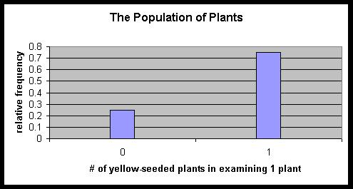
Each individual pea plant—each observation—is either a “success” (yellow) or a “failure” (green). Let’s imagine that a success always gets represented by the number 1 (the plant was “100% successful”) and that a failure always gets represented by the number 0 (the plant was “0% successful”). Those are the only two possibilities for any single plant, so every plant gets assigned a number of either 0 or 1. Let look at the distribution of these “population numbers”. First, every observation is either 1 or 0, so the picture of the population distribution has a “spike” at 0, a “spike” at 1, and nothing in between. (In our problem here, the “spike” at 1 is 3 times as tall as the “spike” at 0, since successes occur three times as often as failures.)

The text in this box explains the formulas for the mean and standard deviation of a “two spike” (Bernoulli) distribution as shown on the bottom of the last page. Feel free to skip it, if you like. We’ll use what we need from it later.

To find the mean μ of this population, you only have to realize that ¾ of the numbers are 1 and that ¼ of the numbers are 0. So if you added up all of the observations in the population and divided by the size of the population, you’d get ¾(1) + ¼(0), or 0.75. That is, the “balance point” of this distribution is at 0.75 on the horizontal axis. We can use this picture to find σ², the population variance, as well. Remember that the population variance is computed by finding the average of the square of the deviations from the mean. Well, in the population shown on the previous page, the mean is 0.75, as we saw. That means that ¾ of the observations (all of those in the “1 spike”) are 0.25 from the mean. The other ¼ of the observations (those in the “0 spike” are 0.75 from the mean. So if I want to find the average of the square of these deviations, then ¾ of the observations contribute (0.25)² each, and ¼ of the observations contribute (0.75)² each. The result is that σ² = ¼(0.75)² + ¾(0.25)² = 0.1875.

We can make our life easier by working out general rules for the proportion. If the probability of a success is π, then the probability of failure is 1-π. Then the mean of the population (by the same logic above) is π(1) + (1-π)0 = π. Further, the observations on the “1 spike” differ from this mean by (1-π), while the observations on the “0 spike” differ from this mean by π. That means that σ² = π(1-π)² + (1-π)π², and this math simplifies very nicely to π(1-π). This gives us the very useful result given below.

In a Bernoulli distribution, each element of the population has either a value of 0 (failure) or a value of 1 (success). If the probability of success is π, then the mean of the Bernoulli distribution is π and the standard deviation of the Bernoulli distribution is SQRT(π(1-π)). It is therefore quite correct to write, for such a population,

Bernoulli Distribution (from which samples involving proportions are drawn) If each observation has a probability π of being a success (1), and a probability (1- π) of being a failure (0), then

μ = π and
σ = SQRT(π(1-π)).

Note that knowing one value (π) gives you both the mean and standard deviation of the population.

Once you know, this, you can treat problems involving proportions just like problems involving any other population. You know that for any population, the sampling distribution for its sample means is essentially normal, provided that the sample is large enough. The mean of the sampling distribution is always the same as the mean of the population. The standard deviation of the sampling distribution is always the standard deviation of the population, but divided by the square root of the sample size. Well, we know μ, we know σ, and we know n. Provided n is large enough, we can proceed exactly as in section W.

So how big an n is “big enough”? For proportion problems this check is easy—just make sure that the number of "expected successes" and "expected failures" are both at least 5. In an sample of n observations with success rate π, the expected number of expected successes is n × π, and the number of expected failures is n × (1 – π). Here, these numbers are 8023 × 0.75 and 8023 × 0.25, and both of these are over 2000—well over 5!

n × π = 8023 × 0.75 = 6017.25. The standard deviation will be SQRT(.75 × .25 × 8023) = 38.785.

So our problem becomes this. We've got a normal distribution that approximates the number of yellow peas plants that we get in a sample of 8023 peas total. This normal distribution has a mean of 6017.25 and a standard deviation of 38.785. What are the chances that an element of this population falls between 6013 and 6021? That is, what are the chances that the counting of 8023 peas plants gives between 6013 and 6021 yellow ones, if each plant has a 75% chance of being yellow? In symbols, we want
P(6013 < # yellow plants < 6021). We know how to do this. Find the z scores for the cutoffs, then use NORMSDIST.

z-score for 6013 = (6013 – 6017.25)/38.785 = -0.1096
z-score for 6021 = (6021 – 6017.25)/38.785 = 0.0967
So our (approximate) answer is = NORMSDIST(0.0967) – NORMSDIST(-0.1096) = 0.08215.

This means that if ol' Mendel were on the up and up, he got a result that is better than you'd expect him to get 92% of the time. If each pea is really a binomial trial with a 75% chance of being yellow, then about 92% of the time you'll end up with a final count of 8023 peas which is more than 4 yellow peas from the mean. This is a little more likely than flipping 5 heads or 5 tails in a row on a fair coin. It can certainly happen…but it's rather surprising.

Cutting to the Chase

Conduct n independent trials, each with an equal probability π of success. Let p be the fraction of the n trials that were successes. Then the distribution of p is has

Mean: μ = π
Standard deviation: σ_{ps} = SQRT(π(1-π)/n)

and this distribution is essentially normal, provided that nπ and n(1-π) are both at least 5.

This means that to find P(a< p < b), you can proceed identically to the approach used in V.

This same calculation is appropriate when considering the fraction p of a sample of size n that satisfies a given requirement.

Two comments on this problem:

- With continuous distributions (like the normal), it makes no difference if you use < or <. (See demonstration U.a.) With a discrete distribution (like the binomial) it does matter. "x > 3" means "at least three successes" in the binomial, and "x > 3" means "more than three successes" in the binomial, and these two conditions are very different! This creates a problem when approximating a discrete distribution with a continuous one. Let me show you want I mean. We just used the normal approximation to find P(6013 < # yellow peas < 6021). Our cutoffs were 6013 and 6021.

But the original question—how likely is it that the number of yellow peas is between 6013 and 6021—could be asked equally well as, "How likely is it that the number of yellow peas is greater than 6012 and less than 6022?" Mathematically, this would be P(6012 < # yellow peas < 6022). If we now solve this using the normal approximation, the cutoffs we'd use are 6012 and 6022. But these are different cutoffs for the same problem! Which ones are right?

Well, neither are exactly right, because this is an approximation. For most purposes, the approximation is okay with either set of cutoffs. The first one gives an answer that is probably a bit smaller than it should be, and the latter will give an answer that's probably a little larger than it should be. If you want to be classy about it, you can do what most statisticians do. Realizing that the lower cutoff could be 6012 or 6013, they use a cutoff of 6012.5. Realizing that the upper cutoff could be 6021 or 6022, they use an upper cutoff of 6021.5. The final answer is still an approximation, but introducing this continuity correction factor usually gives a little better answer.

In our current problem, using the continuity correction factor gives an answer of 0.0949. So Mendel's result is more uncommon than all but 9.49% of the random samples, rather than our original (too small) estimate of 8.21%

- When the numbers n × π and n × (1 – π) are both large, the binomial distribution is very well approximated by a normal curve with μ = nπ and σ = SQRT(nπ(1-π)). As an example, compare the two curves below. The one on the left is the actual binomial distribution when n = 100 and p = 0.2. The one on the right is the normal distribution with
μ = 20 and σ = SQRT(100 × 0.2 × 0.8) = SQRT(16) = 4. Compare them. They're very close!

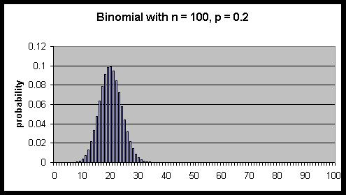
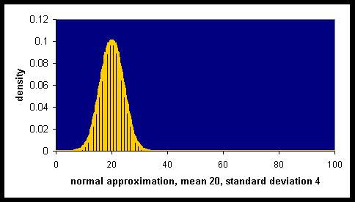

On the other hand, it really is necessary to check that requirement that the "expected successes" and "expected failures" are both at least 5. To see why, compare the two graphs below. The one on the left is the actual binomial distribution with n = 100 and π = 0.005. The graph on the right shows what the "normal approximation" would look like, if we used the technique of this problem. As you can see, it's a terrible match!
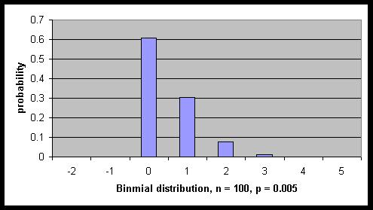
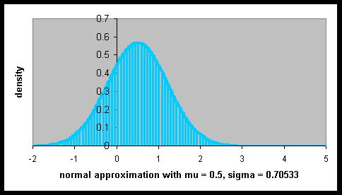

Z. Errors in Experimental Design and Interpretation

Selection bias (Coverage error)

Problem: An examination of 850,000 records of operations performed in 34 hospitals with 4 commonly used anesthetics showed that the percent of recipients dying on the table was 1.7% with anesthetic A, 1.7% with anesthetic B, 3.4% with anesthetic C, and 1.9% with anesthetic D. Is it reasonable to conclude from this information that anesthetic C is twice as dangerous as anesthetics A and B?

This kind of question is important, because the erroneous conclusion that C is twice as dangerous as A is precisely what most people (who aren't doing stat homework!) would conclude. It's quite likely that the data given is subject to selection bias.

Why? Well, suppose that anesthetic C keeps a patient unconscious for 6 to 12 hours, while the other three anesthetics knock out the patient for 30 minutes to 2 hours. Imagine that, in all other respects, the anesthetics are identical.

Under what circumstances would we expect a patient to get anesthetic C? Precisely when a long surgical procedure is anticipated. So operations like removal of wisdom teeth would be done with A, B, or D, whole operations like heart transplant or repair of massive internal trauma would be done with C. C is no more dangerous than the others…it's simply used in more dangerous situations.

In a similar way, records would show that people in weigh loss programs weigh more on average, than people who are not in such programs. Does this mean that the program causes in increase in weight? Of course not. The people in the program are self-selected, and are there precisely because they wish to lose weight.

Nonresponse bias and measurement error

Problem: Shere Hite sent out detailed questionnaires (which, according to Hite, took an average of 4.4 hours to fill out) to 100,000 women and received 4,500 replies, 98% of which said that they were unhappy in their relationships with men. A Washington Post-ABC News poll telephones 1505 men and women and fiound that 93% of the women considered their relationships with men to be good or excellent. How would you explain the difference?

Nonresponse bias, for starters. The Hite Report was widely criticized for its poor response rate—only 4.5%. 95.5% of women receiving the survey never filled it in—understandably, since it took over 4 hours to complete, on average. So the question is: would we expect any consistent differences between those women who filled in the survey, and those who didn't?

Think about women who would spend over four hours on a survey about sex and relationships. Can you make any reasonable guesses? First, they can find several hours in their schedule to fill out a survey. Second, it's likely that many of them have something that they really want to say. It's common that people are more moved to express exceptional dissatisfaction than exceptional satisfaction. So we may well expect that Hite's results will include a disproportionate number of intensely dissatisfied women. Certainly, her report includes a lot of such women—98% of her sample were unhappy. But it bears notice that these women make up less than 5% of the surveys sent out.

The telephone poll, on the other hand, finds that 93% of the women interviewed considered their relationships with men to be good or excellent. As a man, I'm much more likely to accept this stat as closer to the truth—I have a vested, emotional interest in doing so. Watch out for this trait, which we all have, of accepting statistics that support our own conclusions. All stats should be treated skeptically.

So how could the phone poll (no pun intended) have problems? Well, the sample size is good (1505), but we don't know how many of these calls were to women. We don't know if the sample is random or convenience and how nonresponse was handled. But let's imagine that all of these issues are handled to our satisfaction. Anything else?

Yes. These are phone interviews. Imagine someone calling you up and asking you if your relationships with members of the opposite sex are dreadful, unsatisfying, okay, good, or excellent. What are you going to say? This is a conversation, you're certainly not anonymous, and your significant other may be in the room with you. The issue of honesty of respondents has to come up here. Your book considers a deliberately inaccurate response as an example of measurement error.

My expectation, before even seeing the poll results, would be that Hite's average satisfaction would be way too low, and the telephone poll's average satisfaction would be considerably too high.

The discussion that follows here is the logic leading to our approach for proportion problems, but it may be a bit more than you feel like biting off. If that’s the case, you can jump to “Cutting to the Chase” and look at the formula you use for problems like this.

